eee lab logbook

Tong Yong Zhi

02581094

<https://github.com/edstott/EEE1labs>

Imperial College London

Electrical and Electronic Engineering

Arduino Basics

For the experiments under Lab Skills, the circuits will be controlled by a microcontroller called the Arduino. There are 2 main components that will be used: the breadboard and the Arduino Uno.

# Breadboard

The breadboard is a platform to build circuits on. It is made of wires that run the bottom of the breadboard, connecting specific rows and columns electrically.

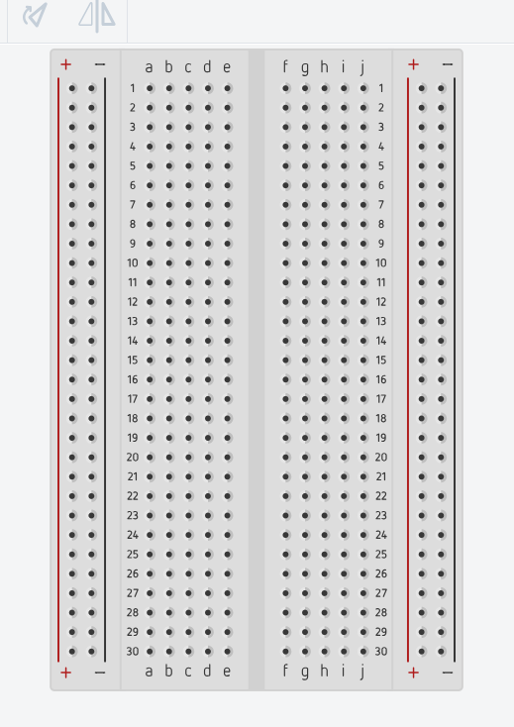There are many holes on the breadboard to insert wires or components in. In the middle of the breadboard, the rows are electrically connected. For example, a1 to e1 are connected. However, the connection does not extend past the gap in the most middle. At the sides, the positive and negative columns are electrically connected, representing the power input and ground respectively.

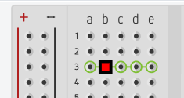

Figure : A row electrically connected

The side columns are important to allow many connections to the power and ground respectively. Connect a wire from the power source into the positive column, and any other hole in the column will receive the same voltage. It is the same for the negative column with ground.

# Arduino UNO

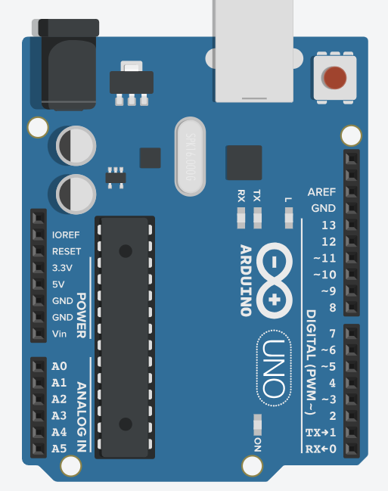The Arduino Uno is the microcontroller used to control the circuits on the breadboard. There are several pins on the surface of the Arduino, including digital input and output; and analogue input and output. The Arduino is easily powered by a USB cable.

# Digital output

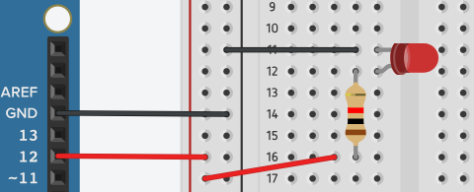The pins labelled 0 to 13 are all digital output or input pins, capable of supplying a constant 5V supply. The pins with the curvy lines are capable of Pulse Width Modulation (PWM), which allows the constant 5V to be rapidly switched on and off to achieve a different average voltage.

In the picture above, the circuit uses digital pin 12 as a voltage source to power the LED. Pin 12 is connected to the positive column, then a wire is connected from the positive column to the resistor. The resistor is connected to the LED in series and the LED is connected to the negative column, which is connected to ground. This forms a complete circuit.

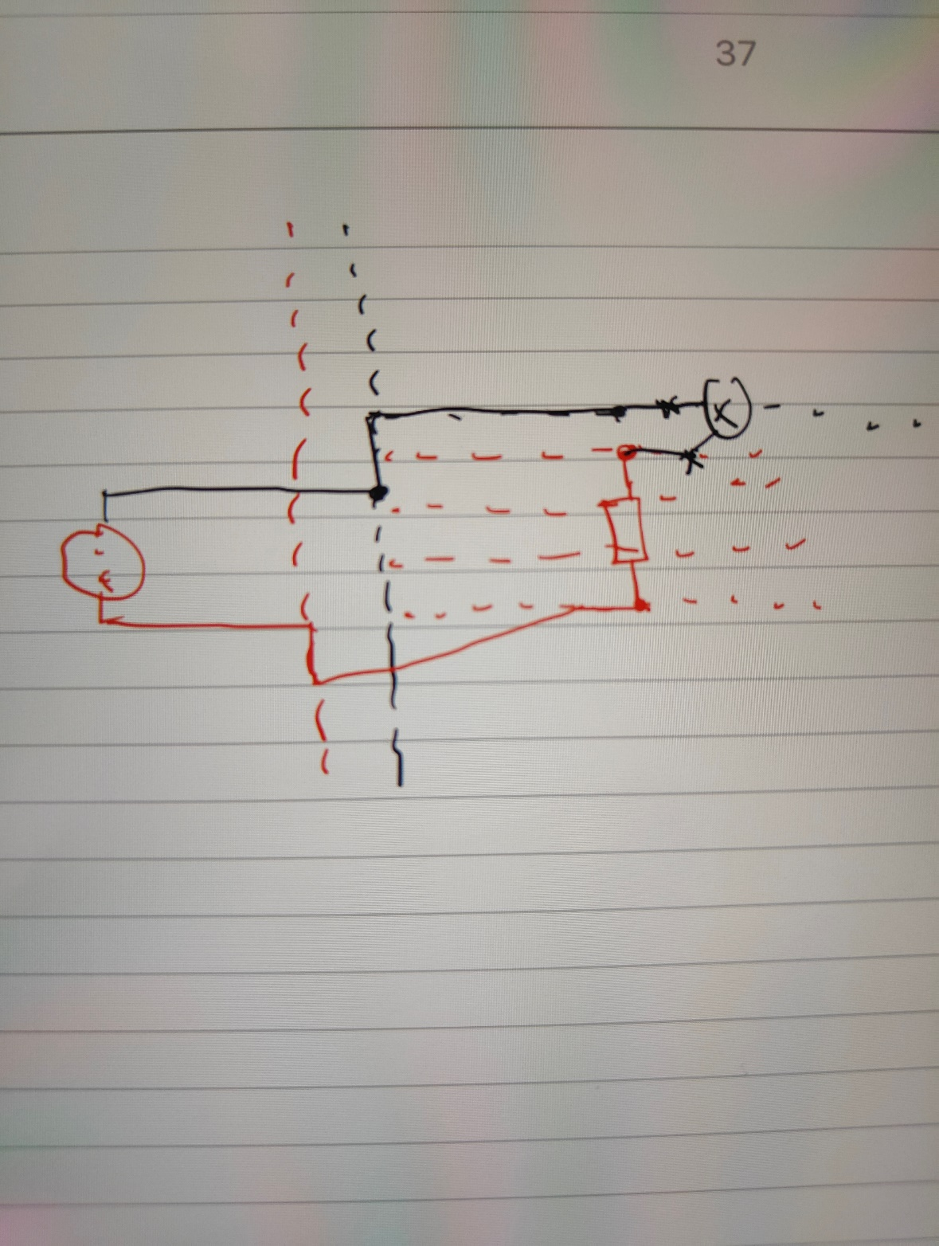

The Arduino can be programmed to make Pin 12 an output pin, and periodically output high and low voltages to make the LED turn on and off.

# Arduino program

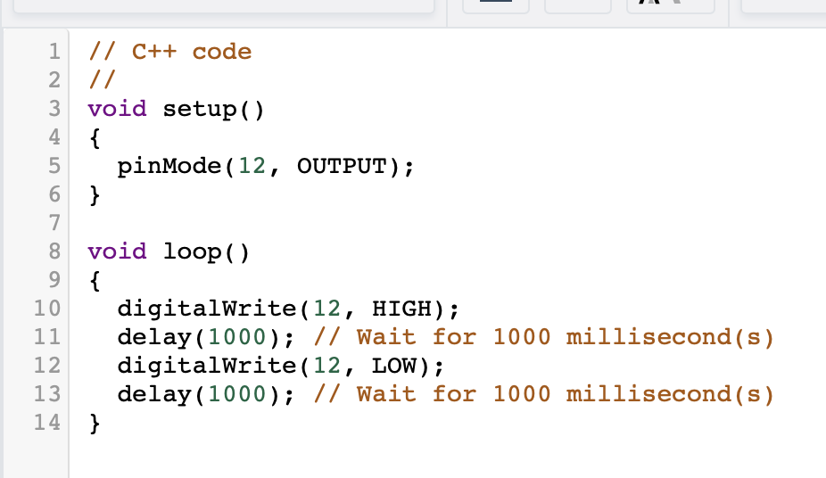

Above is a picture of Arduino code to command an LED to switch on and off for 1 second respectively. In the setup function, code is only executed once. In the loop function, code is executed indefinitely.

In the setup function, the output is designated with the “pinMode” function. pinMode(12, OUTPUT) means that pin 12 is the output.

In the loop function, the digitalWrite(12, HIGH) line means setting Pin 12 to output a high voltage (5V). The delay(1000) line means wait for 1000 ms (1s). Then, the digitalWrite(12, LOW) means setting Pin 12 to a low voltage (0V). The line of code in the loop function is then repeated indefinitely.

# DIGITAL INPUT

The Arduino can receive an input voltage from the circuit and the Arduino can be programmed to use that input voltage to execute certain tasks.

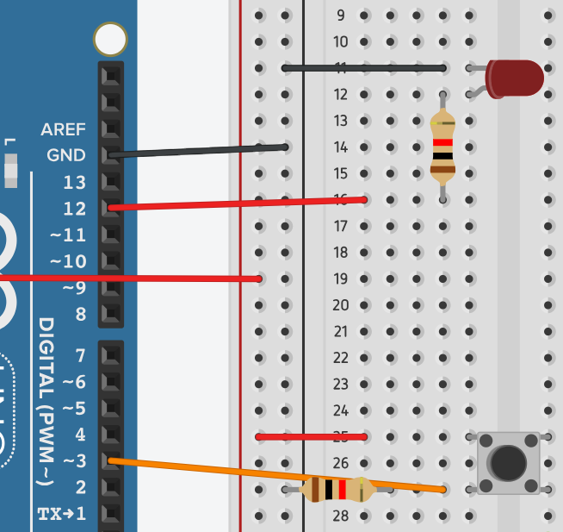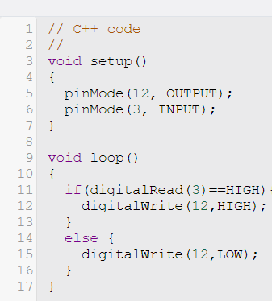

The component at the bottom is a button. When the button is pushed, it makes an electrical connection between rows 25 and 27. The button must be placed at the gap in the middle of the breadboard so that it does not get short circuited.

When the button is pressed, there is a path from 5V to the input pin (from the red wire to orange wire). When the button is not pressed, the default path to the input pin is ground from the resistor. The resistor is there because when the button is pressed, there is a path from 5V directly to ground (red wire to resistor) so the resistor limits the current to protect the Arduino. This button allows a digital input of 5V or 0V to be processed by the Arduino. It is important that the resistor must be connected after the orange wire, as if the circuit passes through the resistor, the voltage is no longer high enough.

In the code, the setup function has a new pinMode line, which assigns Pin 3 as an input pin. In the loop function, there is an if statement, which checks whether the input in the input pin is high or low. digitalRead(3) checks the value of the voltage at Pin 3. If it is high (==HIGH), the LED will turn on (digitalWrite(12,HIGH)). If it is low, (else) the LED will turn off (digitalWrite(12,LOW)).

Lab Skills 2: Pulses

This lab experiment is about using the oscilloscope.

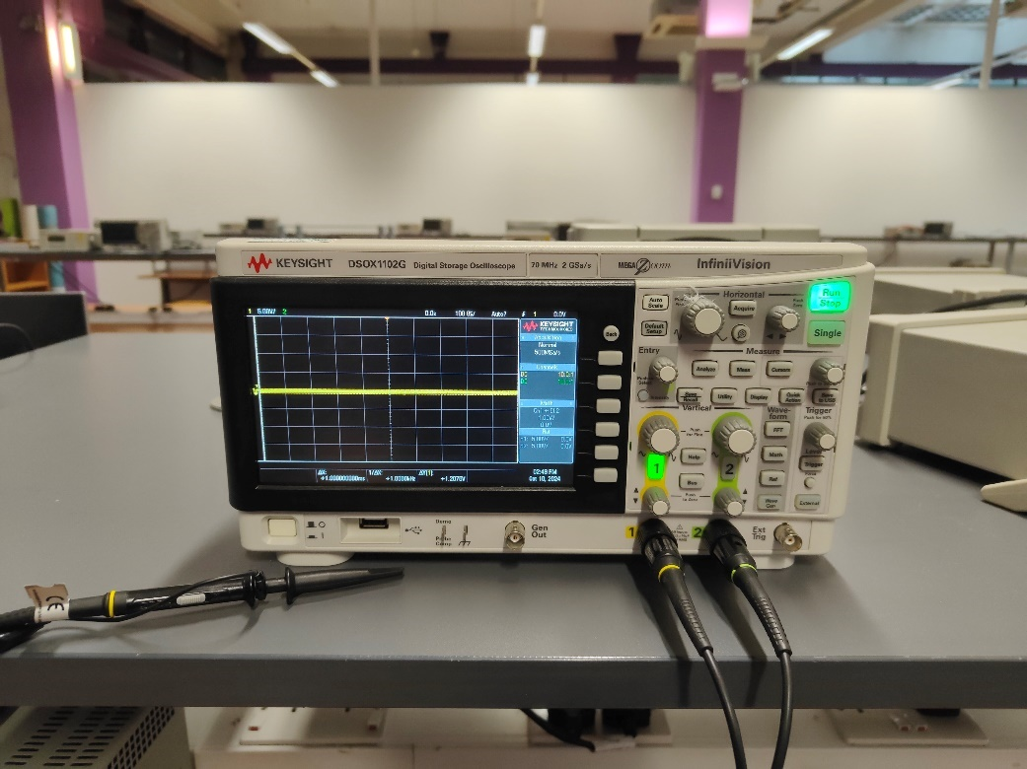

Figure : Oscilloscope starting up

# procedure

[](https://www.youtube.com/embed/0W-hay3QR1k?feature=oembed)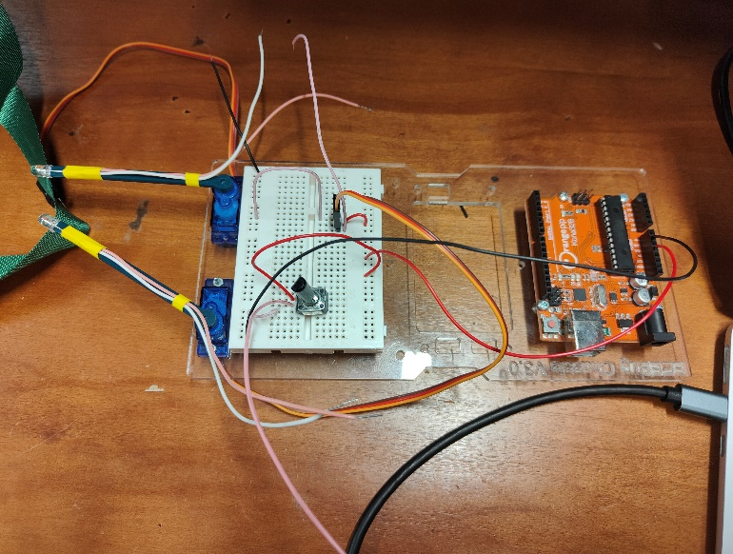The circuit on the chassis is assembled according to the diagram in Fritzing. Afterwards, Arduino is used to program the circuit on the chassis to rotate the servo.

After testing that the motor works, the input and output of the circuit is replaced with wires to observe the signal with an oscilloscope. The potentiometer on the circuit can be turned to change the pulse width.

# Potentiometer

The potentiometer is a voltage divider. It divides the voltage by changing the resistance between 2 nodes, while maintaining the same resistance across the whole potentiometer. When the knob on the potentiometer is turned, the resistance between 2 pins on the potentiometer changes.

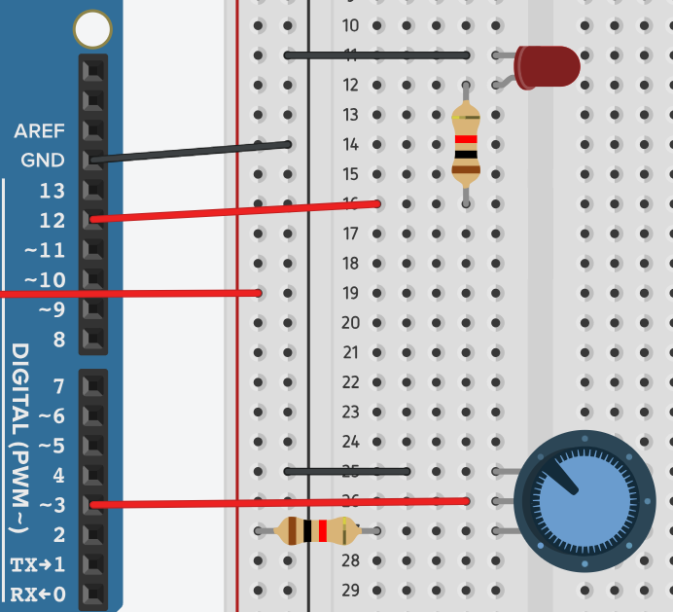In the circuit, the potentiometer is connected from the 5V to ground, then the middle pin is connected to Pin 3. Using the same code from before when using a button, Pin 3 becomes the input pin.

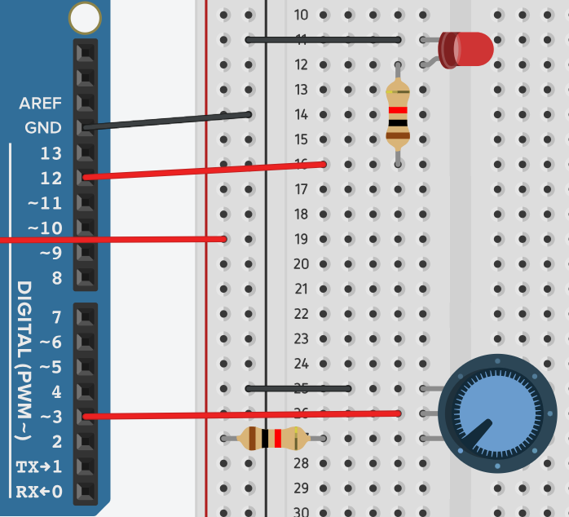When the potentiometer knob is turned clockwise, the resistance between upper and middle pins increases, which increases the voltage of the middle pin. This makes the LED light up, as Pin 3 is detecting a high voltage as an input.

The picture below is the actual connection of the potentiometer in the experiment, which is used to control a servo motor. In the circuit, A0 becomes the digital input pin connected with orange wire. Pin 9 becomes the digital output pin connected to the servo motor. When the potentiometer is turned, the servo motor turns as well.

The code is designed for 2 servo motors (only one will be used in the experiment). In the setup function, pins 9 and 11 are attached to the servo object. In the loop function, analogRead(CH1in) reads the voltage from the input pin A0. The pos1 variable is calculated with the value of analogRead, then pos1 is used in the servo write function to rotate the servo motor.

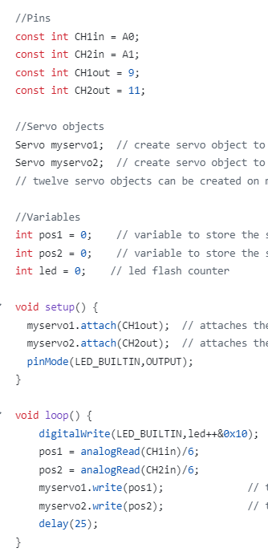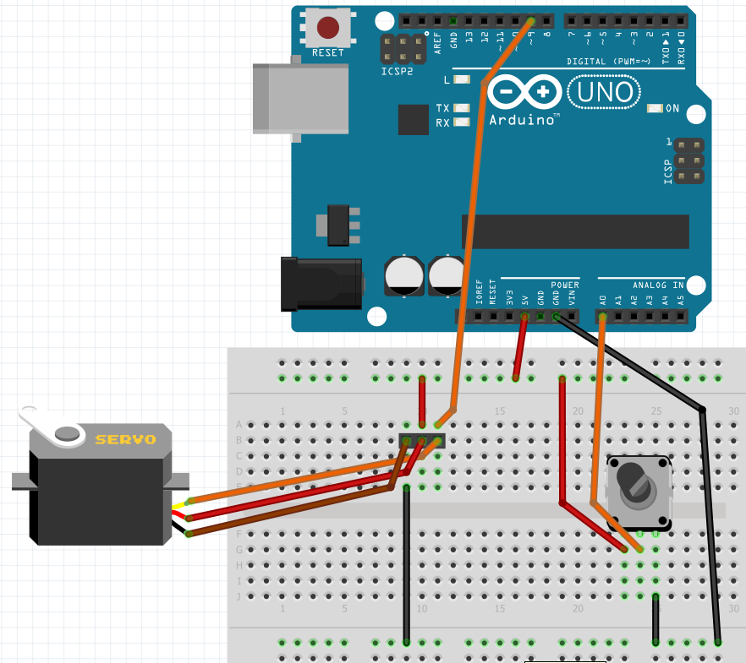

# oscilloscope

The oscilloscope is a device used to measure components of an electrical signal. In this experiment, the oscilloscope measures a pulse.

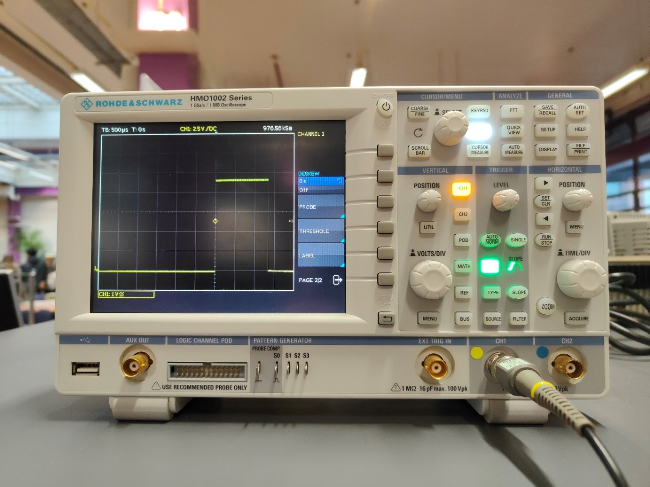

The oscilloscope has a few key parameters used to control the display of the electrical signal. They are:

1. Vertical sensitivity: adjusts the voltage per division.
2. Time base: adjusts the time per division.
3. Vertical/horizontal position: adjusts the level of the equilibrium position of the signal.

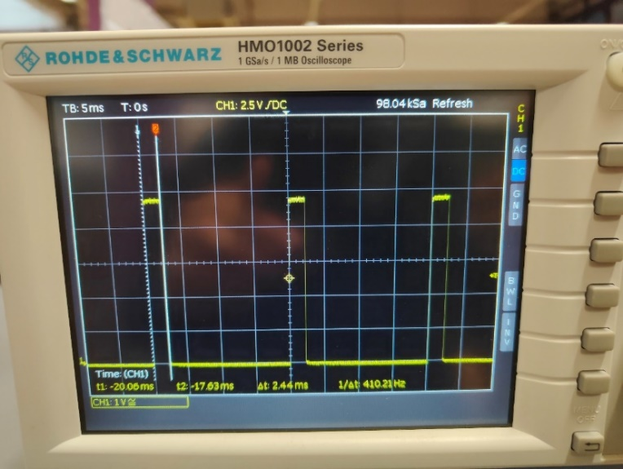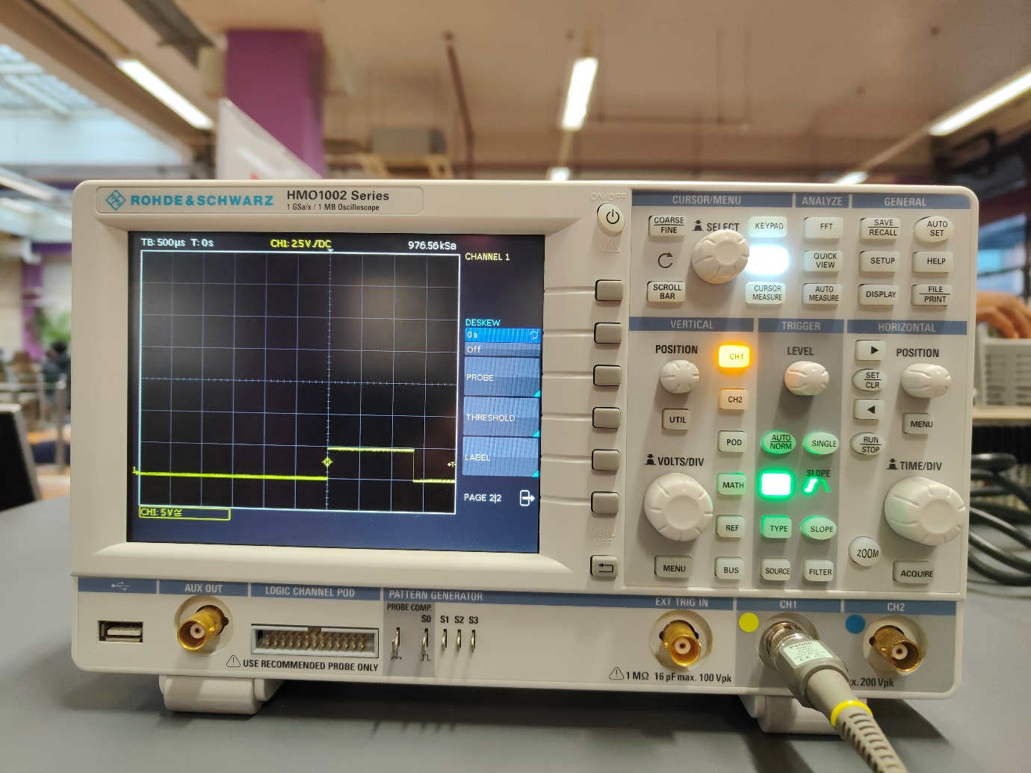

Furthermore, the period and pulse width can be calculated. As shown in pictures above, the markers allow the section of high voltage to be selected, and the pulse width is read as delta-t at the bottom of the oscilloscope screen. To measure the period, the markers must be moved to select the width of the whole pulse.

Turning the potentiometer changes the pulse width, as shown in the video.

[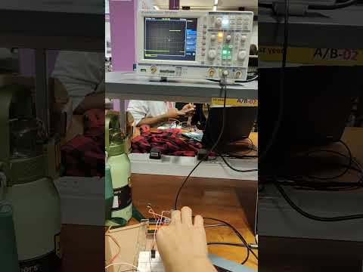](https://www.youtube.com/embed/JuEWZuR8fvE?feature=oembed)

# results

The voltage across the potentiometer can be measured with a multimeter. Due to the limited space in the Arduino, the voltage can be measured by connecting a wire in series with the middle pin of the potentiometer to the red probe of the ammeter, and a wire in series with the ground pin/ground bus to the black end. The variation of the voltage and the pulse width is shown in the table below.

|  |  |
| --- | --- |
| Voltage/V | Pulse width/ms |
| 4.84 | 2.30 |
| 3.27 | 1.73 |
| 2.77 | 1.55 |
| 1.75 | 1.18 |
| 0.73 | 0.81 |

If the oscilloscope is disconnected and the servo motor is reconnected, the relationship between potentiometer voltage, pulse width and rotated angle of the servo motor can be observed. However, no protractor was available during the experiment.

Lab Skills 3: Sinusoids

This experiment is about sinusoidal wave signals.

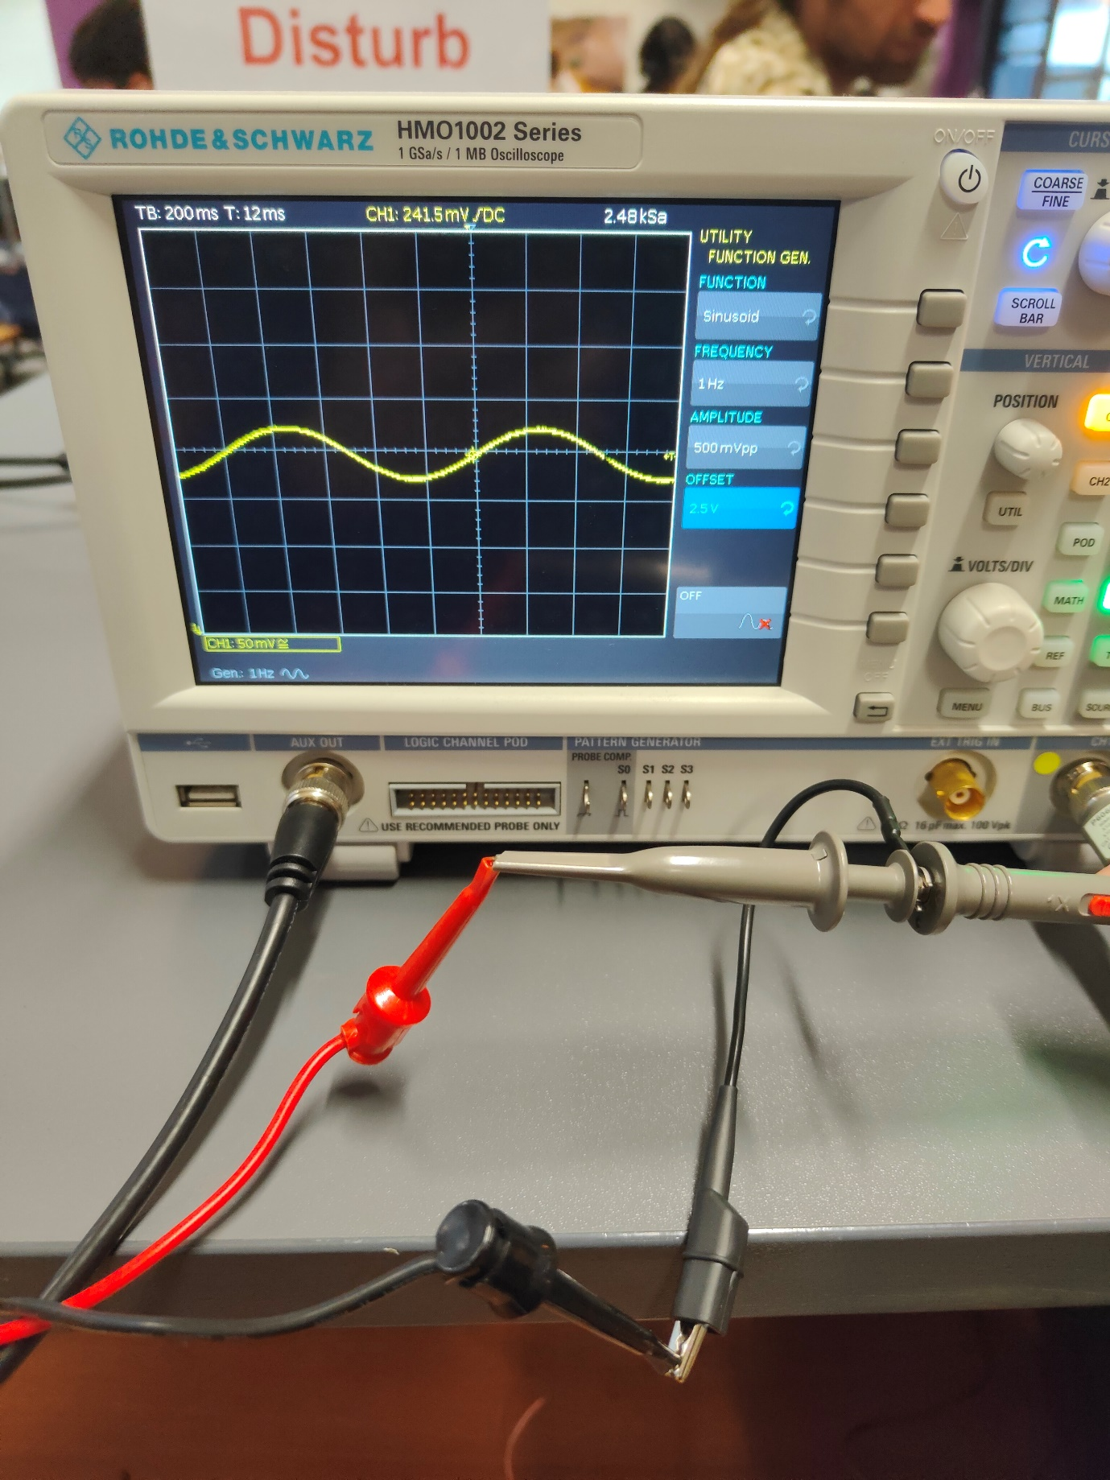

# Procedure

[](https://www.youtube.com/embed/soQANLQerGM?feature=oembed)[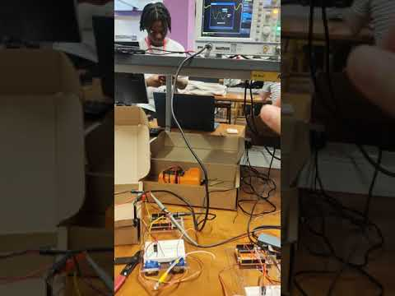](https://www.youtube.com/embed/jZyOkRsZeuE?feature=oembed)A sine wave signal is generated on the oscilloscope with the function generator. The signal is then passed into the circuit to rotate the servo motor periodically.

After that, a second sine wave signal is generated on the oscilloscope, and both sine waves can be used to control 2 motors at once. A phase shifter circuit can be built to change the phase of the second sine wave to make the servo motors rotate out of phase.

# Function generator

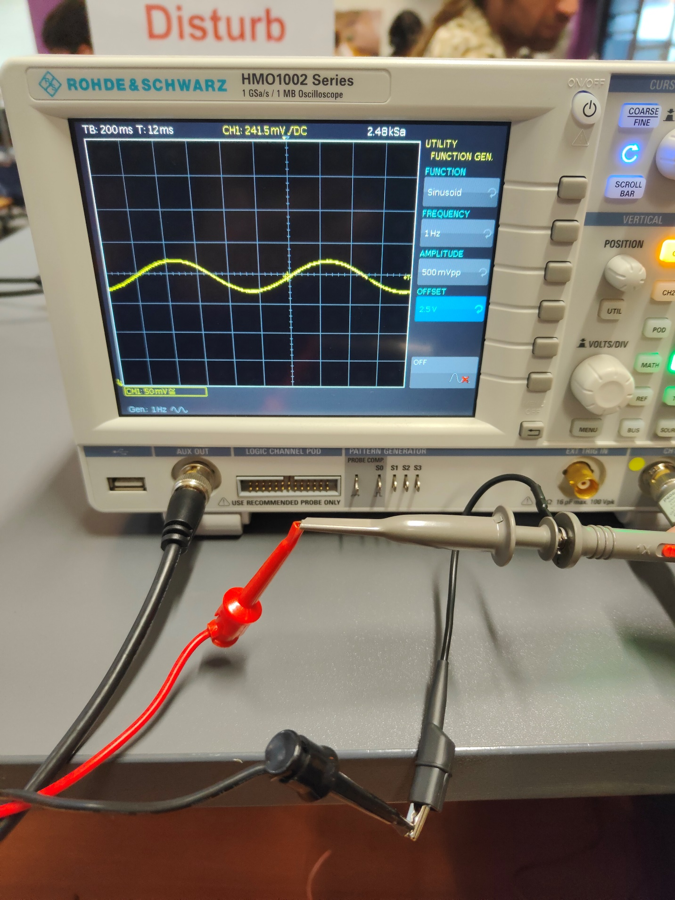The function generator on the oscilloscope is a feature that allows a signal of a specific function of voltage against time to be generated, like sinusoids, sawtooth and rectangle signals. In the experiment, a sinusoidal signal will be used. The signal is in the form Asin(wt)+c, where:

1. A represents the amplitude
2. W represents the angular frequency
3. c represents the offset

These parameters can be adjusted on the oscilloscope to generate the appropriate voltage signal. However, generating the function does not allow the function to be displayed clearly on the screen. In order to see the waveform clearly, the oscilloscope must measure its own voltage output.

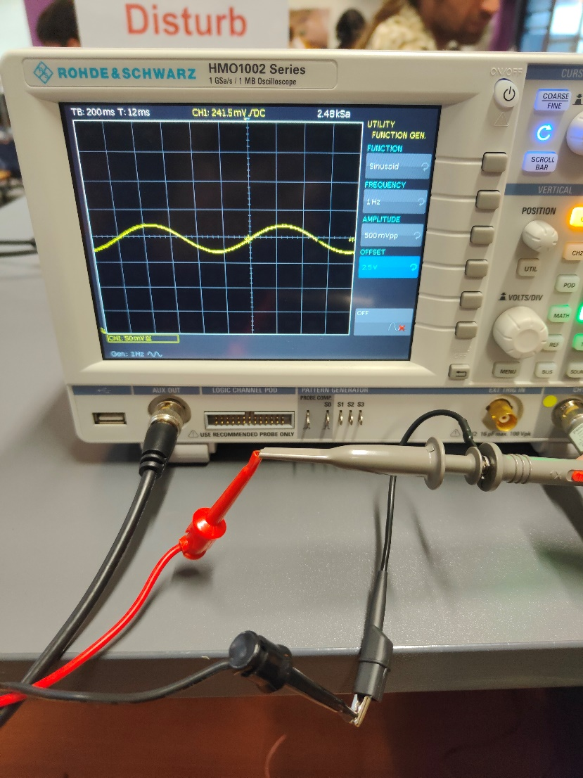In the picture, the black wire on the left is connected to AUX OUT on the oscilloscope, which means this cable is carrying the output voltage of the oscilloscope. The probe on the right connected to CH1 will then be connected to the red part of the output cable to measure the voltage. Lastly, the ground wires are connected and a clear waveform can be seen on the oscilloscope screen.

The circuit from the previous experiment is used. For the oscilloscope to power the motor, the potentiometer and its connecting wires are removed. A free wire is inserted into input pin A0 and the potentiometer output cable is connected to that wire. This will allow a continuous voltage signal to be generated in the input pin, which is read by the code and generates a continuous output voltage through Pin 9 and powering the motor.

If the signal is to be measured while powering the motor, the oscilloscope probe is directly connected to the input pin A0.

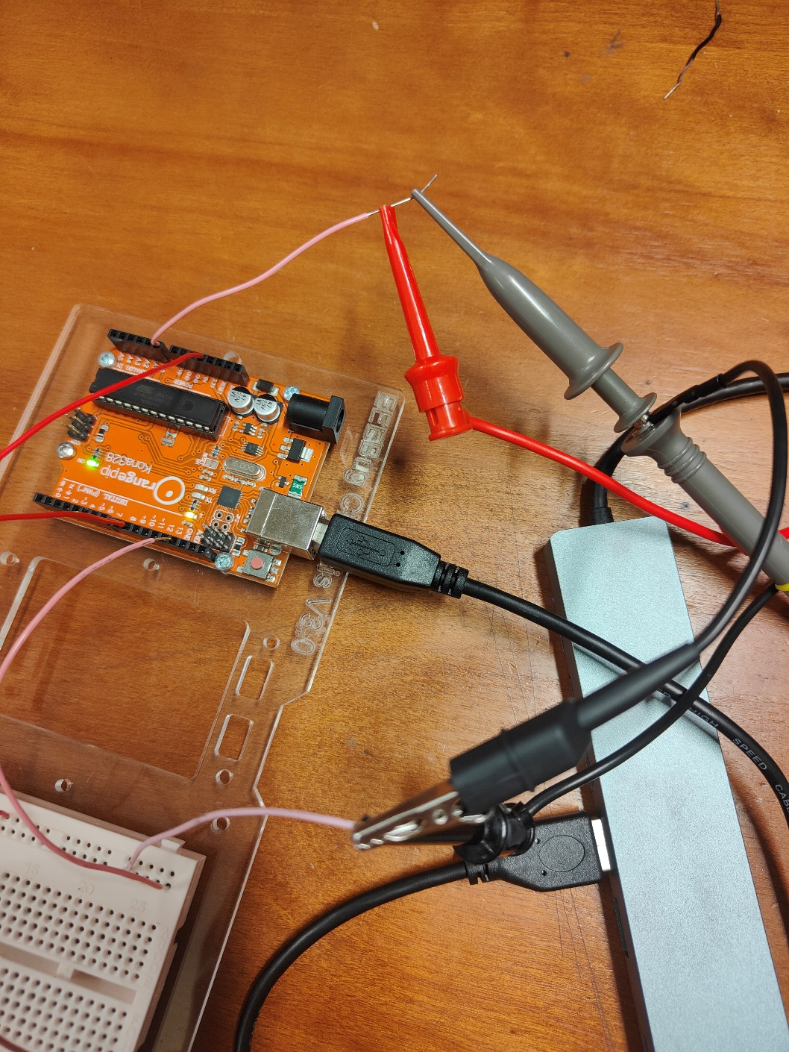

If two functions are to be generated, switch the mode of the oscilloscope to CH2. Then follow the same procedure to generate the first sinusoid in CH1.

# Phase shifter

A phase shifter circuit can be built with a resistor and a capacitor. This makes one of the signals lag the other by a certain angle. To observe the lagged waveform, AUX OUT and CH1 of the oscilloscope is connected to the input of the phase shifter to generate and measure the signal, then CH2 is connected to the output of the phase shifter to observe the shifted waveform.

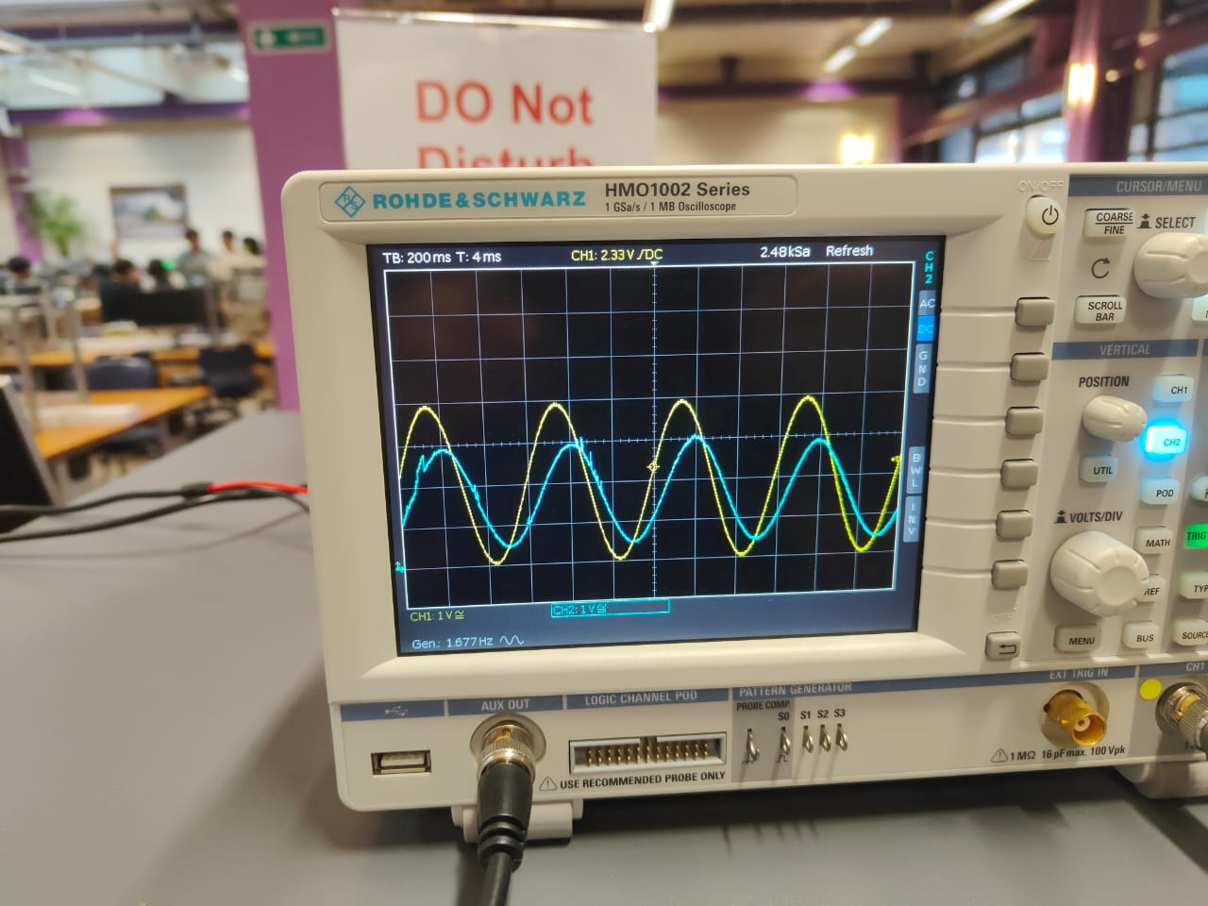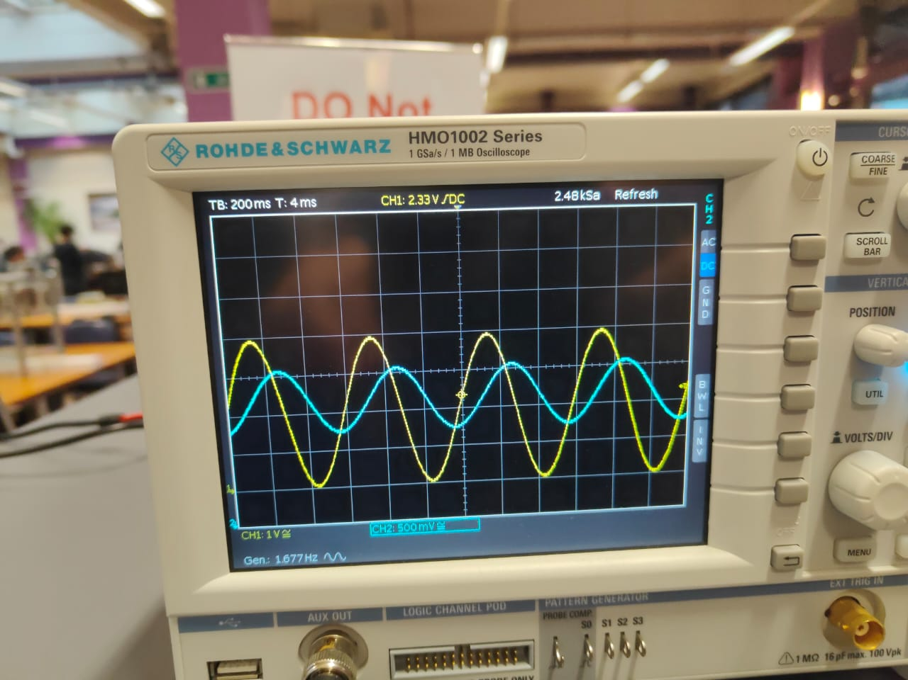

Depending on the resistance, the amount of angle shift changes. In the left picture, the yellow signal is leading the blue signal less than the right picture when the resistor was swapped.

DECA 1: Design with ISSIE

In DECA, most of the circuits will not be made in real life and instead designed on software. The software used will be ISSIE, and it allows us to place logic gates and use things that were learned in DECA.

# Logic gates

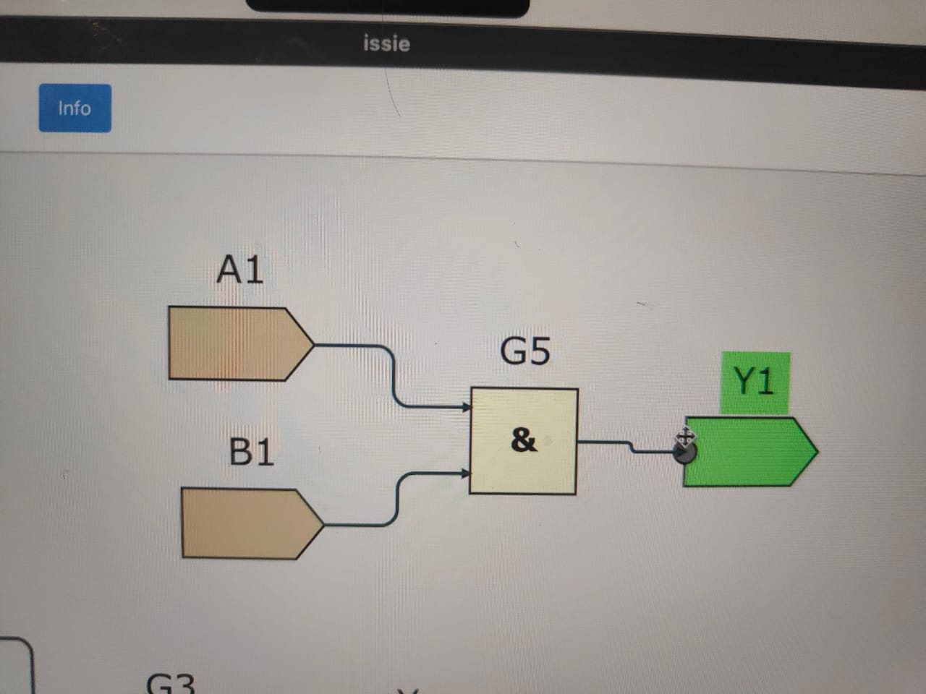Once ISSIE is installed, it can be used to create Boolean circuits. An AND gate can be placed under the gates category in Catalogue. 2 inputs and 1 output can be placed, and the number of bits in the input or output can be adjusted.

Other than the AND gate, ISSIE offers many other gates like NOT, OR, XOR and more.

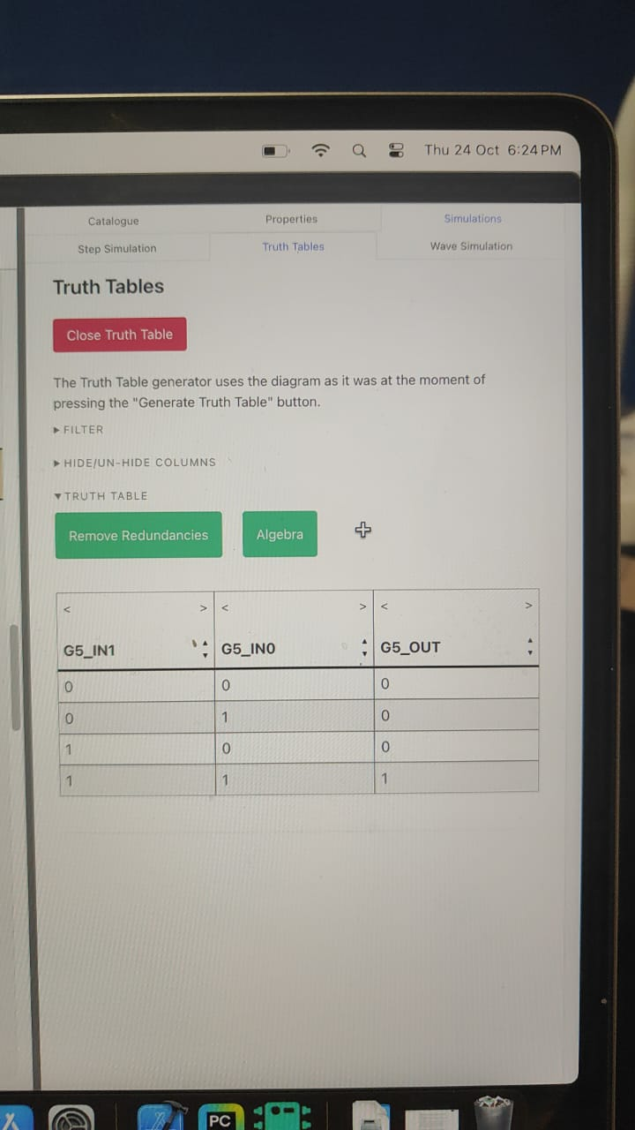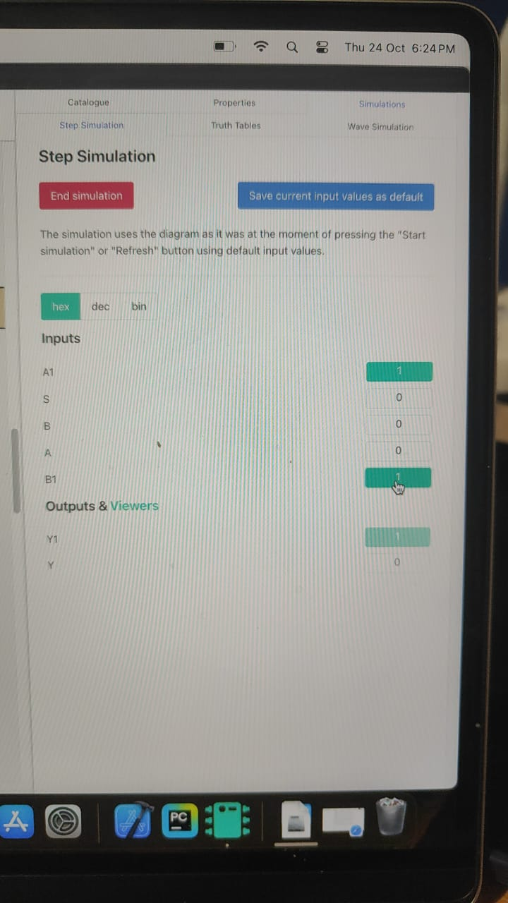To test how the logic gate works, under Simulation, we can press start simulation and manually input the values for A and B, and the output of Y will be displayed. Other than that, the truth table for this circuit can also be generated. Under Truth Tables, pressing generate truth table will generate the truth table for the circuit.

These pictures illustrate different ways of displaying results of the simulation.

# multiplexers

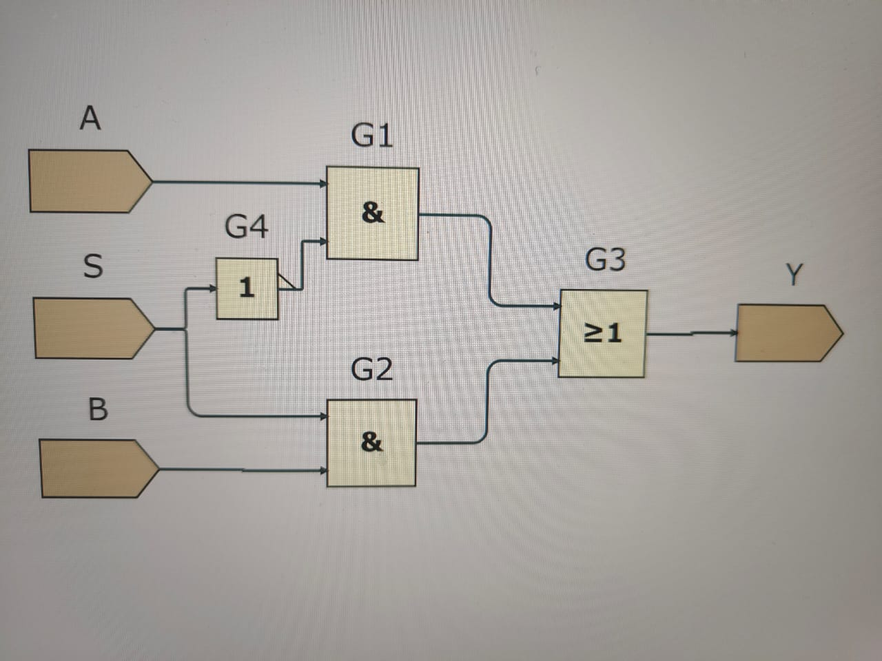A 2 input multiplexer is a Boolean function in the form Y = !SA + SB (!S=NOT S) and it works like an if else statement in programming. If S is false, Y=A. Else, Y=B. To implement the circuit in ISSIE, we can build it with NOT, AND and OR gates.

A 4 input multiplexer is a Boolean function in the form Y=A(!S0)(!S1)+B(S0)(!S1)+C(!S0)(S1)+D(S0)(S1). S0 and S1 becomes the input to decide which of A,B,C,D becomes the output (example: S0=1 S1=0 means B is the output). To build this circuit, instead of placing the gates individually, the 2 input multiplexer(mux2) can be used.

Y=!S1(A(!S0)+B(S0))+S1(C(!S0)+D(S0)), so A and B are put through a mux2, C and D are put through a mux2 and their output is put through a mux2. Under This Project, the circuit from the sheet mux2 can be added.

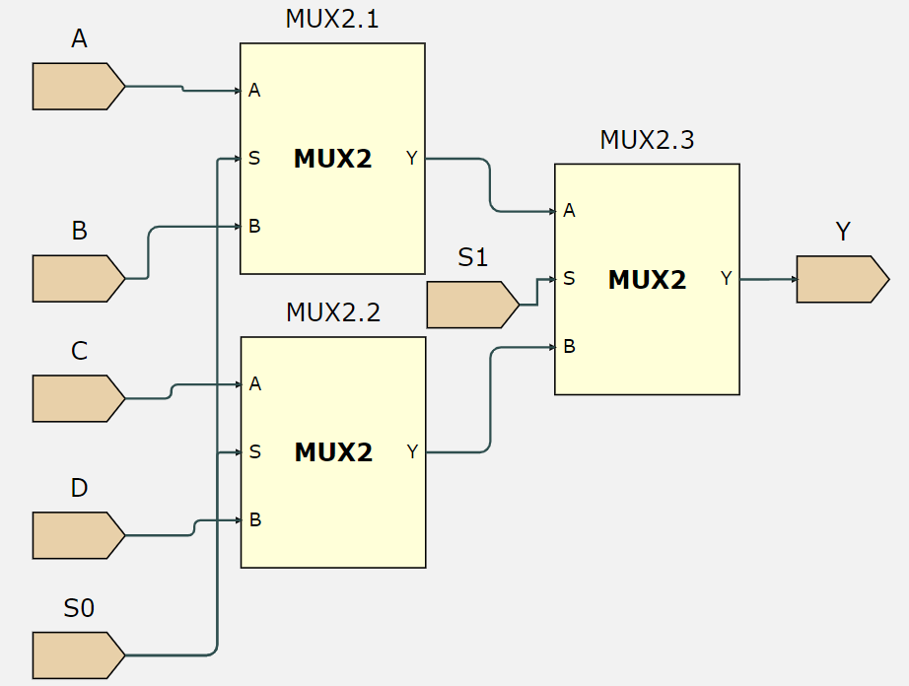

# multiple bits

When multiple bits are used as an input/output, the 1s or 0s are stored in a binary number. Each bit in n bits is given a position from 0 to n-1, like element positions in arrays in programming. A 4 bit input/output will be written as 0:3, meaning bits from position 0 to 3. When an input with multiple bits is passed into a gate, only one of its bits may pass through. ISSIE allows us to allocate the bit passing through the desired gate with buses.

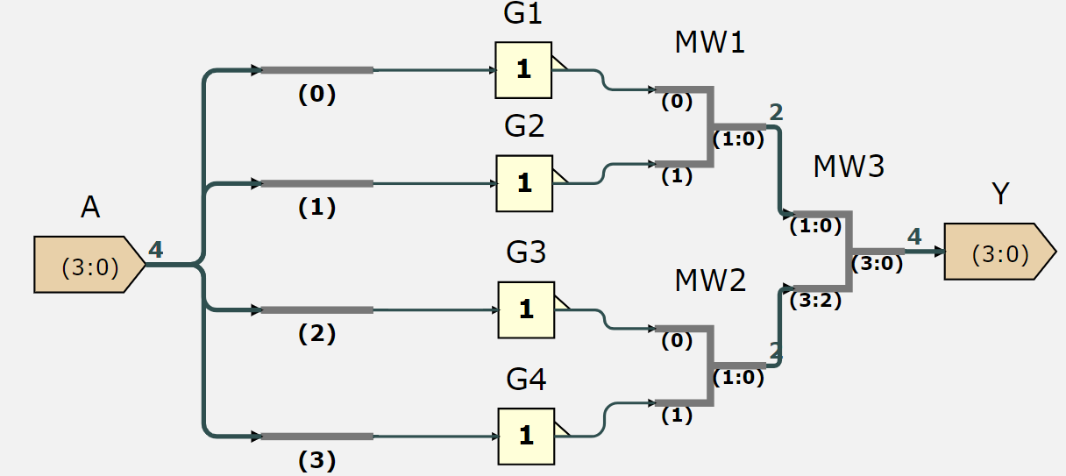

Under buses and pressing bus select, we can add a bus and adjust the least significant bit, that is the bit passing through the gate, labelled by the number below. The buses can then be connected to a wire then the logic gate.

To obtain the output of the buses, we cannot direct 4 outputs into Y, so wire mergers are used. Under Buses, WireMerge allows 2 wires to be connected and come out as 1 output. In the picture above, the circuit is used as a 4 bit NOT gate, which inverts each of the bits in the input.

# DECA 1: CHallenge

The challenge in this experiment is to create a 4 bit NOT, AND, OR and XOR gate, then use a 4-input multiplexer to decide which operations to be used.

The solution to the challenge is in this ISSIE project: [DECA1](https://imperiallondon-my.sharepoint.com/:f:/g/personal/yzt24_ic_ac_uk/EtRpTNXcOP5GnP2K9rNi8OwBKel0ChDWQTg1usTkRqxpAQ?e=JKopEl)

DECA 2: Digital Arithmetic

This experiment is about creating adders and subtracters for binary numbers in ISSIE.

# Half Adders

The half adder is used to add a maximum of 2 bits together, where it uses 2 inputs, A and B, and adds them together to create a sum digit (S) and a carry digit (C). This is implemented using a XOR gate and AND gate, where S=A⊕B and C=AB.

How this works is that S will only return 1 when there is an odd number of 1s and C will return 0, so either A or B is only 1. This represents the situation 0+1 or 1+0 = 01. When there is an even number of 1s(0+0 or 1+1), S will be 0 and C will be either 0 or 1, which represents 0+0=00 and 1+1=10.

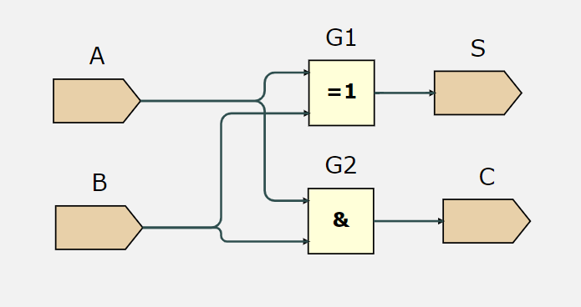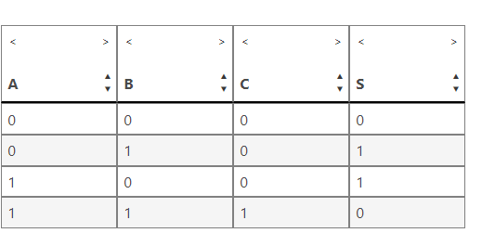This is how to design the half adder circuit in ISSIE. The truth table illustrates how the addition process works visually.

# Full Adders and Ripple Carry Adders

A full adder allows maximum of 3 bits to be added together by using 2 half adders. How it works is that it will add 2 bits first with a half adder and return the first sum and carry value. It will then take the first sum value and add it with the 3rd bit to get the second sum and carry value. Since the maximum result of a 3 bit addition is 11, there can only be one carry value that has a 1 and the other must be a 0. Therefore, both the carry values are put through an OR gate to get the final sum and carry value, which represents the last and first digit.

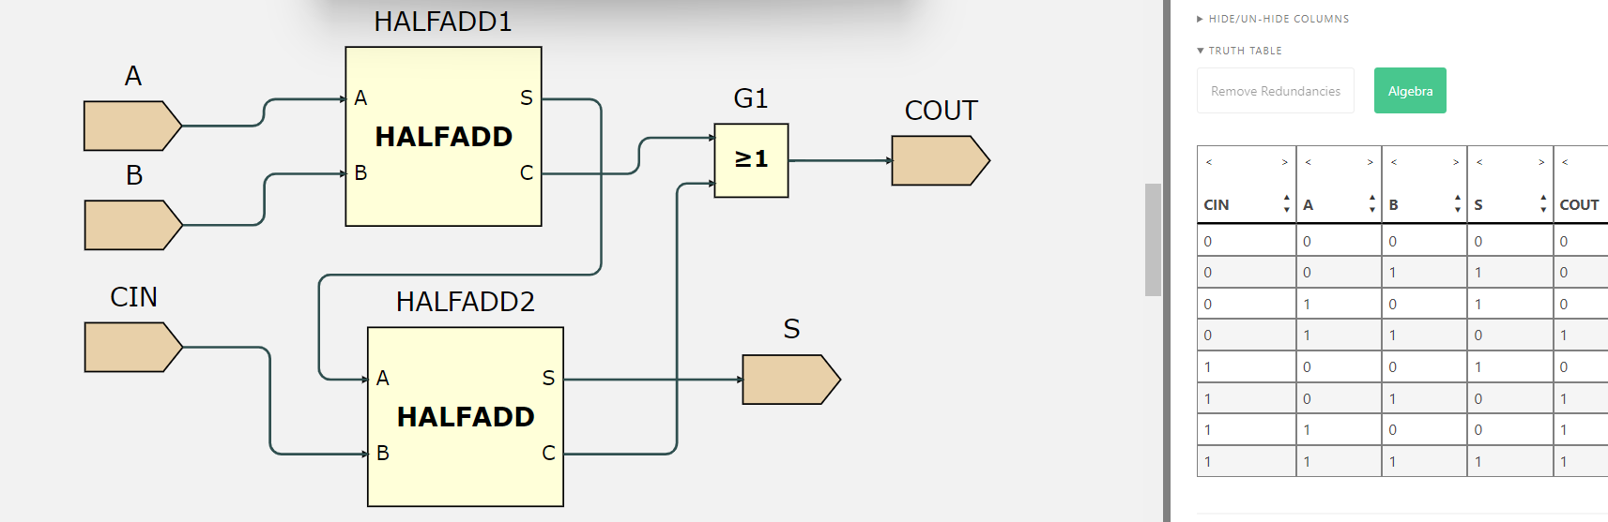

The CIN stands for Carry IN, and COUT stands for Carry OUT. These are useful in chaining multiple full adders together to create an addition just like adding 2 binary numbers together on paper.

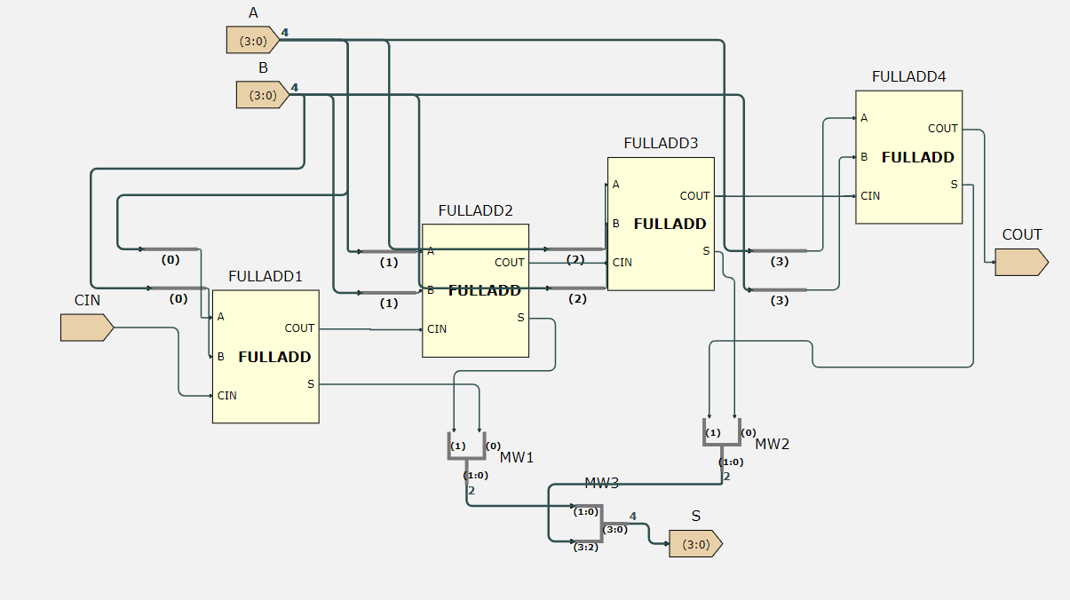When performing the addition of the last digits, no digit will be carried in so CIN will be 0, and the addition will just be A+B only. The addition of the second last digits will involve the digits(A and B) and the carry out digit from the first addition. This is where the CIN input is used to add the COUT output from the first addition. The process is repeated until the whole number is added.

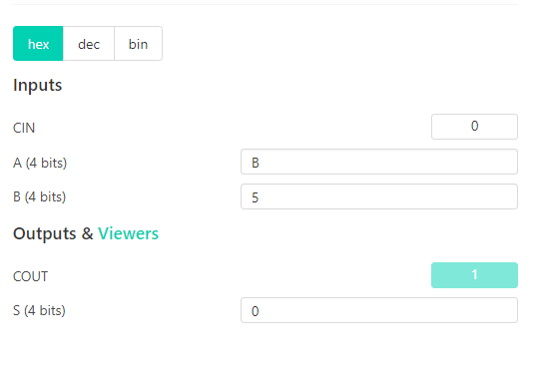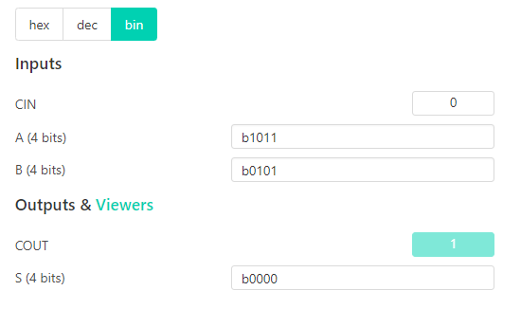

This is an example of the ripple carry adder working for 4 bit addition. The test case can be confirmed that it works in binary and hexadecimal by looking at it. An important note when constructing the ISSIE circuit is to observe the number assigned by the wire merge object at each wire to ensure that the bit position of the output is the same as the input so that the sum is generated correctly.

# Subtractors

Subtractors are implemented using the two’s complement method to subtract binary numbers. To convert a binary number into two’s complement form, the bits of the number must be inverted, then add one to the number. Then, to subtract the number, add the two’s complement form to the number you want to subtract form, and discard the overflowing digit from the subtraction.

We need to build a few circuits to achieve this:

1. Bit inverter

The most obvious way to invert all the bits of the number is to put NOT gates on each bit; however, this does not allow us to select whether we want addition or subtraction. Instead, using the fact that A⊕0=A and A⊕1=!A, we can use XOR gates instead to implement inverting while using another input to choose addition or subtraction. We make a new circuit called Cinv:

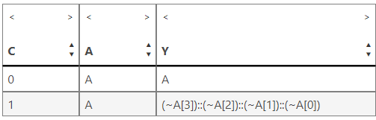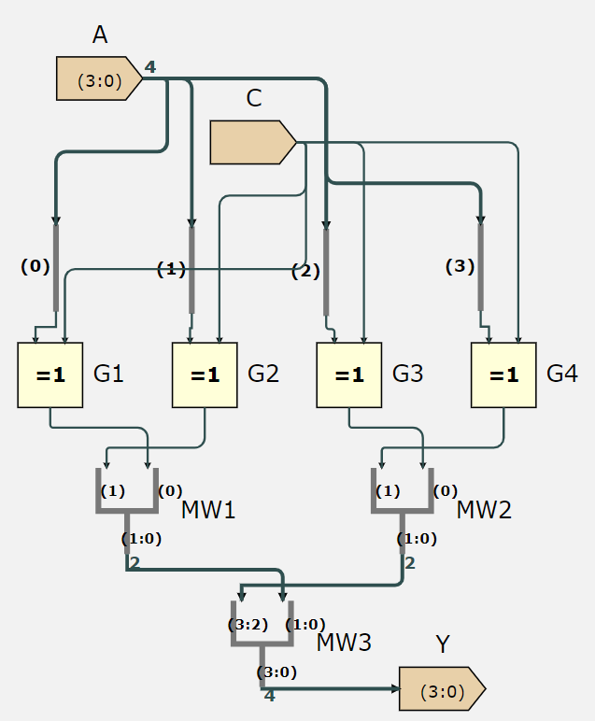As seen above, the output is A if C is 0, and !A if C is 1.

1. Adding one

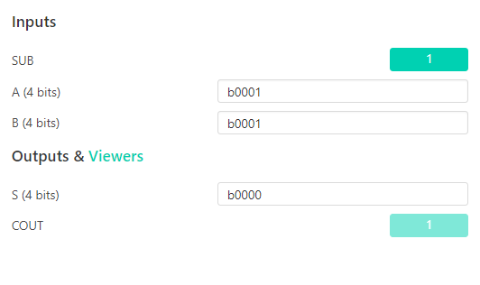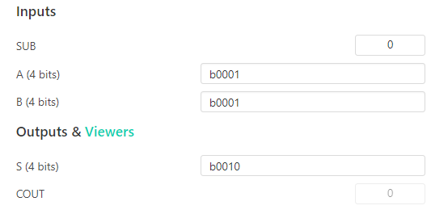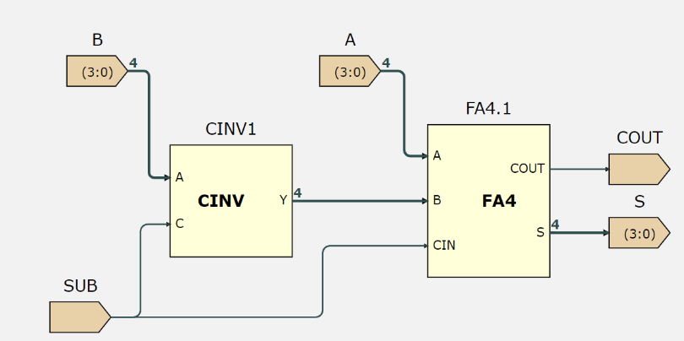When C is 1, the Cinv inverts the bits. The input C can also serve as the Cin input in the full adder, while B is passed through the bit inverter. This effectively creates the subtraction where the output Y=A+B+Cin=A+(Binverted)+1=A-B. When C is 0, the Cinv will buffer the inputs and the output Y=A+B+0=A+B(normal addition)

# DECA 2: Challenge

The challenge of this experiment is to expand the ALU of the previous experiment to include functions such as adding bits, subtracting bits, adding ones and more.

The solution for the challenge is here: [arithmetic](https://imperiallondon-my.sharepoint.com/:f:/r/personal/yzt24_ic_ac_uk/Documents/Documents/arithmetic?csf=1&web=1&e=1S7xFu)

DECA 3: Sequential Circuits

This experiment investigates circuits that store information which can be used as timing circuits or counters.

# D-type Flip Flop

The D-type flip flop stores the value of the input depending on time. The DFF takes 2 inputs, the data and clock. When the clock input rises, the input is stored into the DFF as its output. We can chain 4 DFF together to store the value of a 4 bit number.

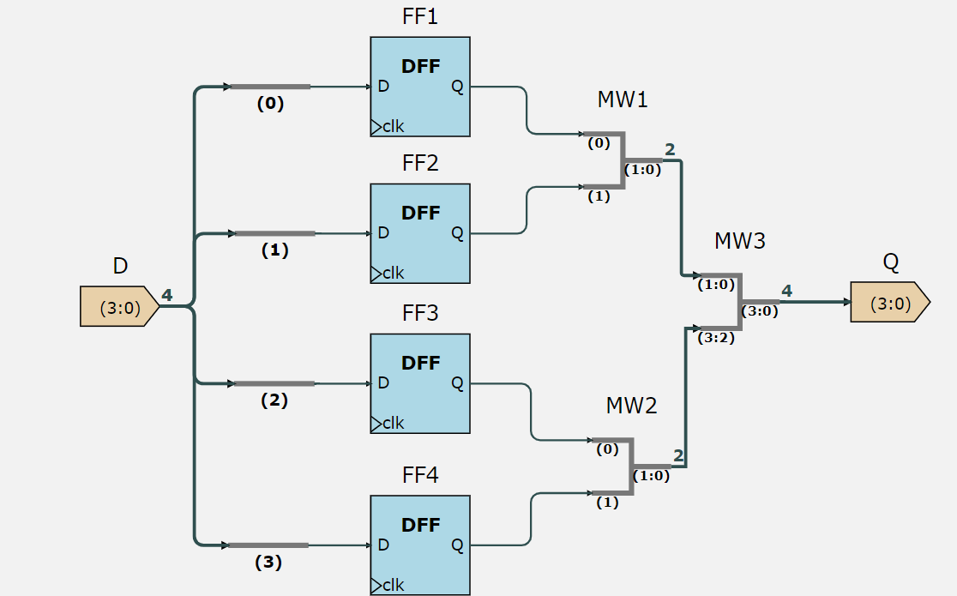The clock input does not have to be wired as ISSIE automatically wires all clocks to the same timing.

To simulate the DFF, we can use step simulation. Entering any input in D, and forwarding the clock by 1 tick will change the output Q into the value entered in D. When the input in D is changed, the clock must be forwarded another tick to update the value of Q.

|  |  |  |
| --- | --- | --- |
| TICK | D | Q |
| 0 | 0011 | 0000 |
| 1 | 0011->0101 | 0011 |
| 2 | 0101 | 0101 |

# Counter

Sequential components like the DFF allow feedback loops to be created in digital electronics. A counter that adds 1 to each number can be made with a DFF by using a full adder and continuously running the previous value into one of its input with 1 as the other output.

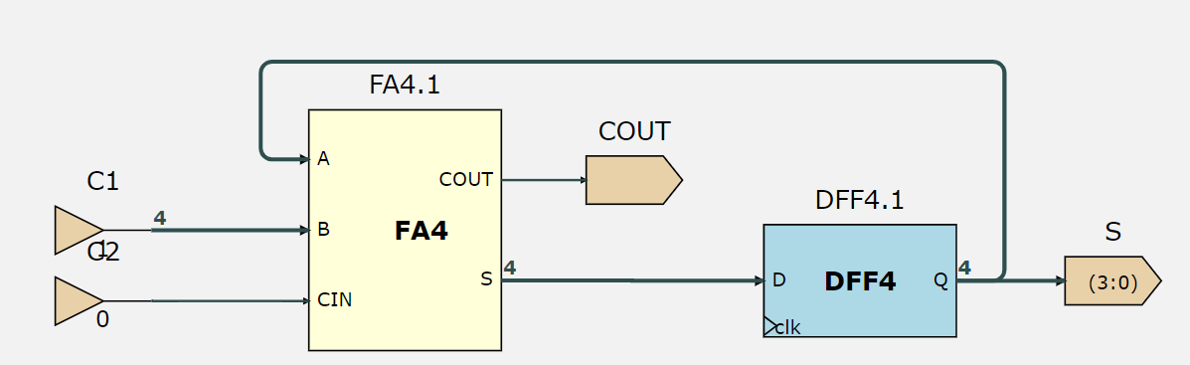

Initially the input into A is 0, then adding will cause S to be 0001. After forwarding 1 clock tick, the value 0001 is stored in Q then passed on to the output S and back to the input A to repeatedly perform the addition of 1.

|  |  |  |
| --- | --- | --- |
| Tick | S | COUT |
| 0 | 0000 | 0 |
| 1 | 0001 | 0 |
| 2 | 0002 | 0 |
| 3 | 0003 | 0 |
| … | | |
| 15 | **1111** | **1** |
| 16 | **0000** | **0** |

When we forward the clock ticks, the pattern is that S increases by 1 every tick except until 15, where COUT increases to 1; at tick 16, S becomes 0000 and COUT becomes 0 again.

This happens because after a tick, S represents the stored value of the previous tick. In tick 1, when Q stores 0001 and is passed to S, Q will also be passed to A and 0001 will +1 to become 0010 so S(from the FA4) will be 0010, and will be waiting for the next tick to then be stored in S(from the DFF).

Similarly, at tick 14, 1111 is already waiting at D, and when the next tick happens, it is passed to S as the output. However, during the same tick, 1111 is added to 1 which is 10000 and this creates a carry out, making COUT 1. At tick 16, S(from FA4) is now 0000 and is passed to S as the output, as well as A to be added with 1 and the whole cycle repeats.

This relationship can be simulated more clearly with a wave simulation in ISSIE. Under wave simulation, when we start the simulation we can select the wave and enable S(from DFF) and S(from FA4) which will its value at each tick represented at the top.

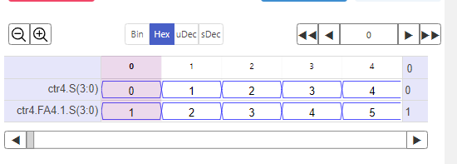

# Synchronous Load

A synchronous load allows the counter to start at a desired value. With a 2 input multiplexer, we can select between 2 options for the circuit: incrementing the output by 1, or freeze the output at the desired value.

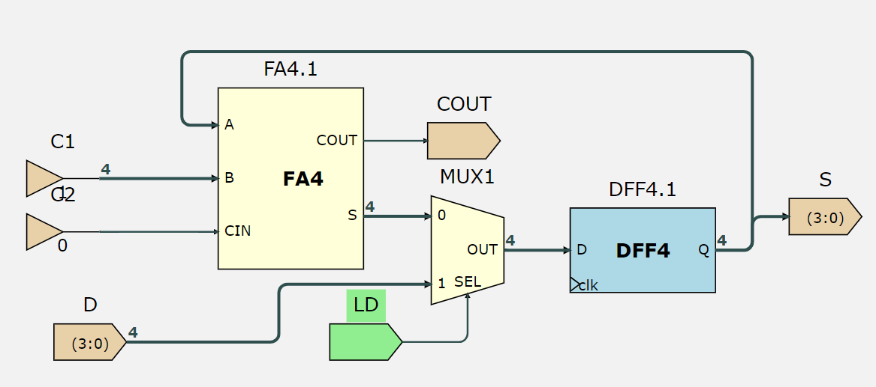

When LD is 0, S(from FA4) is passed to the DFF and S increments by 1 each tick. When LD is 1, input D is passed to the DFF and S will be the same as D no matter how many ticks have passed.

When we set LD to 1 such that the counter starts at the value of D, then go forward 1 tick and set LD back to 0, the circuit will continue counting from D as the ticks increase.

|  |  |  |  |
| --- | --- | --- | --- |
| Tick | LD | D | S |
| 0 | 0 | 1000 | 0000 |
| 1 | 0 | 1000 | 0001 |
| 2 | 0->1 | 1000 | 0002 |
| 3 | 1 | 1000 | 1000 |
| 4 | 1->0 | 1000 | 1000 |
| 5 | 0 | 1000 | 1001 |

# deca 3: cHALLENGE

The challenge for this experiment is to create a countdown timer that will reset after a certain number of clock ticks.

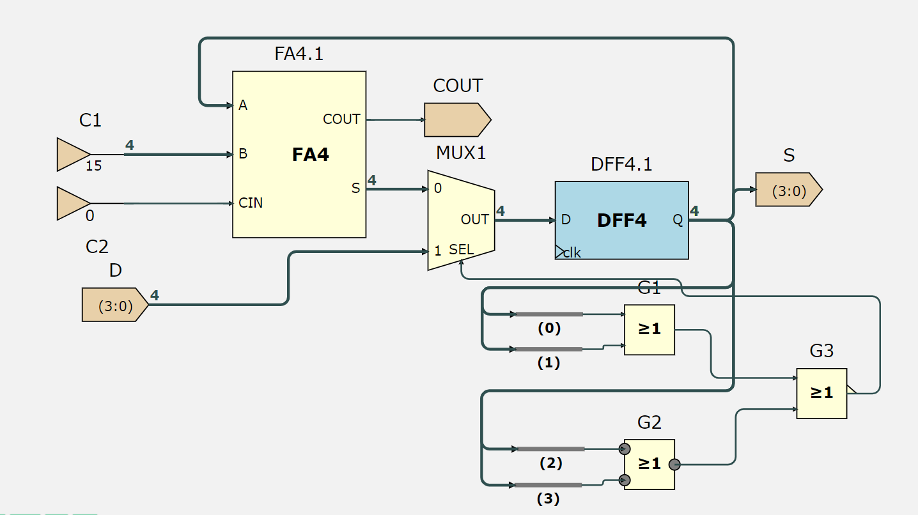

|  |  |  |
| --- | --- | --- |
| Tick | D | S |
| 0 | 0100 | 0000 |
| 1 | 0100 | 0100 |
| 2 | 0100 | 0011 |
| 3 | 0100 | 0010 |
| 4 | 0100 | 0001 |
| 5 | 0100 | 0000 |
| 6 | 0100 | 0100 |
| 7 | 0100 | 0011 |

Initially, Q is 0, so the reduction NOR gate returns 1 and is passed to the select input in the multiplexer so at tick 1, The output of the MUX2 becomes the value of D(0100). During tick 1, Q is passed into A and 1 is subtracted from 0100 which leaves 0011 waiting at the input of the multiplexer. Because Q = 0100, the reduction NOR gate returns 0 and 0011 is passed to the DFF.

The cycle repeats until Q becomes 0, which makes the reduction NOR gate return 0 and select the value of D again, which starts the countdown again.

DECA 4: Memory

This experiment is about using ROM and simulating it to access different data according to their addresses. Before building the logic circuit, we prepare a message encoded in Unicode, where each symbol is stored with a 8-bit binary code. (128 possible symbols)

A-0x41 P-0x50 P-0x50 L-0x4C E-0x45

# ROM

We will use a synchronous ROM to simulate the function. In memories, we can add a synchronous ROM unit and under properties tab, we can change the data set at each address.



We need to add a 4-bit input, and an 8-bit output. In step simulation, we can change the value of the input to correspond with the address and forward the clock tick to update the value of the output.

# DECA 4: Challenge

The challenge for this experiment is to use the counter from the previous experiment to cycle through the message in the ROM. However, the counter from the previous circuit decrements 1 from the given input until 0 then restarts; we want the output to be incrementing 1 from 0 until the given input, so the message can be displayed in ascending order.

To do this, we can add a subtractor from DECA 2 and subtract the output of the counter from the initial input to get the output of the subtractor in ascending order. (I=5; CTR=5,4,3,2,1,0; ADDSUB=(5-5),(5-4),(5-3),…=0,1,2,3,4,5)

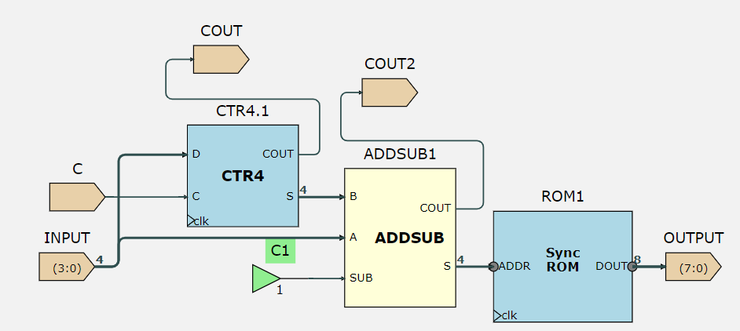

In the circuit above, the input is put into A and D(of the counter, to set the number to count), and the output of the counter is put into B, to make S=A-B, which allows the message to be displayed in ascending order.

|  |  |
| --- | --- |
| Input=4, Clock tick | Output |
| 0 | X00 |
| 1 | X41 |
| 2 | X50 |
| 3 | X50 |
| 4 | X4C |
| 5 | X45 |
| 6 | X41 |

Additionally, we can add a trigger input(C) to only read out the message when it is requested. When the counter reaches 0, the message will not be displayed if C is high, and the output freezes at its original value. When the C is set to high, the output will continue displaying the message. The table summarises the logic of C and the counter:

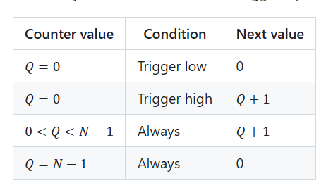

To do this, we need to change the circuit of CTR4 with a 4 input multiplexer. The select inputs are a function F of the output of the DFF and the input C.

|  |  |  |
| --- | --- | --- |
| F | C | Out |
| 0 | 0 | Out-1(S from FA4) |
| 0 | 1 | Out-1(S from FA4) |
| 1 | 0 | 0(constant) |
| 1 | 1 | D(input) |

In the truth table, F is 1 only when all the bits of the output from the DFF is 0, which means F=!(A+B+C+D). Because this is implemented on the counter which counts down, the next output is output-1.

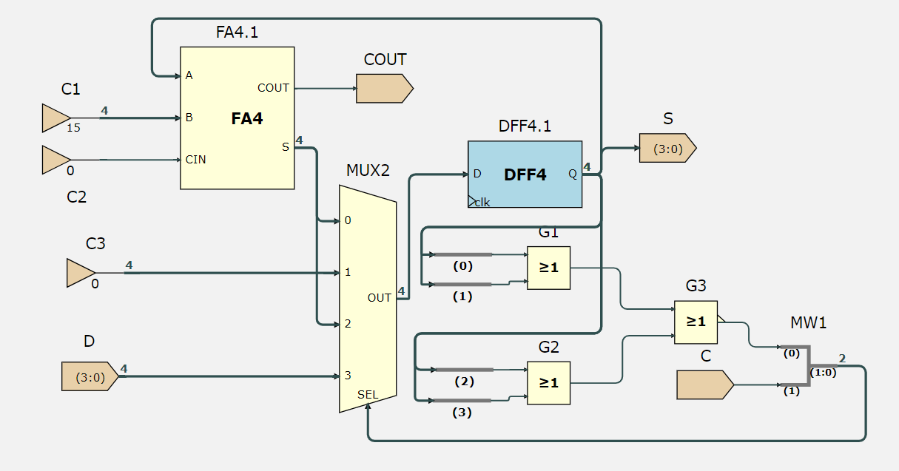

Using this new CTR4 in our ROM circuit, we can simulate the result depending on C:

|  |  |  |
| --- | --- | --- |
| Input=4, Clock tick | C | Output |
| 0 | 0 | x00 |
| 1 | 0 | x45 |
| 2 | 0->1 | x45 |
| 3 | 1 | X45 |
| 4 | 1 | X41 |
| 5 | 1 | X50 |
| 6 | 1->0 | X50 |
| 7 | 0 | X4C |
| 8 | 0 | X45 |
| 9 | 0 | X45 |
| 10 | 0 | X45 |

DECA 5: State Machines

This experiment is about designing a logic circuit to model a state machine for a vending machine.

# State machine setup

There are 4 states used to represent this vending machine:

START(00) - start of the vending program

W/COIN(01) – waiting for a coin

W/SEL(10) – waiting for a selection

VEND(11) – vending in progress

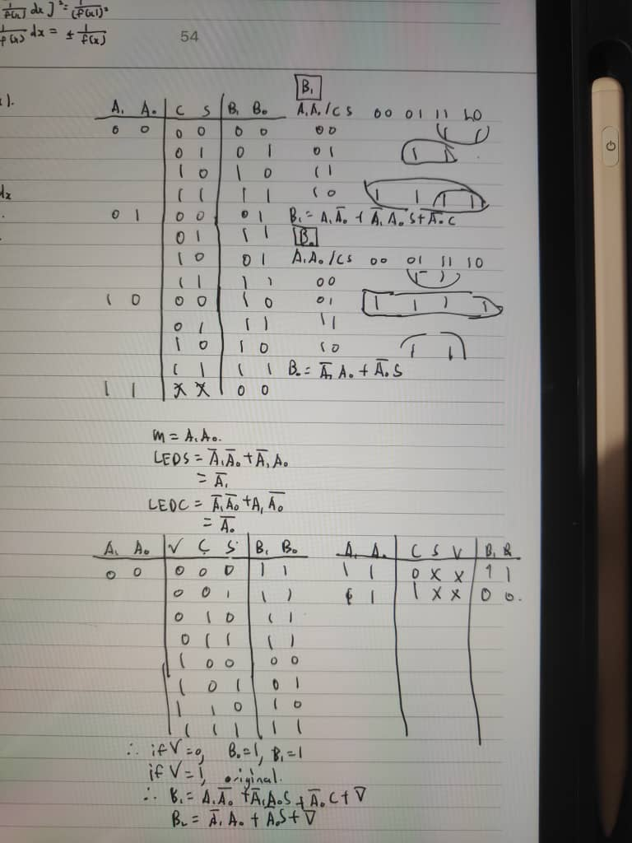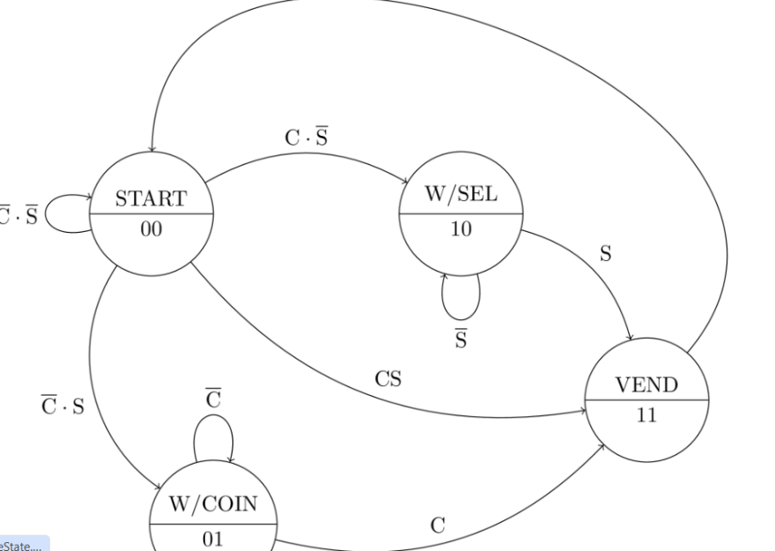The transitions of these states depend on both the inputs C and S, which stand for coin and select respectively. If a coin is inserted without a selection(C=1, S=0), the machine will transition from state START(00) to W/SEL(10).

The state diagram can be summarised with the truth table above, where A1 and A0 represent the previous state, and B1 and B0 represent the next state. To implement the state machine in a logic circuit in ISSIE, we need to convert the truth table for each next state variable(B1 and B0) into a boolean expression, where B1/B0=f(A1,A0,C,S).

By using Karnaugh maps, we can deduce the minimum SOP expression for B1 and B0.

# State machine implementation

Now that we have the Boolean expression for the next state variables, we can build the circuit in ISSIE. In the sheet DFFn, we make a D-flip-flop for 2 bits. Then in the sheet NXT, we create the logic for each next state variable.

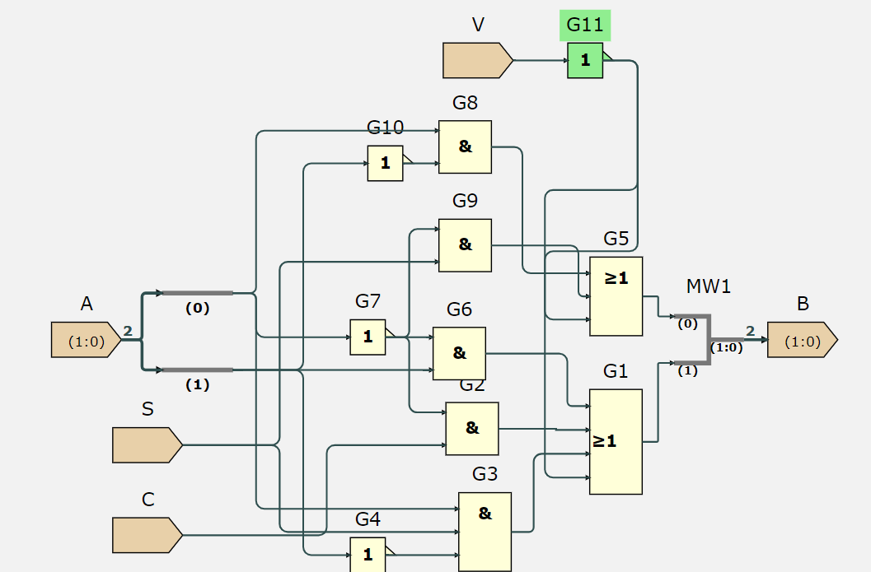This is the sheet NXT with the circuit for the logic of B1 and B0. With this circuit, we can feed the output of the DFF into the NXT block and depending on the inputs C and S, this changes the next state variable B.

|  |  |  |  |
| --- | --- | --- | --- |
| A | C | S | B |
| 00 | 0 | 1 | 01 |
| 01 | 1 | 0 | 11 |
| 11 | 1 | 0 | 00 |
| 10 | 0 | 0 | 10 |

For the state machine to be useful, it must use the next state variables to control the output of the vending machine.

When the machine is vending: in state VEND(11), the machine will turn on the motor described with output M. When the machine is waiting for a coin: in state W/COIN(01), the machine will turn on the LED for “insert coin” described with output LEDC. When the machine is waiting for a selection: in state W/SEL(10), the machine will turn on the LED for “selection needed” described with output LEDS. These results can be summarised with a truth table:

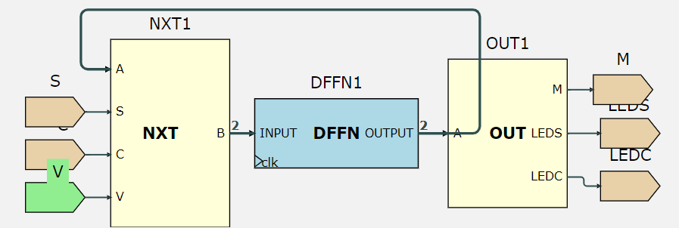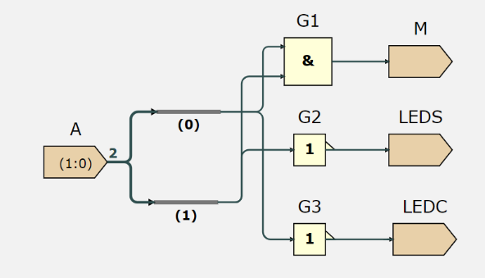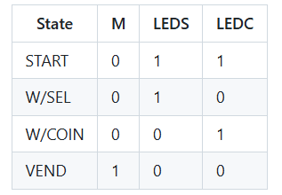To implement this output, we need to write the outputs M, LEDS, LEDC as a Boolean expression of the next state variable. By looking at the table, we can deduce that M=B1B0, LEDS=!B1!B0+B1!B0=!B0, LEDC=!B1!B0+!B1B0=!B1. We can then use another sheet OUT to implement the logic circuit for these outputs.

We can now implement the full state machine in a sheet VEND, where the output of the DFFn is connected to the NXT block to update the next state variable, and connected to the output block to determine the output of the vending machine.

|  |  |  |  |  |  |
| --- | --- | --- | --- | --- | --- |
| Clock tick | C | S | M | LEDS | LEDC |
| 0 | 0 | 0->1 | 0 | 1 | 1 |
| 1 | 0->1 | 1 | 0 | 0 | 1 |
| 2 | 1 | 1 | 1 | 0 | 0 |
| 3 | 1 | 1 | 0 | 1 | 1 |

# DECA 5: Challenge

The challenge for this experiment is to add an input V to indicate whether the product has been vended, and the machine will only change from state VEND to START if V is 1, which means product is still vending at V=0.

To do this, recognise that whenever V=0, the state must always equal to VEND(11). This means that B1 and B0 must both be 1 whenever V=0, which just means OR-ing !V to each expression for B1 and B0. We implement this in the NXT sheet and we can observe the effect of the state machine with the new input:

|  |  |  |  |  |  |  |
| --- | --- | --- | --- | --- | --- | --- |
| Clock tick | C | S | V | M | LEDS | LEDC |
| 0 | 0 | 0->1 | 1 | 0 | 1 | 1 |
| 1 | 0->1 | 1 | 1 | 0 | 0 | 1 |
| 2 | 1 | 1 | 1 | 1 | 0 | 0 |
| 3 | 1->0 | 1 | 1 | 0 | 1 | 1 |
| 4 | 0 | 1 | 1->0 | 0 | 0 | 1 |
| 5 | 0->1 | 1->0 | 0 | 1 | 0 | 0 |
| 6 | 1 | 0 | 0->1 | 1 | 0 | 0 |
| 7 | 1 | 0 | 1 | 0 | 1 | 1 |
| 8 | 1 | 0 | 1 | 0 | 1 | 0 |

DECA 6: CPU Datapath

The DECA labs from now involve using ISSIE to simulate computer architecture. We need to download the relevant files and software to set up the labs, like the assembler to convert EEP1 assembly to machine code. We will use the ISSIE EEP1 CPU and link it to different RAM files to observe its functionality.

# MOV and ADD

The MOV instruction is to update a register with a new value, while the ADD instruction is to add values in registers or constants and store the sum in a specified register.

|  |  |
| --- | --- |
| MOV R5, #3 | 0x00 0x0b03 |
| MOV R6, #-1 | 0x01 0x0dff |
| MOV R7, #13 | 0x02 0x0f0d |
| MOV R0, R6 | 0x02 0x0f0d |
| ADD R1, R5, R7 | 0x04 0x1ae4 |
| ADD R2, #3 | 0x05 0x1503 |
| ADD R4, #255 | 0x06 0x19ff |

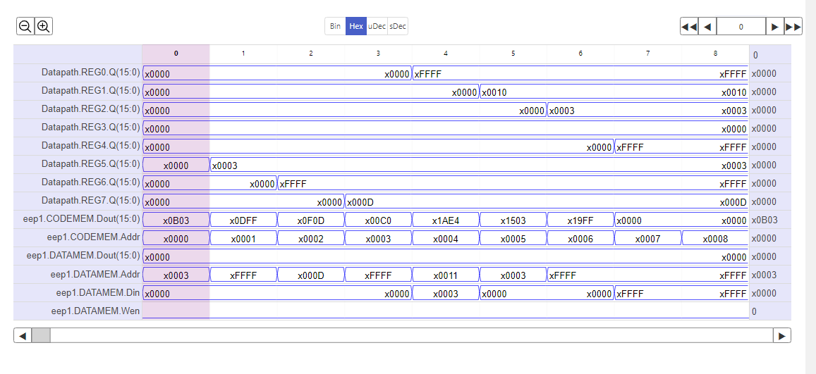

**(Task 2)** The picture above is wave simulation in ISSIE showing 8 clock cycles that is executing the 7 instructions given in the table. CODEMEM stores the instructions while DATAMEM stores the data to be updated in the registers.

We can confirm that the CPU is working correctly. At the first instruction, MOV R5, #3, we can see that the CODEMEM at tick 0 corresponds to the machine code of this assembly instruction, 0x0dff. As a result, R5 updates to 0x0003 at tick 1. The instruction ADD R1, R5, R7 at tick 4 corresponds to 0x1ae4. As a result, R1 updates to 0x0010. (R5=3, R7=13, R1=3+13=16=0010)

The registers are only updated with the new value indicated by the instructions at the tick after the instruction tick. (e.g. REG5 is only updated to x0003 at tick 1, while the instruction MOV R5, #3 was executed at tick 0). This is because the registers run on D-flip-flops, which can only update its value after a rising clock edge is detected, so even if the instruction has been executed during a clock tick, the value will not update yet until the next tick.

**(Task 3)** Based on the RAM file, we can create our own assembly instructions and test the assembler. We manually convert the assembly code into binary then hexadecimal and confirm our answer with the assembler that this is the case.

1. 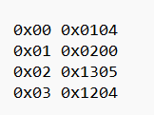MOV R0, #4 – 0b0000 0001 0000 0100 – 0x0104
2. MOV R1, R0 – 0b0000 0010 0000 0000 – 0x0200
3. ADD R1, #5 – 0b0001 0011 0000 0101 – 0x1305
4. ADD R1, R0 – 0b0001 0010 0000 0100 – 0x1204

**(Task 4)** We need to write a truth table for each instruction line that shows the value of Op2Sel and AD1SelC, which can be found under the datapath subsheet, under the custom components section in dpdecode.

|  |  |  |  |
| --- | --- | --- | --- |
| Instruction Machine Code | Assembly | Op2Sel | AD1SelC |
| 0x0104 | MOV R0, #4 | 1 | 0 |
| 0x0200 | MOV R1, R0 | 0 | 0 |
| 0x1305 | ADD R1, #5 | 1 | 0 |
| 0x1204 | ADD R1, R0 | 0 | 1 |

We then need to write an algebraic truth table for the outputs DIN1 and AD1. From analysing the hardware, DIN1 is the data which is to be written into the registers, while AD1 is the address input to the demultiplexer in the register file, which is used to choose which register to enable.

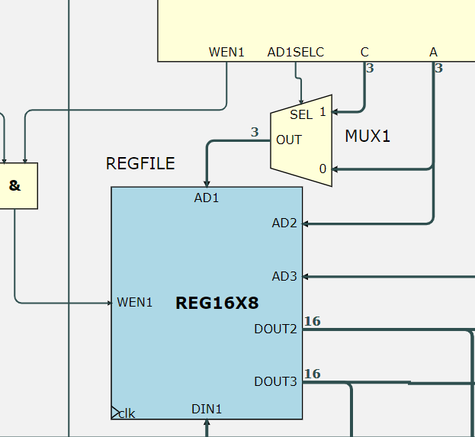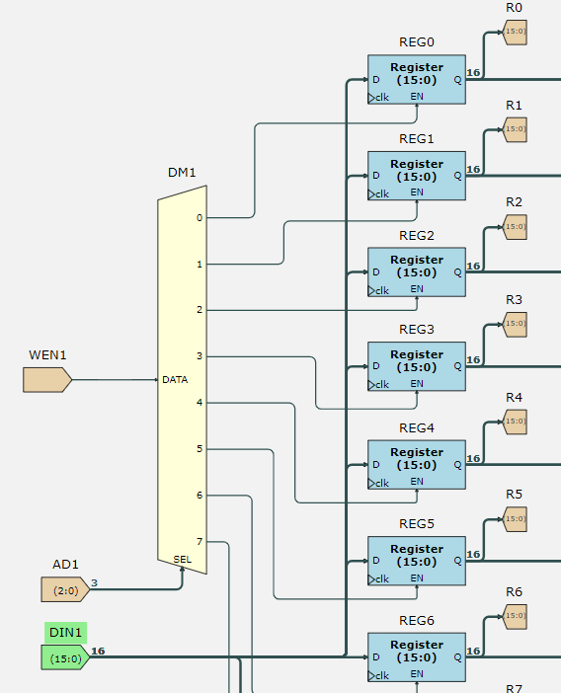

The input AD1SelC is used to select which address input, A or C to control the demultiplexer in the register file, for example in instructions such as ADD R1, R1, R0; where R1=Rc. Finally, the input Op2Sel is to select whether the instruction involving registers only or registers and constants. Thus, the truth tables can be constructed (a, b, c stands for REGFILE[a], REGFILE[b], REGFILE[c] respectively):

**ALUOPC=0 (MOV):**

|  |  |  |  |  |  |  |  |  |
| --- | --- | --- | --- | --- | --- | --- | --- | --- |
| ASSEMBLY | A | B | C | Imm8 | Op2Sel | AD1SelC | DIN1 | AD1 |
| MOV Ra, Rb | a | b | c | n | 0 | 0 | b | a |
| Not possible | a | b | c | n | 0 | 1 | x | x |
| MOV Ra, #Imm8 | a | b | c | n | 1 | 0 | n | a |
| Not possible | a | b | c | n | 1 | 1 | x | x |

**ALUOPC=1 (ADD):**

|  |  |  |  |  |  |  |  |  |
| --- | --- | --- | --- | --- | --- | --- | --- | --- |
| ASSEMBLY | A | B | C | Imm8 | Op2Sel | AD1SelC | DIN1 | AD1 |
| Not possible | a | b | c | n | 0 | 0 | x | x |
| ADD Rc, Ra, Rb | a | b | c | n | 0 | 1 | a+b | c |
| ADD Ra, #Imm | a | b | c | n | 1 | 0 | a+n | a |
| Not possible | a | b | c | n | 1 | 1 | x | x |

# ADDSUB Block

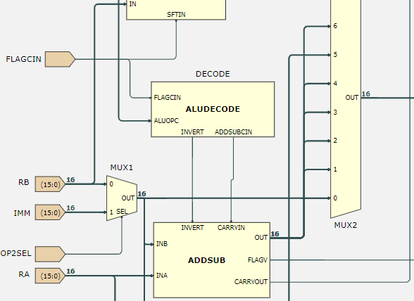The ADDSUB Block in the implements addition and subtraction in the ALU. It allows 5 different functions to be executed: ADD, SUB, ADC, SBC, CMP.

The functionality of the ADDSUB is controlled by the INVERT and CARRYIN inputs from the ALUDECODE block. We need to construct an algebraic truth table for the ADDSUBOUT output from the inputs INA, INB, INVERT and CARRYIN. We can do this by looking at the ADDSUB block circuit.

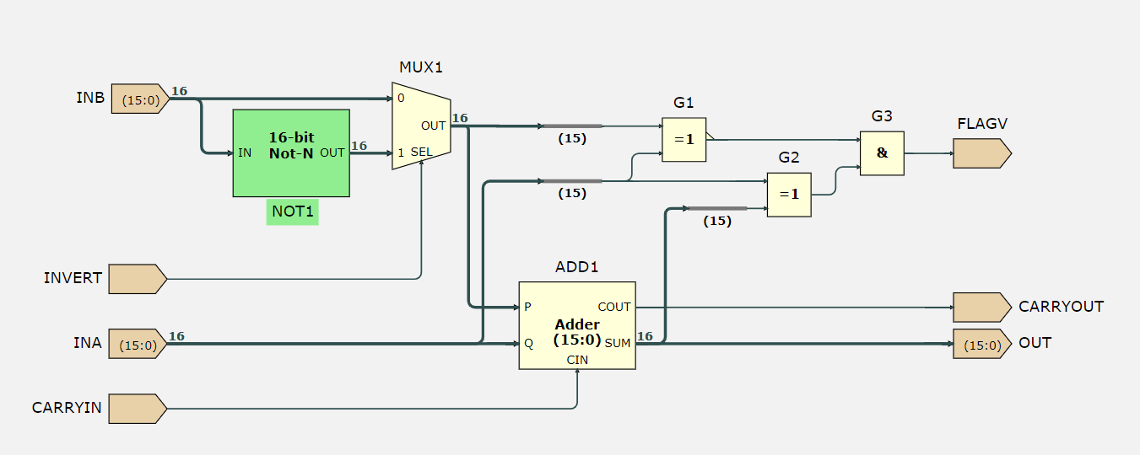

|  |  |  |  |  |
| --- | --- | --- | --- | --- |
| INA | INB | INVERT | CARRYIN | OUT |
| A | B | 0 | 0 | A+B |
| A | B | 0 | 1 | A+B+1 |
| A | B | 1 | 0 | A-B-1 |
| A | B | 1 | 1 | A-B |

**(Task 5)** We can also work out the truth table of the output in the ALUDECODE block. There will be 3 rows in the truth table where the output is don’t care, as some of these outputs which relates to the assembly instruction are not implemented with the ADDSUB block (MOV, AND, SHIFT).

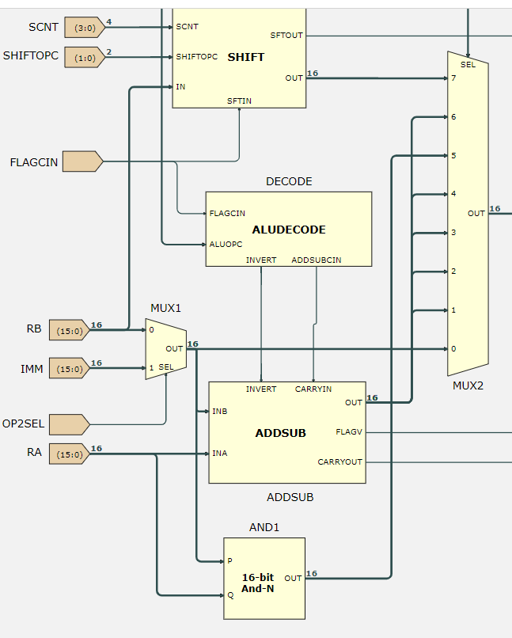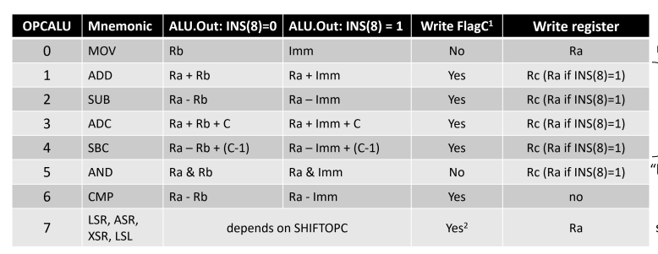On the right picture, ADDSUB is only connected to ports 1, 2, 3, 4, 6 of the multiplexer MUX2, while the rest are controlled by SHIFT, 16-bit AND and MUX1. When ALUOPC=000, 101, 111, the outputs are don’t care.

|  |  |  |  |
| --- | --- | --- | --- |
| ALUOPC | FLAGCIN | INVERT | ADDSUBCIN |
| 000 | 0 | X | X |
| 1 |
| 001 | 0 | 0 | 0 |
| 1 |
| 010 | 0 | 1 | 1 |
| 1 |
| 011 | 0 | 0 | 0 |
| 1 | 1 |
| 100 | 0 | 1 | 0 |
| 1 | 1 |
| 101 | 0 | X | X |
| 1 |
| 110 | 0 | 1 | 1 |
| 1 |
| 111 | 0 | X | X |
| 1 |

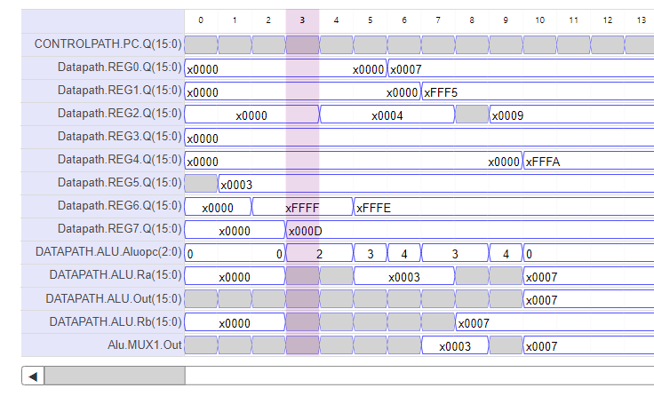We can confirm with the register values that the CPU datapath works. (R5=0003 after tick 0, R6=255 after tick 1, R7=13 after tick 2)(R2=3-(-1)=4 after tick 3, R6=255-1=254=(FFFE)b16 after tick 4 and more…)

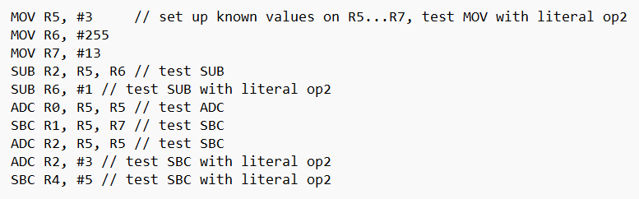

# CMP and AND

(Task 8)We need to figure out the value of WEN1 that depends on the ALU instruction. By looking at the dpdecode sheet, we can draw the truth table for the value of WEN1:

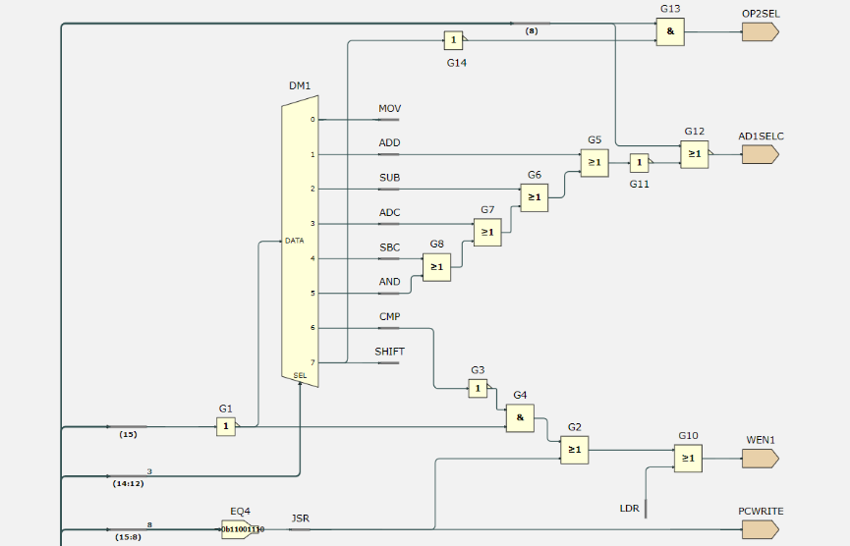When bits 14:12 in the machine code instruction is any number between 0 and 7 except for 6, the value coming from the CMP wire will be 0. As bit 15 in the instruction will always be 0, the output of G4 will be 1 and WEN1 will be 1.

Other than that, if bits 14:12 = 110, which means the CMP instruction is selected, the value of the CMP wire will be 1 the output of G4 will be 0. Depending on the value of bits 15:8, as long as they are not equal to the binary number 11001110, the input into G2 will be 0 and the value of WEN1 is 0.

|  |  |
| --- | --- |
| ALU Instruction | WEN1 |
| MOV | 1 |
| ADD | 1 |
| SUB | 1 |
| ADC | 1 |
| SBC | 1 |
| AND | 1 |
| CMP | 0 (the only one where register is not written) |
| SHIFT | 1 |

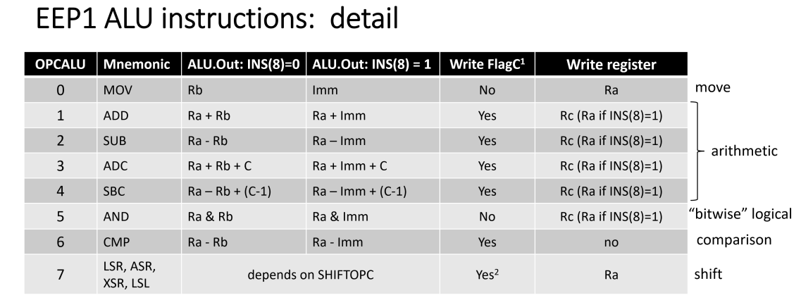

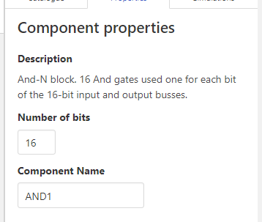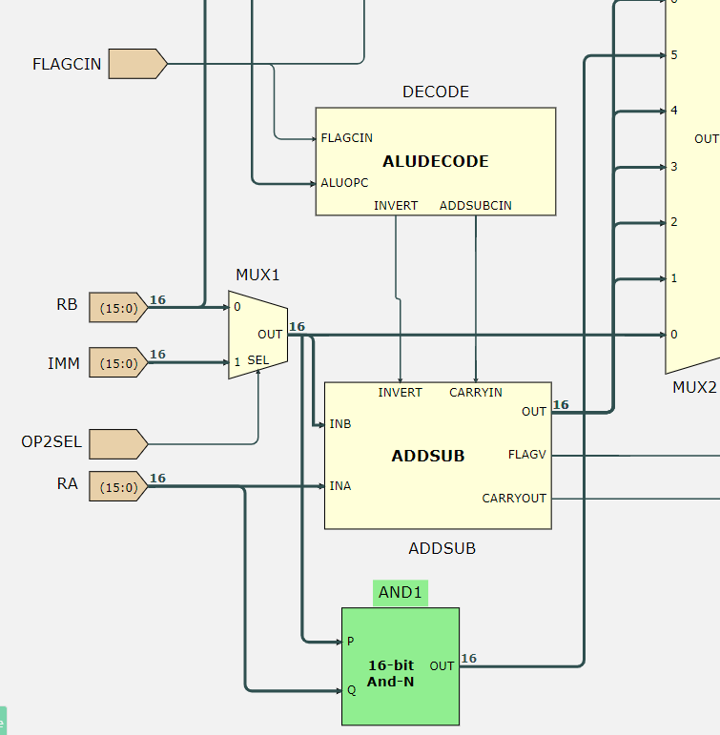As for the AND instruction, it is carried out by the 16 bit AND gate in green, then its output is connected to input 5 of the MUX2.

(Task 9) We need to use the source file lab1testandcmp to test the functionality of these instructions.

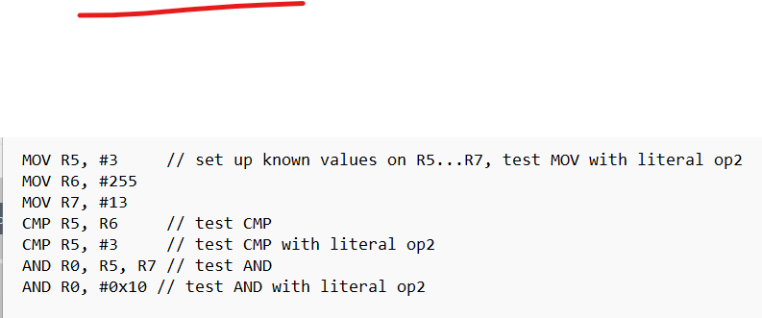

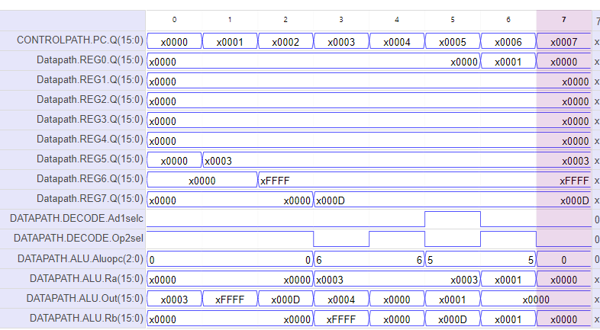

The pictures above show the assembly code found in the source file and the resulting waveform from executing the code. From tick 1 to 3, the values of R5, R6, R7 are stored accordingly to the assembly code. From tick 4 to 5, the registers do not update as it is a CMP function, but the output of the ALU in tick 3 gives the value of R5-R6, which is 3-(-1)=4, corresponding to CMP R5, R6. Similary, CMP R5, #6 can be confirmed by the ALU output of 3-3=0 in tick 4. At tick 6, the register R0 is updated with the value of R5 AND R7 which gives the last 4 binary numbers as 0011 AND 1101, which is 0001, and the rest of the numbers 0, which makes the value at R0 x0001.

**(Task 10)** We need to predict the waveform of the registers of the SHIFT operations.

MOV R2, #0x1 // set up known value on R2, test MOV with literal op2

LSL R2, R2, #1 (R2=0x0002)

LSL R2, R2, #2 (R2=0x0008)

LSL R2, R2, #4 (R2=0x0080)

LSL R2, R2, #8 (R2=0x8000)

ASR R2, R2, #3 (R2=0xF000)

LSR R2, R2, #6 (R2=0x03C0)

ASR R2, R2, #6 (R2=0x000F)

MOV R2, #0Xff (R2=0x00FF)

ADD R0, #0 // FLAGC := 0

XSR R2, R2, #3 (R2=0x1FFF) (shift 0 into the MSBs of the value)

SUB R0, R0, R0 // FLAGC := 1

XSR R2, R2, #2 (R2=0xC7FF)

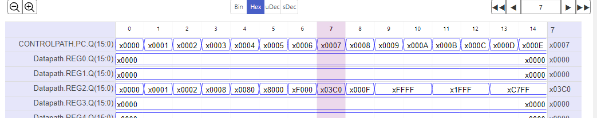

**(Task 11)** We need to explain how the SHIFTn.EN works for the SHIFT function.

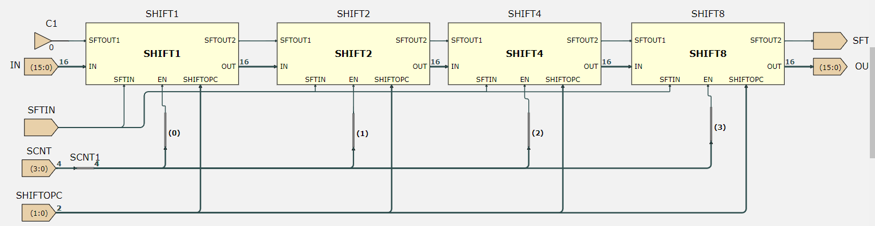

By looking at the hardware, The buses split SCNT into its respective bits. LSB to SHIFT1, bit 1 to SHIFT2 (because 10=2), bit 2 to SHIFT4 (because 100=4) and bit 3 to SHIFT8. This allows the hardware to shift by any number of bits because for example, in a number 0110=6, SHIFT4 and SHIFT2 will be enabled, and these 2 SHIFTS in series create a shift of 6 bits.

DECA 7: Control Path

# NEXT Block

The next block controls the value of the Program Counter(PC) which stores the address of the instruction for the CPU to execute.

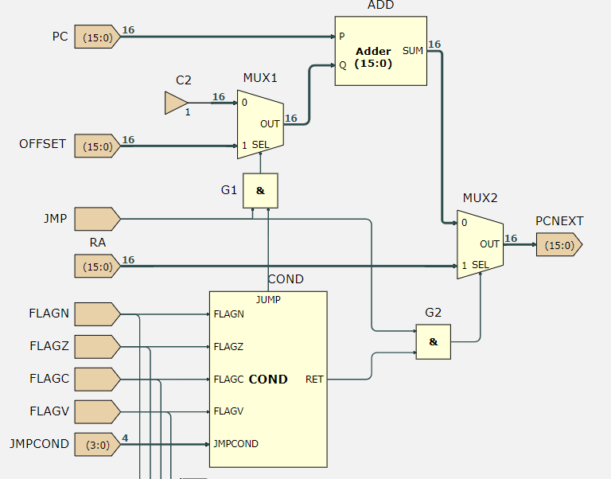**(Task 1)** According to the hardware above, we can determine the truth table for PCNEXT depending on PC, OFFSET RA, COND.JUMP, COND.RET and JMP:

|  |  |  |  |  |  |  |
| --- | --- | --- | --- | --- | --- | --- |
| PC | OFFSET | RA | COND.JUMP | COND.RET | JMP | PCNEXT |
| a | b | c | 0 | 0 | 0 | a+1 |
| a | b | c | 0 | 0 | 1 | a+1 |
| a | b | c | 0 | 1 | 0 | a+1 |
| a | b | c | 0 | 1 | 1 | c |
| a | b | c | 1 | 0 | 0 | a+1 |
| a | b | c | 1 | 0 | 1 | a+b |
| a | b | c | 1 | 1 | 0 | a+1 |
| a | b | c | 1 | 1 | 1 | c |

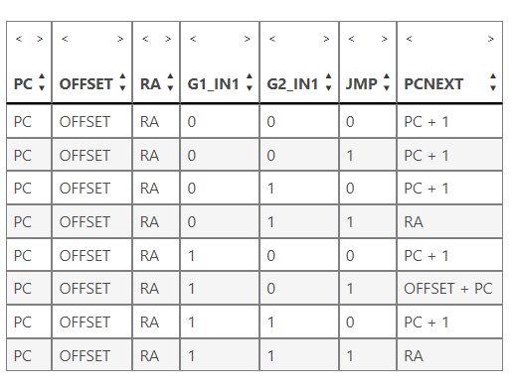

We can confirm that the truth table drawn is the same as the one generated in ISSIE.

Whenever JMP=0, PCNEXT will always be PC+1, as JMP=0 indicates that the instruction being executed is not a JUMP instruction, so the CPU proceeds to the next instruction. Whenever COND.JUMP is 1 (and JMP is 1), PCNEXT will be equal to PC+OFFSET, as this means that the instruction is a JUMP type and the condition for jump is satisfied. Whenever COND.RET is 1, PCNEXT will be equal to Ra, as this means the return instruction is being executed.

# JUMP CONDITIONS

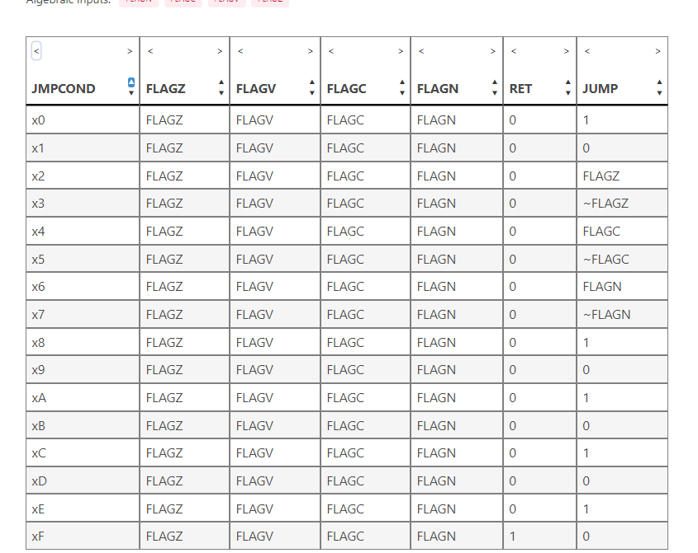

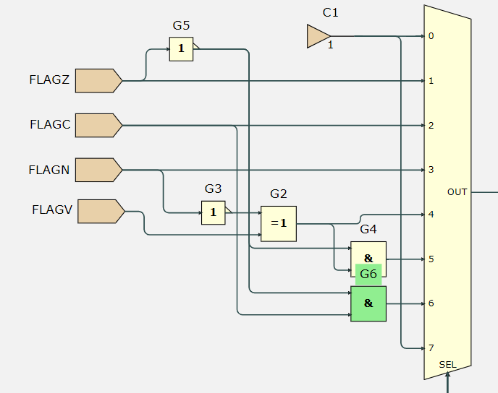(Task 2) This is the truth table for the cond sheet. The table matches the jump instruction summary, where when JMPCOND[0] = 1, the JUMP output is the NOT of the FLAG. Furthermore, it also follows the JMPOPC for 0,1,2,3,7; for example, JMPCOND=0011=x2, SEL=1 which selects FLAGZ, while JMPCOND[0]=1, so the output is FLAGZ XOR 1=!FLAGZ.

Now, according to the jump conditions in the instruction summary, we implement the logic for instructions 4,5,6. We can confirm the result with an ISSIE truth table:

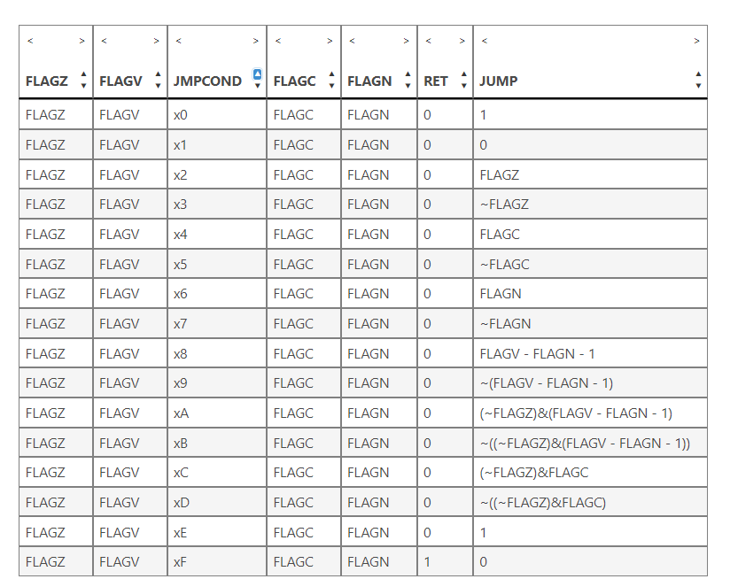

# mULTIPLICATION SOFTWARE

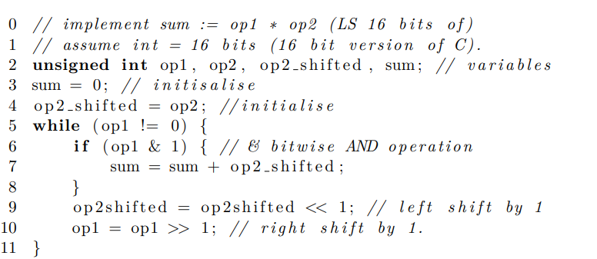**(Task 3)** This C++ code implements multiplication of op1*op2. We need to trace by hand the multiplication of op1=12 and op2=5, where the code should give us the result sum=60.

Initially, we set op1=12=1100, op2=5=0101, sum=0 and op2_shifted=5=0101. Since op1 is not 0, we enter the while loop. If(op1 & 1) ANDs the LSB of op1 with 1, and executes the code in the if statement if the result is 1(LSB op1=1). In this case, the LSB is 0 so the code is not executed. Then, op2_shifted is left shifted by 1 bit: op2_shifted=10100, and op1 is right shifted by 1 bit: op1=0110.

|  |  |  |  |
| --- | --- | --- | --- |
| Iteration | Op1 | Op2_shifted | Sum |
| 1 | 110**0**->0110 | 0101->1010 | 0 |
| 2 | 011**0**->0011 | 10100->10100 | 0 |
| 3 | 001**1**->0001 | 101000->101000 | 10100 |
| 4 | 000**1**->0000 | 1010000->1010 000 | 10100+101000 =20+40=60 |

The similarity of this method compared to the one in Lecture 3 is that 5 is multiplied by the power of 2 and then added to sum, whenever there is 1 at that position in the binary number. In the code, we do 5x2^2=10100, and 5x2^3=101000 as 12=1100 and add them up. This is similar to the method in the notes, as in 5x12=5x(12 split into sum of power of 2)=5x(2^2+2^3).

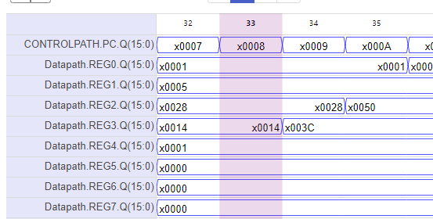**(Task 4)** Now we need to convert the C++ code into assembly language.

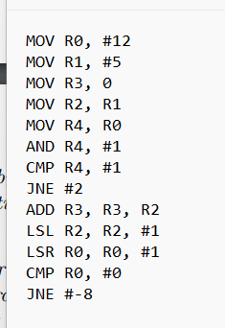

When we convert the assembly code into machine code then run it in the EEP1 CPU, we get the correct result of the multiplication in register 3, 003C=3x16+12=60.

**(Task 5)** Now we need to change the program such that the variables Op2_shifted and sum are 32 bit integers instead of 16 bit. We can achieve this by changing the operations into multiple word add and shifts. Using R0=Op1, R1=Op2, R2:R3=Op2_shifted, R4:R5=sum. As seen below, the value of R5=003C, while R4=0000, which makes sum=0x0000 003C=60, so the multiplication program is working correctly.

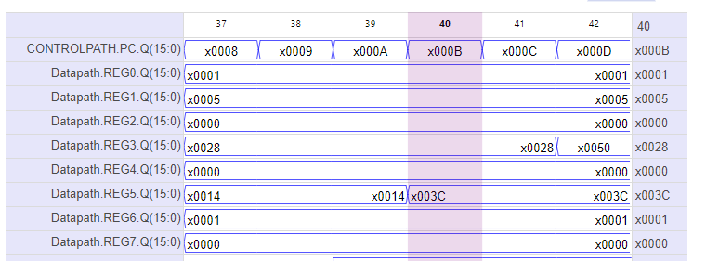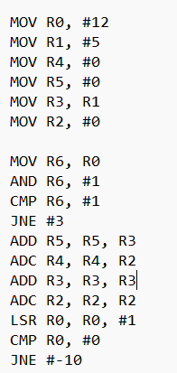

# Challenge

The challenge for this lab is to implement a multiplication method that is faster than the previous software. We do this by adding new hardware and making use of a new operation in EEP1 assembly. The constraint for this challenge is that we **cannot use more than 64 full adders.**

**IDEA:**

We adopt a similar approach to the multiplication software, but instead of multiplying 1 bit at a time, we multiply 4 bits at a time, which will make the method 4 times faster. To do this, we need:

1. A 16 bit x 4 bit multiplication hardware in ISSIE
2. A way to only use the last 4 bits of a 16 bit number
3. Connect the hardware correctly to utilise the RC(2:0) section of the opcode to implement our new instruction.
4. Write new software to perform the multiplication.

**A:**

To design the multiplication hardware, we follow the examples in the lecture notes.

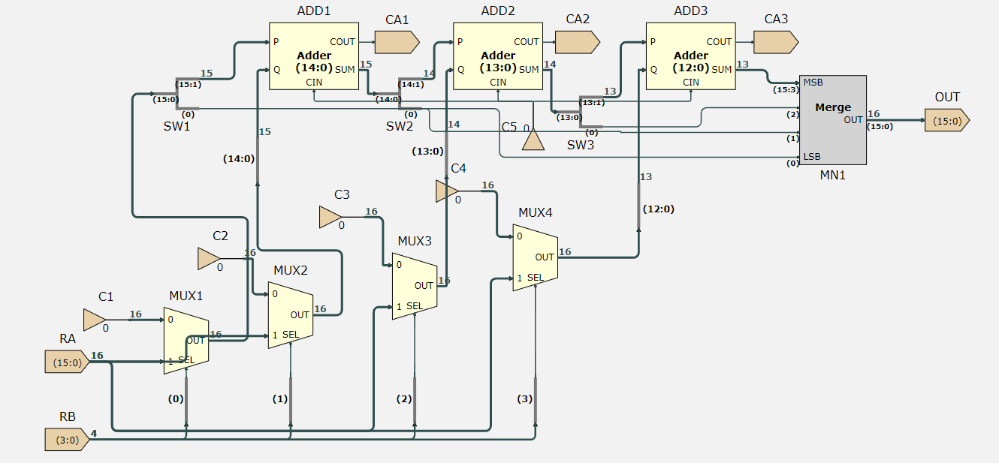

The way the hardware works is that depending on RB(4 bit number), if the current n bit is 1, we will add 2^n x RA to the result. As there is only 1 write port in the register file for EEP1, we can only write to 1 register at a time so the output can be a maximum of 16 bits only. Therefore, we use 15 bit, 14 bit and 13 bit full adders. (The 15 bit full adder adds bits 15:1 of 2^0 x RA + 2^1 RA because the carry out will be a 17th bit, and similar logic for the rest). This is a total of 15+14+13=42 full adders which follows the requirements of the challenge.

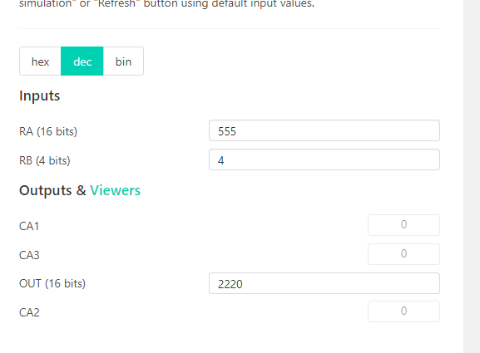We can confirm that the hardware works, as 555x4 is indeed 2220.

**B:**

Now we want to extract the last 4 bits of a 16 bit number so that we can use it in the hardware built in part A. 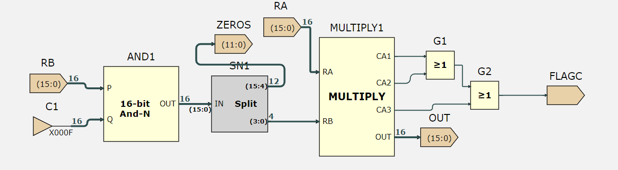

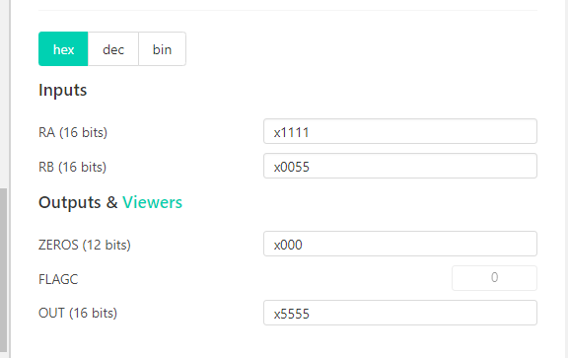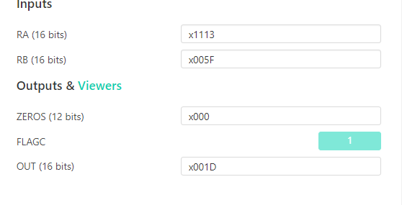The way this is done is by bitwise ANDing RB with 0x000F (0000 0000 0000 1111). Because X AND 1=X and X AND 0=0, this extracts the last 4 bits of RB. We then split the result into 15:4 (the zeros) and 3:0 (the 4 bit number required). We then pass this into the multiply software. For FLAGC, as long as there is a carry from either one of CA1, CA2, CA3, it means there is an unsigned overflow. (CA1: 2^16 overflow, CA2: 2^17 overflow)

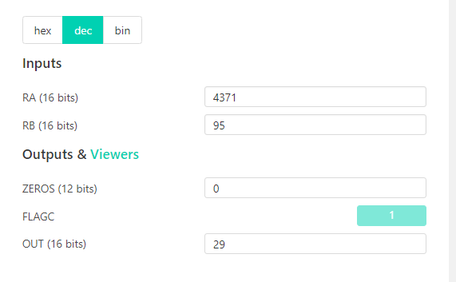In the example on the left and above(same numbers, just hex and decimal), 4371x95=415245>65536, so there is an unsigned overflow and the 16 bit multiplication result is 29.

**C:**

To connect the hardware made to EEP1’s datapath, we need to add another multiplexer in the DPDECODE sheet.

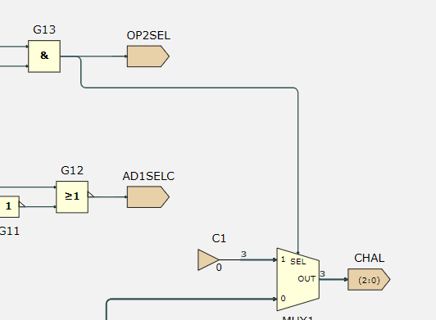The bottom wire is connected to C (address for RC in the opcode). Depending on OP2SEL, if it is 0 (RC=RA op RB), we will select C as the input for CHAL. If it is 1(RC=RC op #IMM) we will select 0 as the input for CHAL.

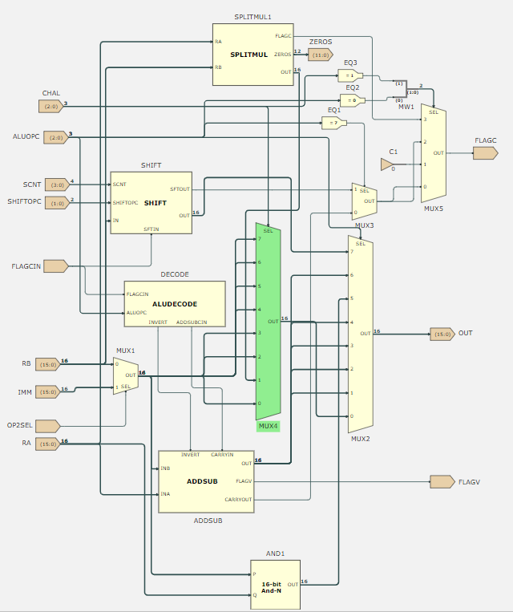

There is an additional 8-bit multiplexer(MUX 4) in the ALU sheet that controls the function of ALUOPC 000. If CHAL is 001 and ALUOPC is 000, this means that we have a custom function, so we pass the output of SPLITMUL (hardware made in B) into port 1 of MUX4.

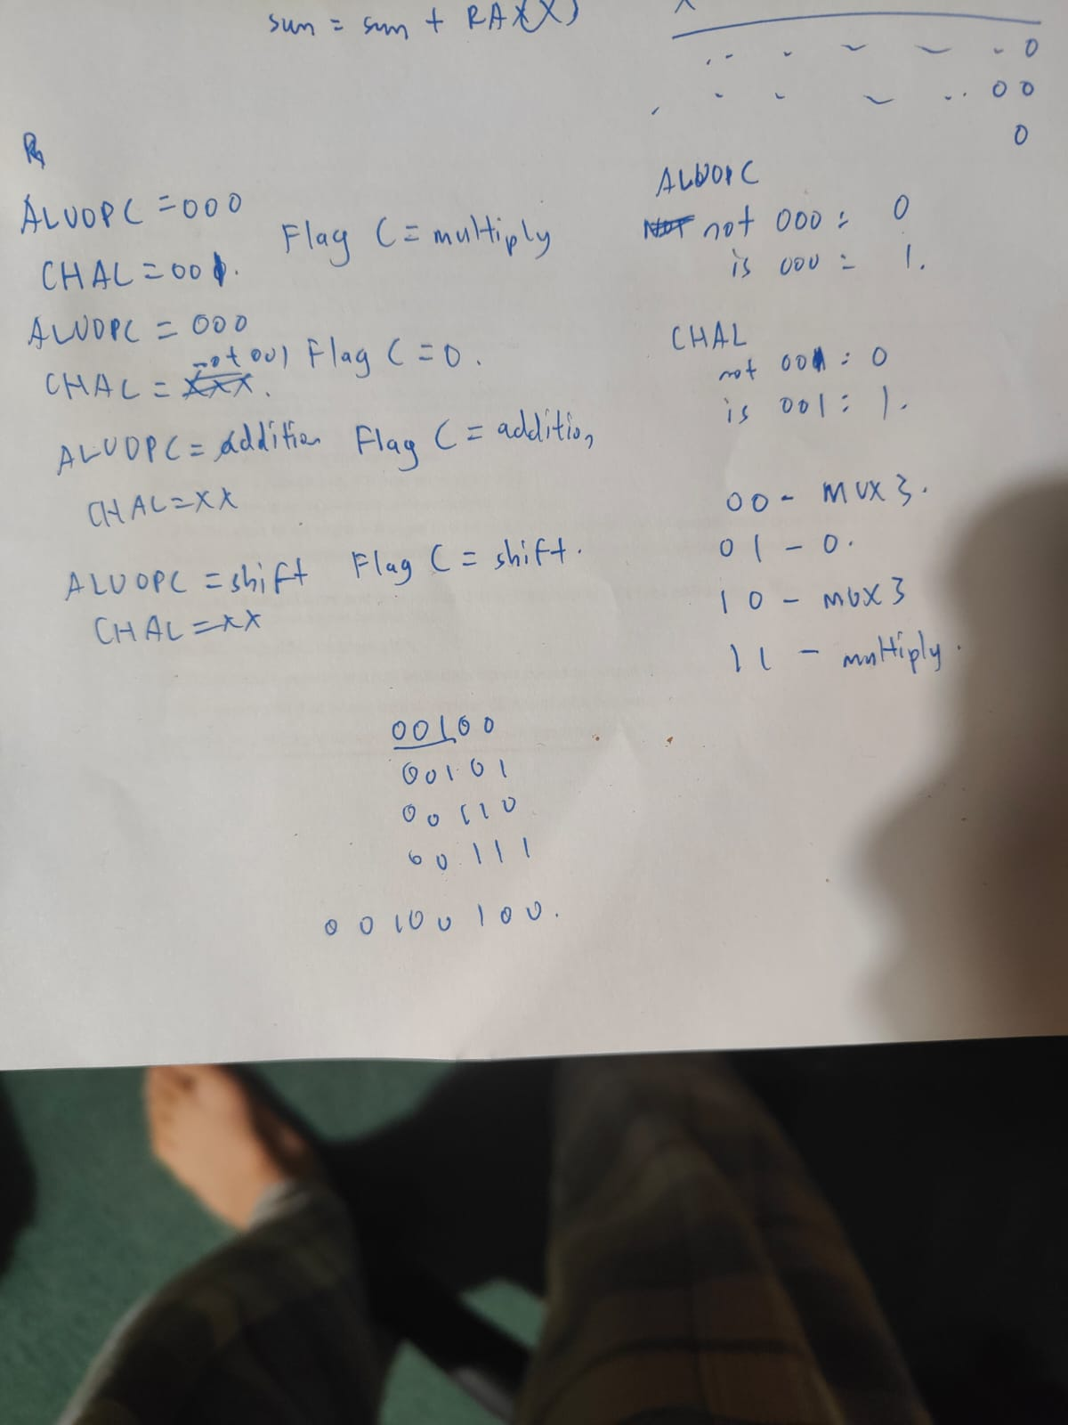To handle the carry out, we need to consider the carry out from normal ALU operations, shifts and the new multiply hardware.

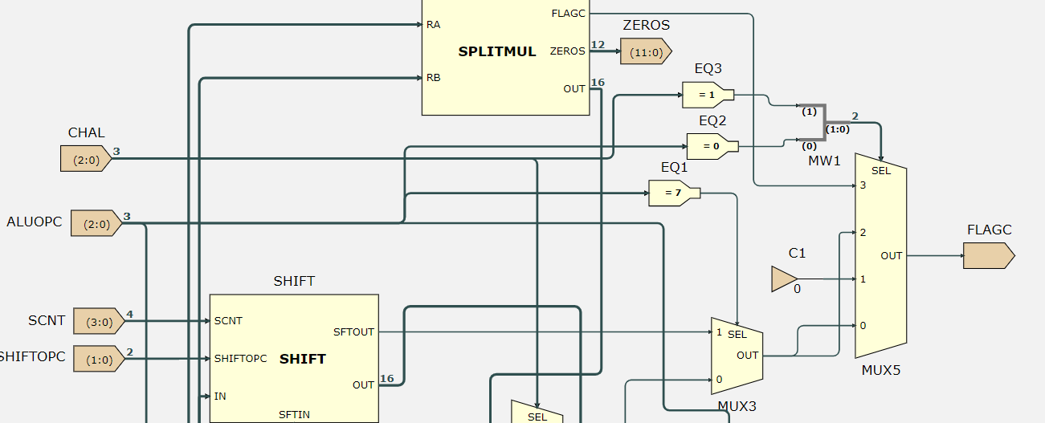

Based on the conditions written, we need 2 equalisers with value 0 and 1 for the inputs CHAL and ALUOPC. Then, we will use a 4 bit multiplexer to control the output of flagC.

**D:**

The software that we have to write is something like this:

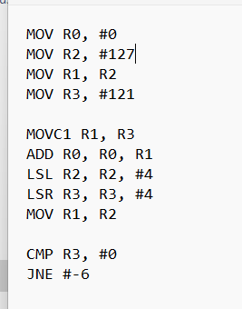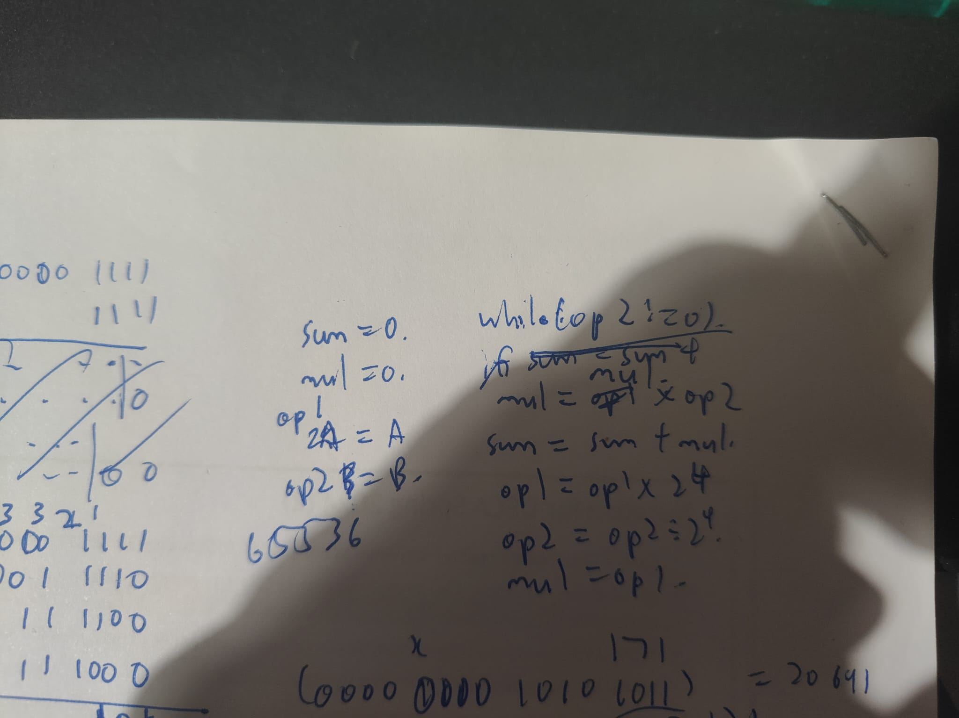

When converted to assembly, the code how it is on the right. It is similar to the previous multiplication software, but instead of sum=sum+opshifted, we have sum=sum+R1*(last 4 bits of R3), and we shift bits at once, so the multiplication can be completed in 4 cycles instead of 16.

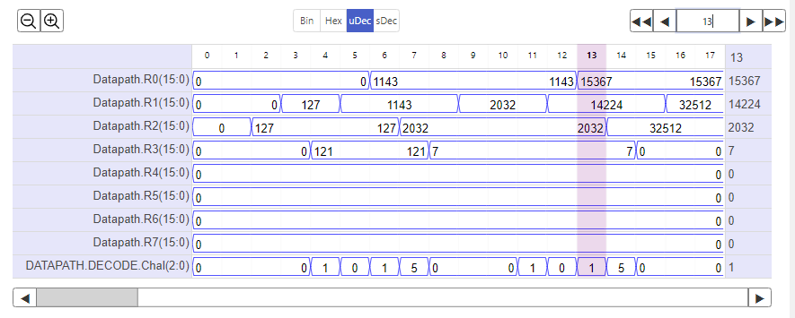

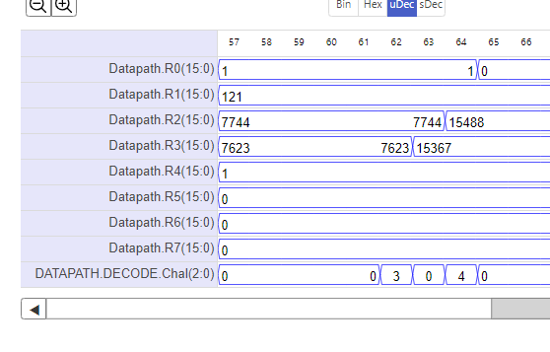

The top is the new multiplication software: we can see that the multiplication is done in 12 clock cycles compared to the 62 clock cycles of the old one. We can also confirm that 121x127=15367 by calculator.

Because the EEP1 can only assign a maximum positive value of 127 for immediate values, we need to add something to a register to get it to 16 bits. We add the line LSL R2, R2, #8, ADD R2, #127 to make R2=32639. Since 32639x121=2^21+2^20+2^19+2^18+17159, we can confirm that the multiplied result is correct.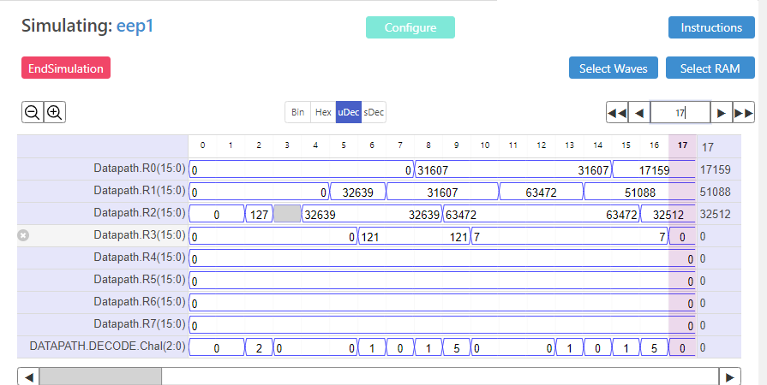

ADC 1: Measuring Impedance

Most of the following experiments will involve AC.

# Oscilloscope Measurement

Using an oscilloscope, we can generate a sinusoidal voltage input in the circuit and measure the voltage drop across components. In this experiment, we will use resistors and measure their impedance.

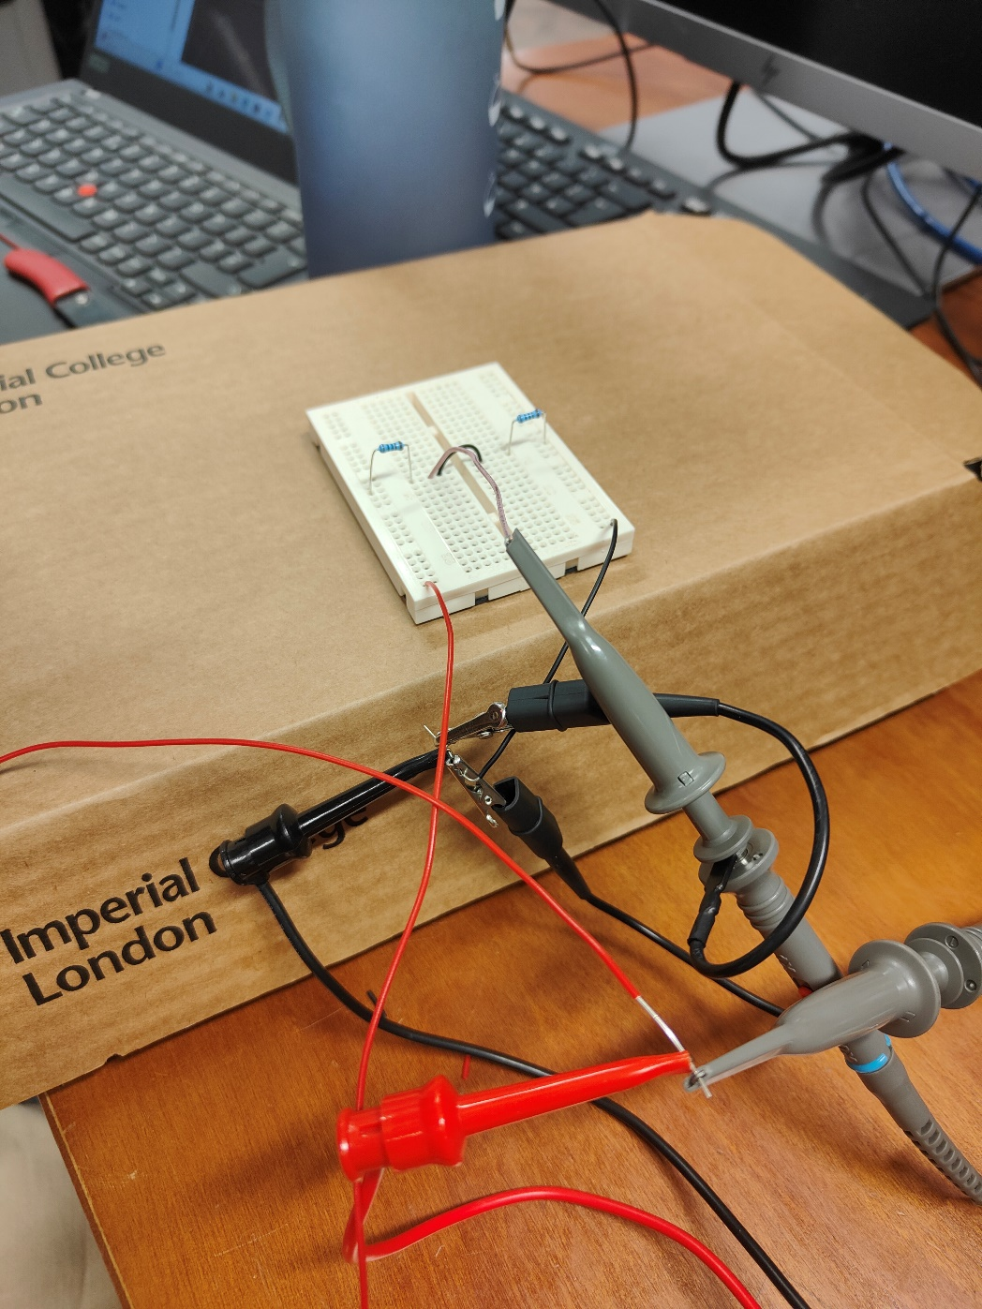In the circuit, the red clip is connected to the red wire as the input voltage from the oscilloscope. In order to measure the voltage of the 2 resistors, we cannot connect the oscilloscope probes between both ends of the resistors, as the oscilloscope’s black clip uses ground and a reference.

Instead, we measure the voltage across both resistors(probe connected to red wire) and the voltage across the resistor on the right (probe connected to yellow wire). The voltage across the left resistor is the voltage across both – voltage across right.

# Waveform Analysis

On the oscilloscope, the voltage across both (CH1) and voltage across right resistor (CH2) will be displayed. We can get Vch1 – Vch2 by using the math function on the oscilloscope and changing the operator to CH1-CH2. The resulting red waveform is the voltage across the left resistor. To see the red waveform more clearly, we can hide CH1 and move the horizontal position of CH2 downwards.

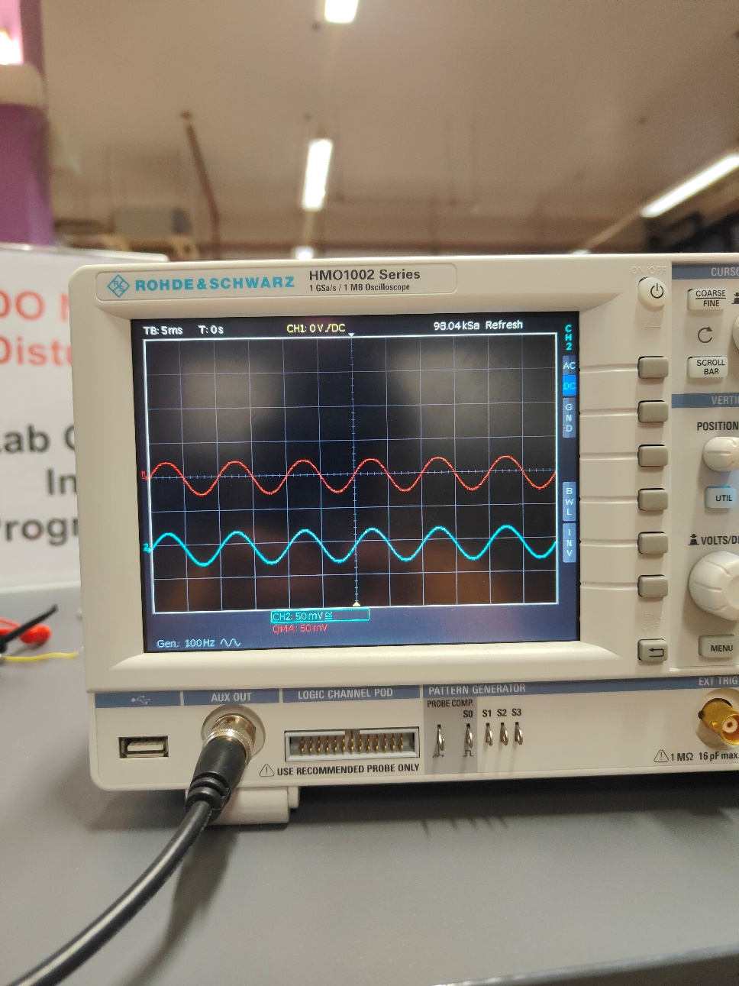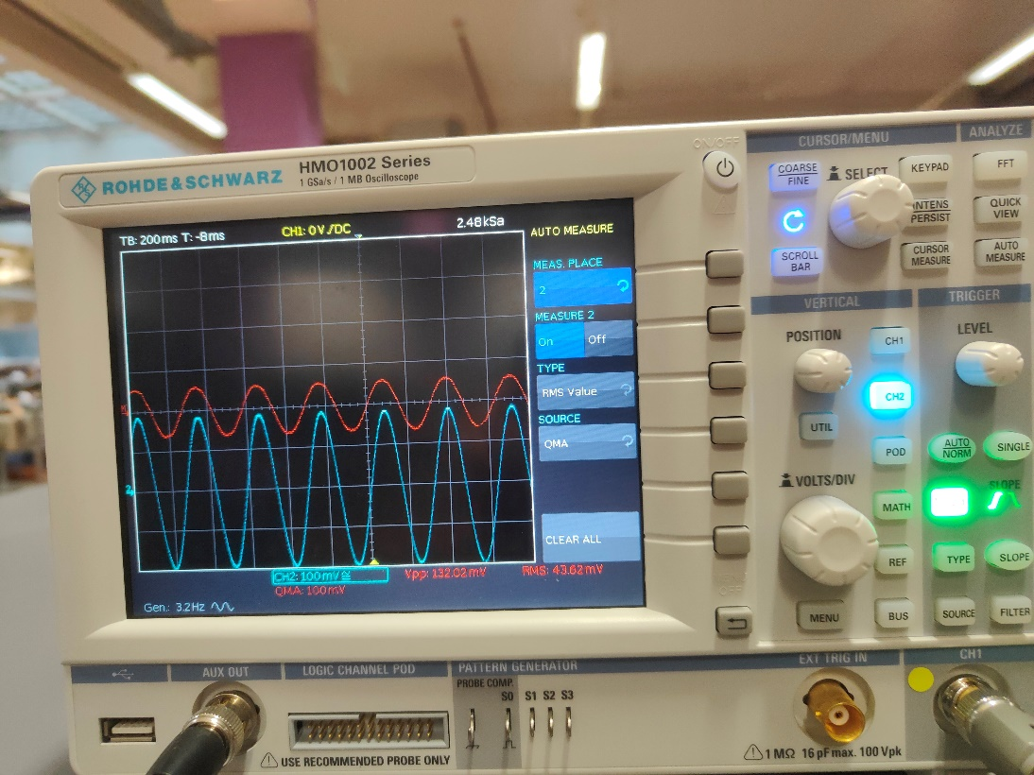

We can obtain the amplitude, RMS value and other properties of these waveforms by using the automeasure function on the oscilloscope. By adjusting the source(CH2/QMA) and type, there will be the corresponding measurements at the bottom of the screen(as shown in the right image)

An important note when calculating the waveform from other waveforms is to ensure that the peak of a wave should be at least 2 divisions on the oscilloscope. The picture on the left is a bad example. The oscilloscope works by sampling the waveform on screen and subtracting each individual value to generate a resulting waveform. If the peak is too small, there will not be enough data points for the oscilloscope to sample, and the resulting waveform looks distorted, making measurements inaccurate.

# adc 1: challenge

The challenge in this experiment is to measure the source impedance of signal generator. We connect the oscilloscope’s output to a circuit with a load resistance, then measure the output voltage across the load resistor. By using voltage division, we know that Vsource/Vload=(Rload+Rsource)/Rload. By taking 2 measurements of Rload and Vload respectively, we can solve for Vsource and Rsource respectively.

The results are shown in the following table:

|  |  |  |  |
| --- | --- | --- | --- |
| Vload/mV | Rload/ohm | Vsource/mV | Rsource/ohm |
| 328 | 200 | 422 | 57 |
| 420 | 10000 |

Vsource is an unknown because we may not exactly get the value that we set as the amplitude of the function generator as the output of the oscilloscope.

ADC 2: Reactive Components

This experiment investigates the reactive components, capacitors and inductors.

# impedance

In real life, capacitors and inductors are not ideal and they have parasitic resistance due to the components used to make the components. They are usually illustrated with a resistor in series with the component, and this resistance affects the magnitude and phase of the impedance. 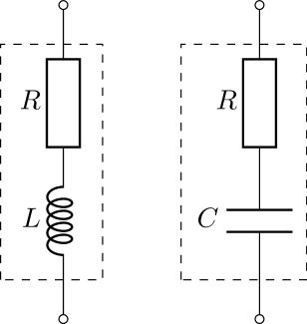

Before the experiment, we calculate the theoretical magnitude and phase of the impedance of an inductor. By letting L=1mH and R=10 ohms, Z=jwL+R.

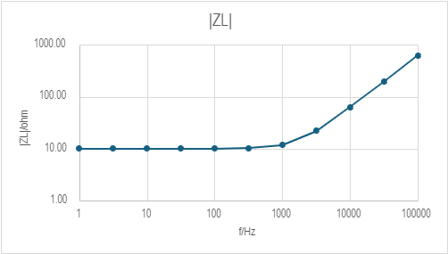By varying the frequency(f), we can obtain the relationship between f and |Z| and arg(Z), where |Z|=sqrt((wL)^2+R^2) and arg(Z)=tan-1(wL/R), and we can plot a graph of the result.

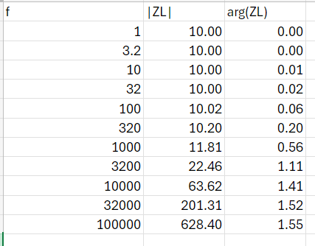

# Capacitors

Now the experiment will be conducted to investigate the relationship between f and the impedance of a capacitor. Zc=1/jwL, so the magnitude of impedance is expected to be inversely proportional to frequency(when 1/wL is much bigger than R).

We connect a resistor to the capacitor in series, then perform the same measurement method as ADC 1. Firstly, a capacitor of 1uF is used, then 33nF.

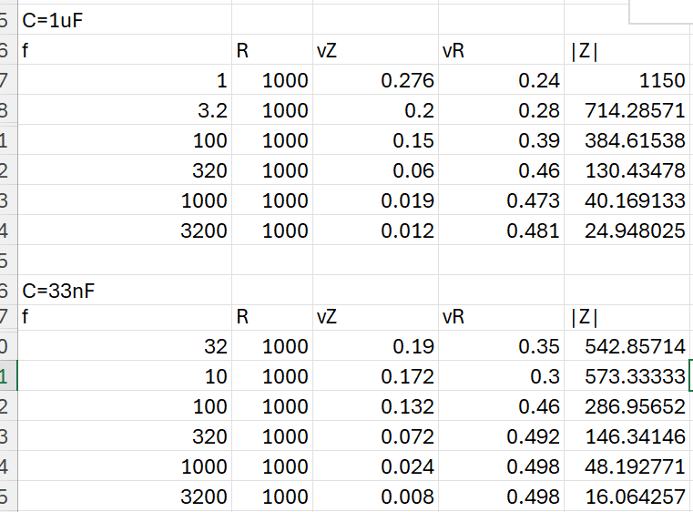

The x-axis is plotted with a logarithmic scale so that the graph can be seen better. Anomalous results were removed from the experiment. The graphs are inaccurate but still show the inverse relationship between frequency and impedance.

As f is increasing, 1/wC decreases so |Z| becomes constant, approximately equal to R.

# INDUCTORS

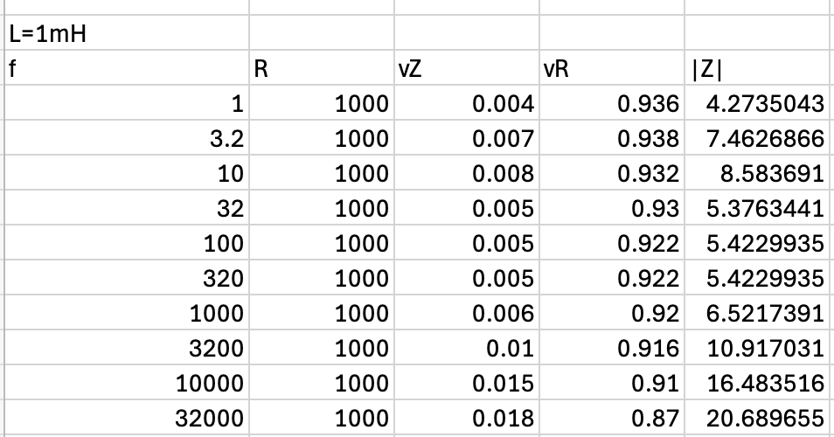The capacitor is now replaced with an inductor and the experiment is repeated. The impedance is of inductor is ZL=jwL, so the magnitude of impedance should be directly proportional to f(for jwL much bigger than R)

|ZL| remains about constant from 1 to 1000 Hz because jwL is much smaller than the parasitic resistance of the inductor, so |ZL|=(approx.)R. When jwL is much bigger than R, |ZL| will start to increase.

Anomalous results at f=3.2 and f=10 can be caused by many factors, such as moving the circuit and causing the voltage values to displace, or faulty components. In this experiment, a faulty 100k ohm resistor was used at the beginning which caused some issues, so we tested the resistor and discovered that the voltage across it was 1/10 of the source voltage.

# adc 2: cHALLENGE

The challenge of this section is to use the same measurement methods to measure the impedance of a capacitor and inductor with unknown capacitance and inductance. By using test values from 1 to 5000Hz, we obtained the value of |ZC| and |ZL| respectively. |ZL|=wL, so in a graph where |Z| is against w, L will be the gradient.

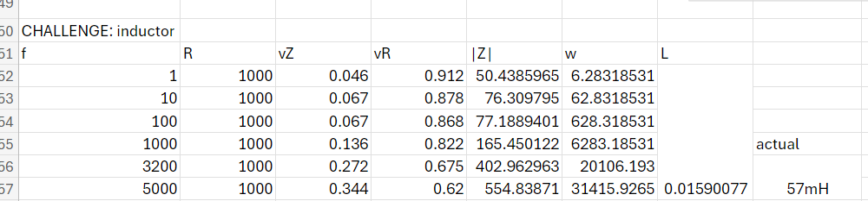

The gradient of the best fit line for these points is calculated with the SLOPE function in Excel, which gives us a value of L=15.9 mH, which is reasonably close to the actual value.

Similarly, |ZC|=1/jwC, so 1/C represents the gradient of |ZC| against (1/w).

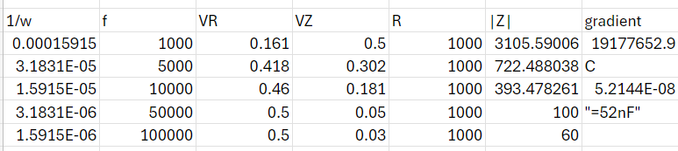

By using a similar calculation, we can find the capacitance of the capacitor. The actual value of the capacitor is 47.59 nF using the RCL meter, so our measurements are reasonably accurate.

ADC 3: Resonance and Filters

This experiment investigates the behaviour of the different types of filters.

# Series and Parallel LC

Resonance occurs when the impedance of the capacitor is equal to the inductor but in opposite signs. Using the same method of measurement in section 1 and 2, We can measure the voltage of the series/parallel combination of inductor and capacitor.

Series LC

|  |  |  |  |  |
| --- | --- | --- | --- | --- |
| f | R | vz | vR | |Z| |
| 1 | 1000 | 0.04 | 0.936 | 42.7350427 |
| 10 | 1000 | 0.04 | 0.938 | 42.6439232 |
| 100 | 1000 | 0.041 | 0.939 | 43.6634718 |
| 1000 | 1000 | 0.025 | 0.95 | 26.3157895 |
| 2000 | 1000 | 0.006 | 0.935 | 6.4171123 |
| 2500 | 1000 | 0.003 | 0.933 | 3.21543408 |
| 3200 | 1000 | 0.008 | 0.937 | 8.53788687 |
| 5000 | 1000 | 0.015 | 0.946 | 15.8562368 |

Theoretically, the resonant frequency occurs when the total impedance of the inductor and capacitor is 0. However, due to parasitic resistance of these components, the resonant frequency makes the total impedance a minimum positive value, due to the constant resistance in each component.

From the results above, the impedance is at a minimum at around 2000-3200 Hz, which suggests that the resonant frequency is in that range of frequencies, with the smallest recorded value of 3.22 ohms at 2500 Hz.

Parallel LC

|  |  |  |  |  |
| --- | --- | --- | --- | --- |
| f | R | vz | vR | |Z| |
| 1 | 1000 | 0.011 | 0.924 | 11.9047619 |
| 10 | 1000 | 0.011 | 0.929 | 11.8406889 |
| 100 | 1000 | 0.011 | 0.929 | 11.8406889 |
| 1000 | 1000 | 0.03 | 0.925 | 32.4324324 |
| 2000 | 1000 | 0.068 | 0.905 | 75.1381215 |
| 2500 | 1000 | 0.079 | 0.896 | 88.1696429 |
| 3200 | 1000 | 0.07 | 0.909 | 77.0077008 |
| 5000 | 1000 | 0.04 | 0.927 | 43.1499461 |

Theoretically, the resonant frequency occurs when the total impedance of the capacitor and inductor is infinite. However, due to parasitic resistance, this makes the admittance of the combination a minimum positive number, which makes the impedance a maximum, due to the constant resistance in each component.

From the results above, the impedance is at a maximum at around 2000-3200 Hz, which suggests that the resonant frequency is in that range, with the largest recorded value of 88.2 ohms at 2500 Hz.

The resonant frequency is the same in both series and parallel because we use the same inductance and capacitance, so wc=1/sqrt(LC) will be the same(L=47mH, C=100nF, fc=1/2pisqrt(LC)=2321 Hz). We can see that the experiment matches the actual resonant frequency.

# First order filter

Filters are circuits that allow a certain range of frequencies to produce a high output. The simplest filter that can be made is an RC circuit, which can be low pass or high pass depending on the placement of the components.

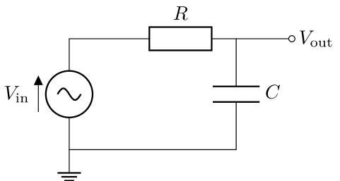A low pass filter can be made with output Y and ground across the capacitor.

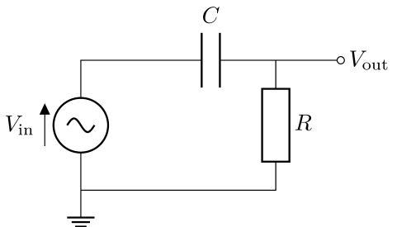A high pass filter can be made with output Y and ground across the resistor.   
Using the oscilloscope, we can measure the Vout. With the automeasure function we can measure the amplitude of Vout and the phase angle of Vout with respect to Vin.

Low pass filter

|  |  |  |  |  |
| --- | --- | --- | --- | --- |
| f | Vin | Vout | |H| | arg(H) |
| 1 | 0.985 | 0.098 | 0.09949239 | -1.16 |
| 10 | 0.985 | 0.099 | 0.10050761 | -3.6 |
| 100 | 0.985 | 0.08 | 0.08121827 | -33 |
| 1000 | 0.985 | 0.015 | 0.01522843 | -76.4 |
| 2000 | 0.985 | 0.008 | 0.00812183 | -79.3 |
| 3200 | 0.985 | 0.005 | 0.00507614 | -80 |
| 5000 | 0.985 | 0.003 | 0.00304569 | -82.1 |

As seen above, the |H| is the greatest at the smallest frequency, indicating a low pass filter. At high frequencies, H approaches 1/jwRC, which means the phase approaches -90 degrees.

High pass filter

|  |  |  |  |  |
| --- | --- | --- | --- | --- |
| f | Vin | Vout | |H| | arg(H) |
| 1 | 0.92 | 0.0006 | 0.00065217 | 85 |
| 10 | 0.92 | 0.006 | 0.00652174 | 82.7 |
| 100 | 0.92 | 0.052 | 0.05652174 | 54.3 |
| 1000 | 0.92 | 0.093 | 0.10108696 | 9.9 |
| 2000 | 0.92 | 0.095 | 0.10326087 | 6.6 |
| 3200 | 0.92 | 0.095 | 0.10326087 | 5.7 |
| 5000 | 0.92 | 0.096 | 0.10434783 | 5.4 |

As seen above, the |H| is greatest at the highest frequency, indicating that it is a high pass filter. At high frequencies, H approaches 1, which means the phase approaches 0.

# ADC 3: Challenge

The challenge for this experiment is to create a second order filter(RLC circuit) to achieve a certain resonant frequency and simulate the circuit. For my lab pair (A02) I have been instructed to make a high pass filter with fc=8700Hz. Furthermore, I need to have a damping factor of 1. By using this circuit diagram for a high pass filter: 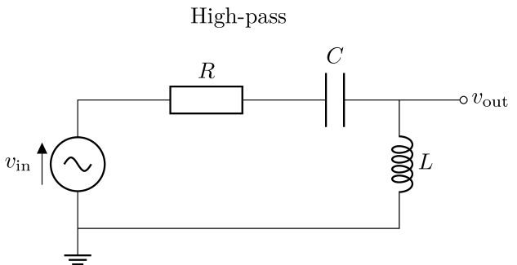

$$w_{c}=\frac{1}{\sqrt{LC}} \\ f_{c}=\frac{1}{2π\sqrt{LC}} \\ H=\frac{jwL}{R+\frac{1}{jwC}+jwL} \\ =\frac{LC{\left(jw\right)}^{2}}{LC{\left(jw\right)}^{2}+RCjw+1} \\ =\frac{LC{\left(jw\right)}^{2}}{{\left(\frac{jw}{w_{c}}\right)}^{2}+\frac{RC}{\sqrt{LC}}\left(\frac{jw}{w_{c}}\right)+1} \\ ∴damping factor=\frac{RC}{2\sqrt{LC}}=1$$

By setting one of the variables (L or C) to be a value that is found in the lab, the other variables can be found and I can construct a circuit with the values closest to the calculated value.

Challenge

|  |  |  |  |  |
| --- | --- | --- | --- | --- |
| f | Vout | Vin | |H| | arg(H) |
| 1000 | 0.0015 | 0.984 | 0.00152439 | 125 |
| 3200 | 0.011 | 0.984 | 0.01117886 | 130 |
| 8700 | 0.046 | 0.984 | 0.04674797 | 89 |
| 10000 | 0.053 | 0.984 | 0.05386179 | 81 |
| 32000 | 0.088 | 0.984 | 0.08943089 | 30 |
| 50000 | 0.089 | 0.984 | 0.09044715 | 18 |

We do not observe a peak value of |H| as expected at resonant frequency because the capacitor and inductor has some parasitic resistance, which only makes the reactive part of impedance cancel out, so it is hard to observe the maximum gain.

ADC 4: Biasing and amplification

This experiment is about op-amps and how its used in signal sources.

# Components

The components used in this experiment are the op-amp, signal source, earphone adapter and signal generator(oscilloscope).

1. Op-amp

The op amp used in this experiment is the LT1366, where there are 2 op-amps integrated into the module. The op-amp must be connected such that there is no short circuit between any 4 of the terminals, which means it can only be connected across the gap of the breadboard. Both the op amps share the same Vcc and -Vcc.

1. Signal source

The signal source used in this experiment has an OUT pin, to deliver the signal to parts of the circuit; and a SYN pin, to synchronise 2 signal sources used in the same circuit. The signal source must be connected the same way as the Op-amp.

1. Earphone adapter

The earphone adapter has a L and R pin, where L is the input to the adapter and R is usually grounded.

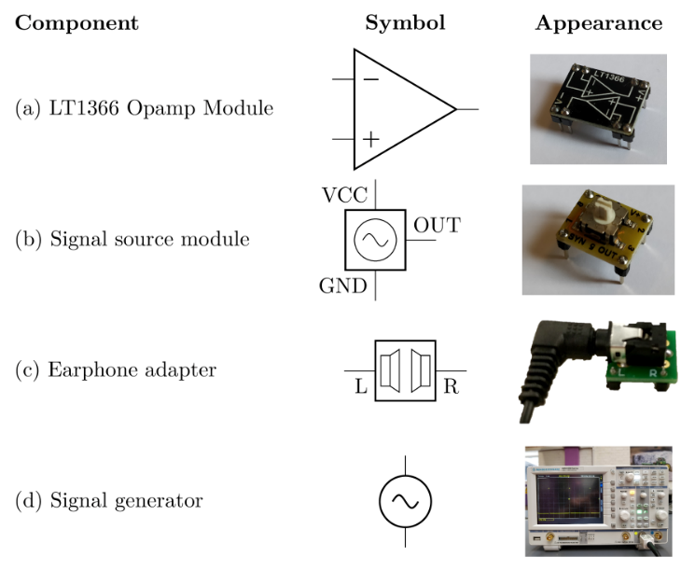

# Signal source

The signal source has 10 different modes, where some of the modes can play music if listened to on earphones. The output of the signal source must be connected to the L pin of the earphone adapter.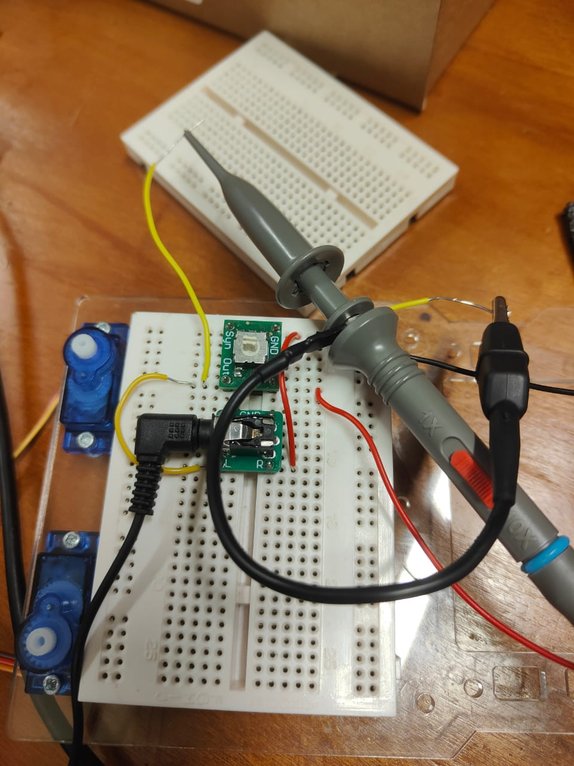

The signal source knob has a marking that indicates which mode the signal source is in. Other than that, we can measure the signal with an oscilloscope. The sound heard will be quite soft because the signal source cannot provide enough current when the circuit is closed(earphones connected).

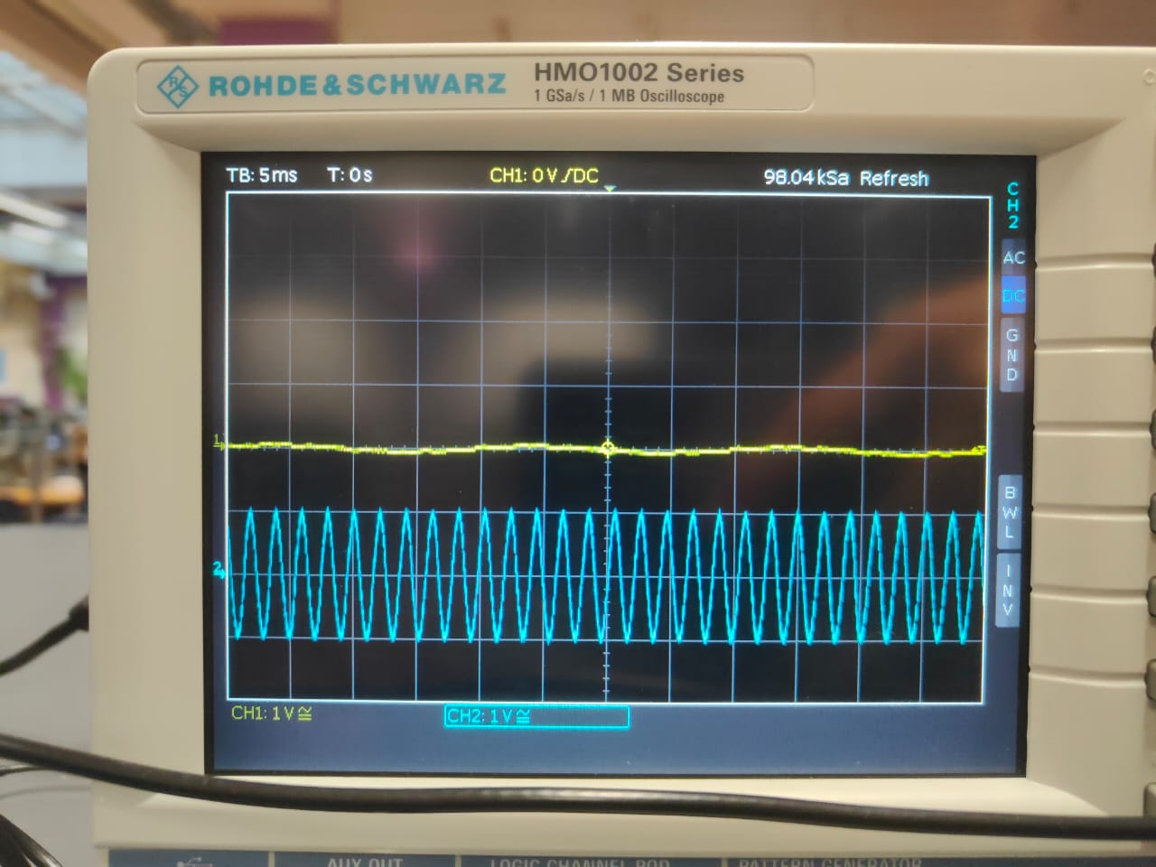

In a simplified diagram, the signal source is made of an ac voltage source with a resistor and capacitor in series, while the earphone+adapter is also made of a resistor and capacitor in series. When the earphone is connected, there will be a voltage drop across the signal source ac voltage source and capacitor, which decreases the voltage across the earphones. When the earphone is not connected, the oscilloscope measures the output of the signal source only, which will be higher than the voltage across earphones.

# Inverting amplifier

The gain of inverting amplifiers will be negative compared to the input, so we expect to see the output voltage to be negative of the input. By using nodal analysis, we can show that Vin/1.5=-Vout/Rfb => Vout/Vin=-Rfb/1.5. For the gain to be -1.5, we need Rfb=1.5^2=2.25.

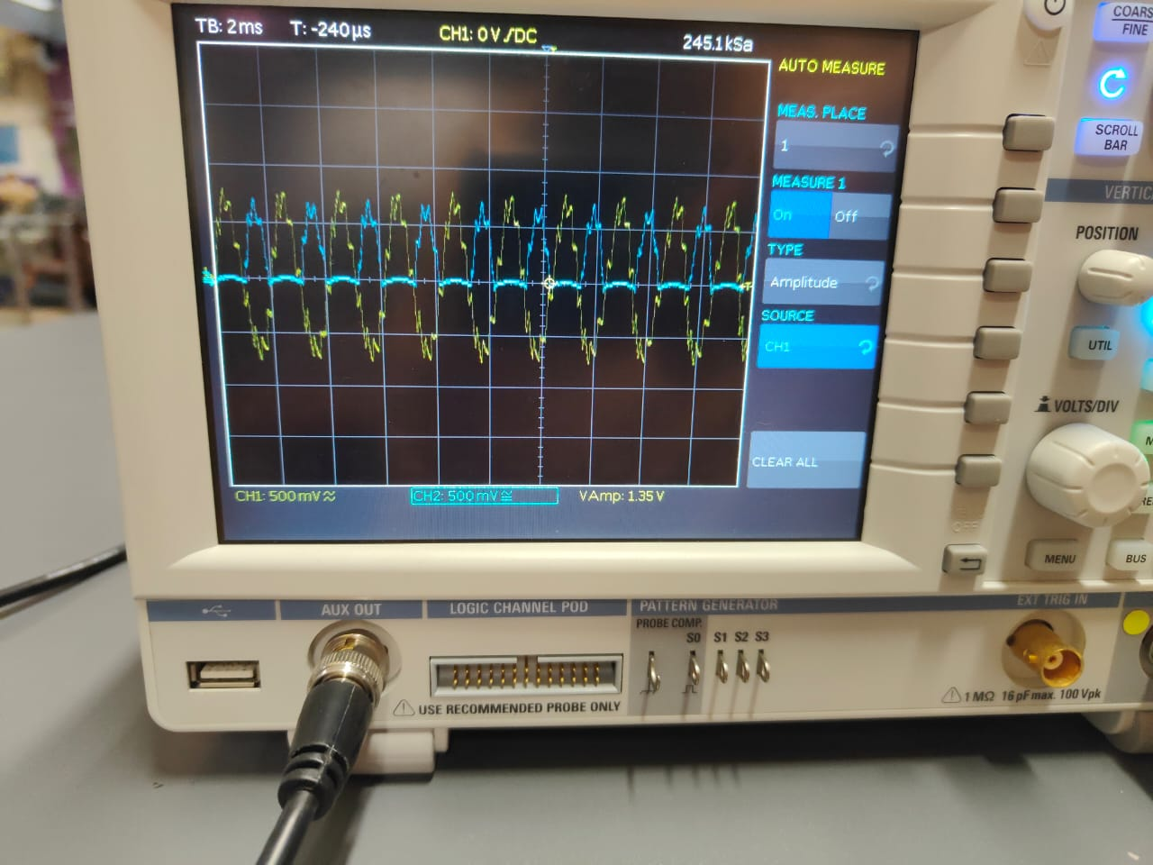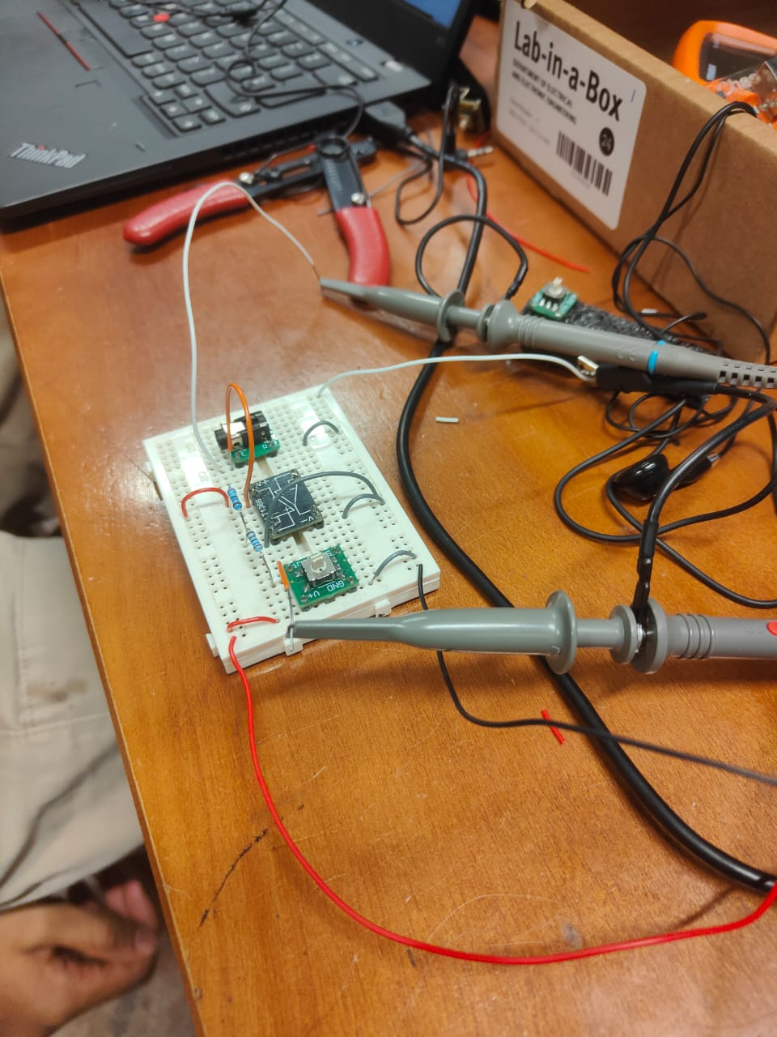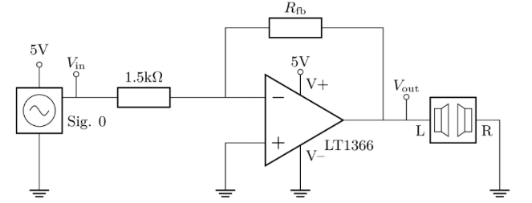

The circuit above will not work properly however and the waveform will look very distorted and similar to half-wave rectification. The op amp cannot produce a voltage that is lower than its -Vcc, which is 0 in this case, so the op-amp limits the negative voltage at 0.

To fix this, we make the non-inverting terminal have a voltage of 2.5V instead of 0V. Using KCL at the inverting terminal, this makes Vin-2.5/1.5=2.5-Vout/Rfb, => Vout-2.5/Vin-2.5=-Rfb/1.5, which means that the gain oscillates around 2.5 instead of 0, which is in the middle of Vcc=5V and -Vcc=0V. This fixes the output waveform looking like a half-wave rectification.

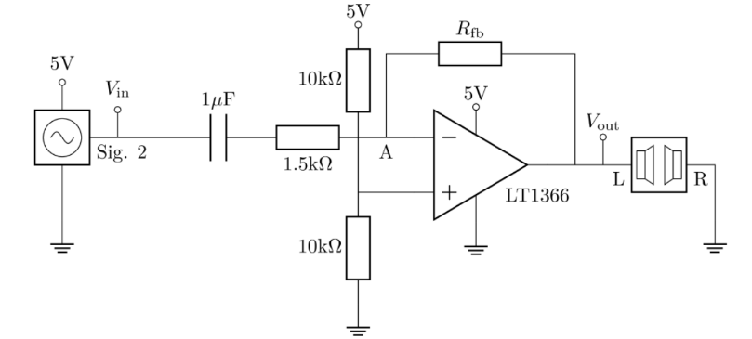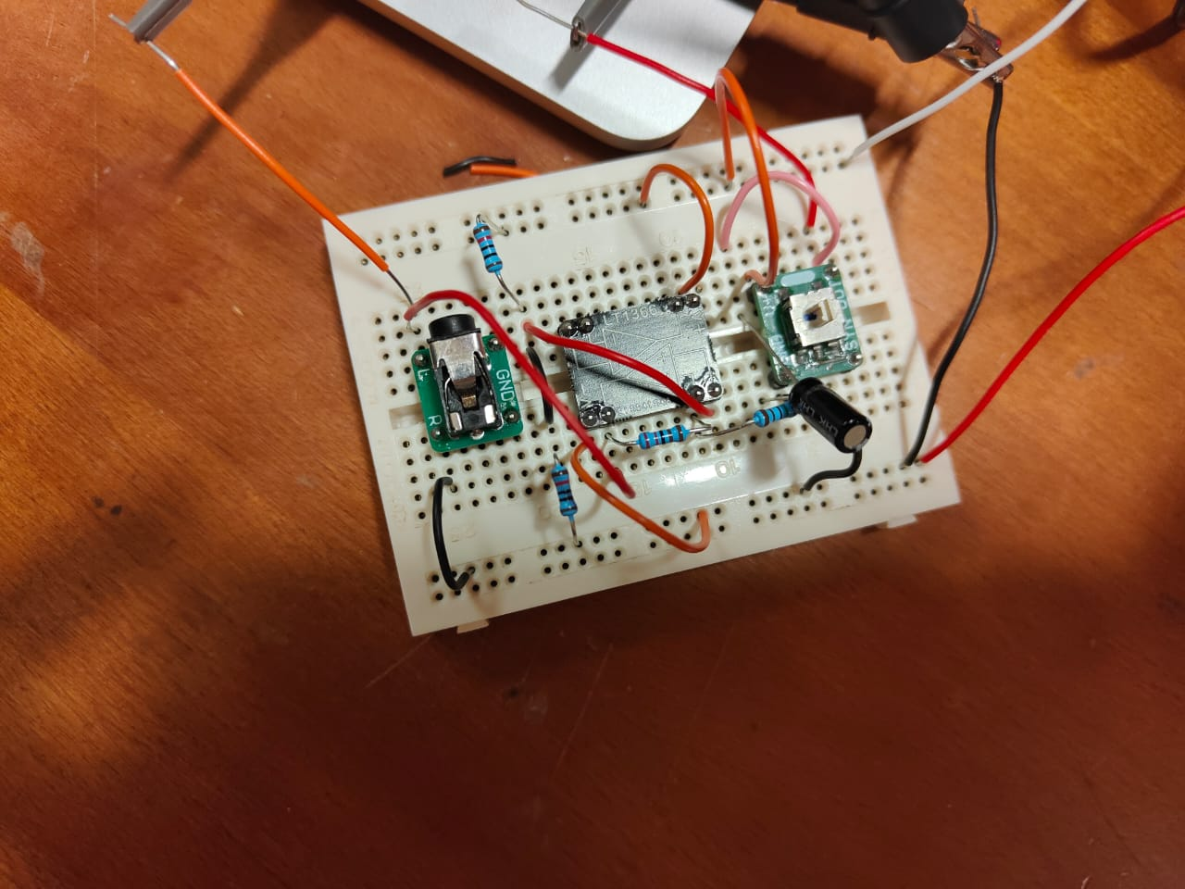Other than that, put a capacitor between the signal source and the amplifier. This blocks the DC part of the signal source and allows AC to pass only, which allows the signal source to instead oscillate between 5V and -5V to 5V and 0V, where 2.5V is the middle, matching up with the voltage of the non-inverting amplifier. The capacitor also acts as a high pass filter with corner frequency of 100Hz, which matches with the minimum frequency of the signal source.

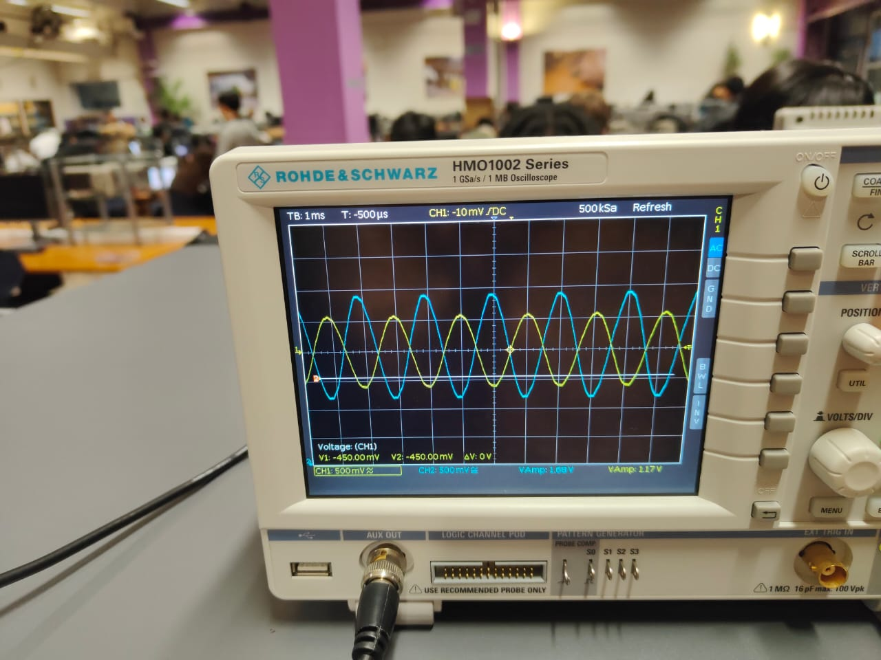In the oscilloscope shown, the blue signal is the output waveform. The amplitude is 1.68V while the input amplitude is 1.17V, which is about 1.5x the input. Other than that, the blue signal is in antiphase with the yellow, which shows that it is negative of the input signal so the circuit works properly.

# Non-inverting amplifier

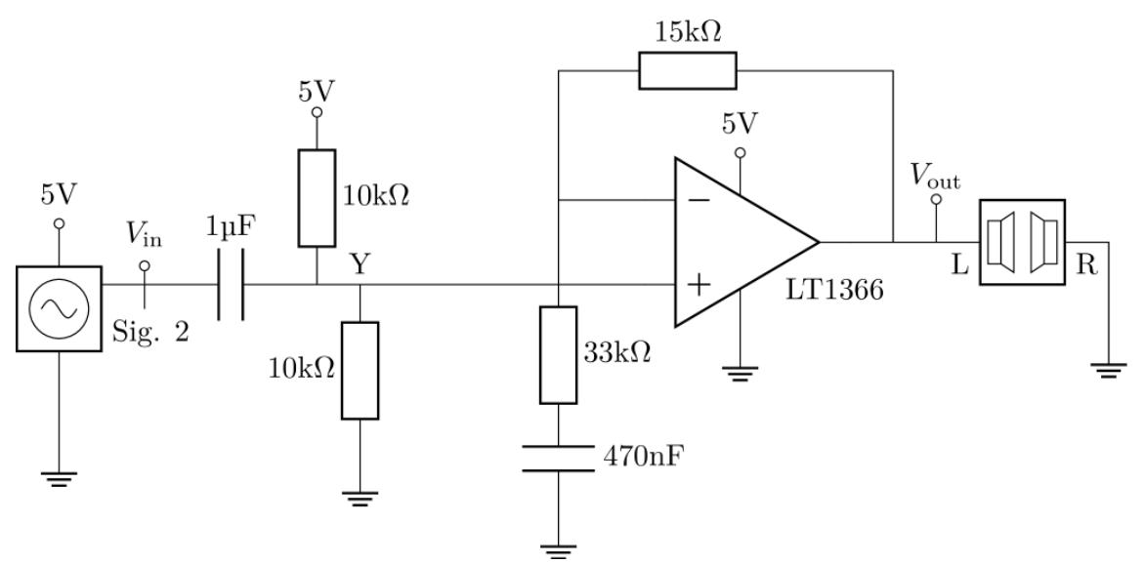

In the non-inverting amplifier above, there are modifications similar to the inverting amplifier, including the 1uF capacitor and the 2.5V into the non-inverting terminal. There is now a 470nF capacitor in series with the 15kohm and 33kohm resistor to block the DC voltage of the fed-back voltage. This prevents the offset of 2.5V from being amplified passing through the op-amp, which would cause problems as the peak AC voltage may be bigger than 5V.

In the above circuit, using KCL: Vout-Vin/15=Vin/33 => Vout/Vin=15/33+1=1.45.

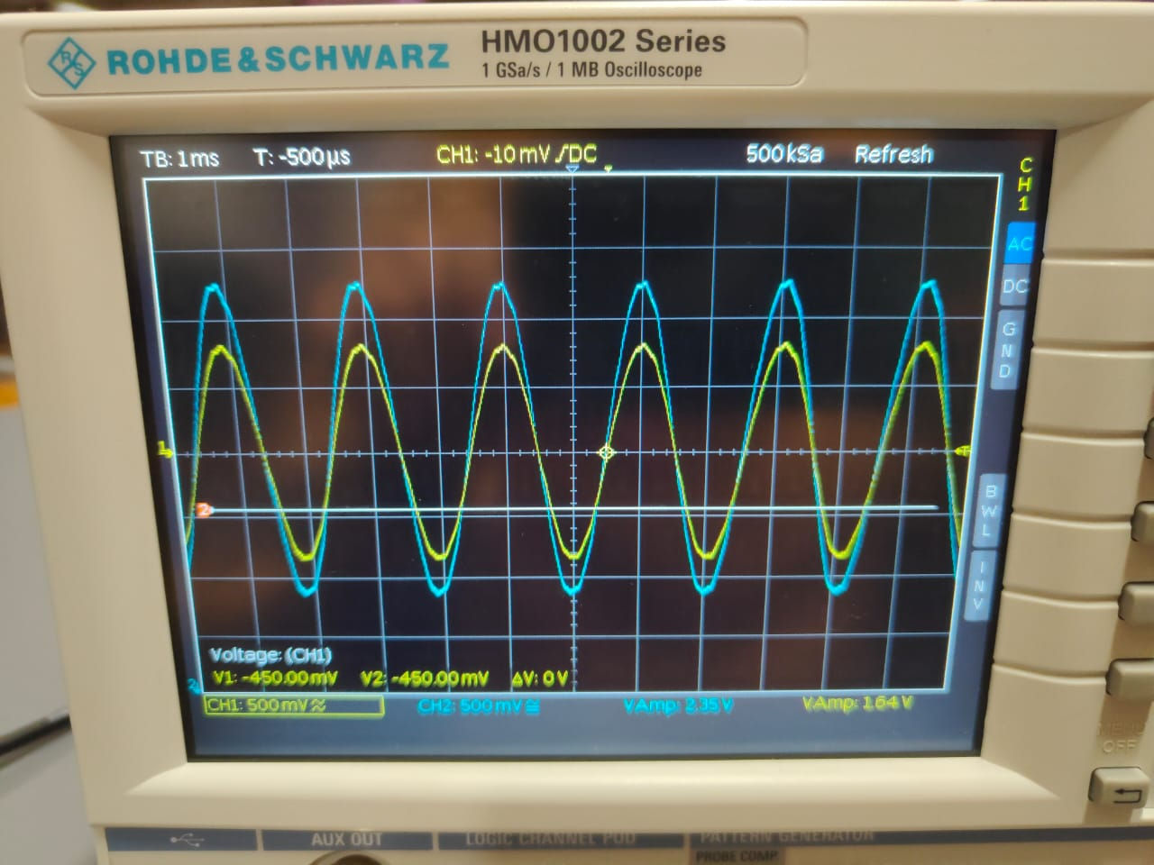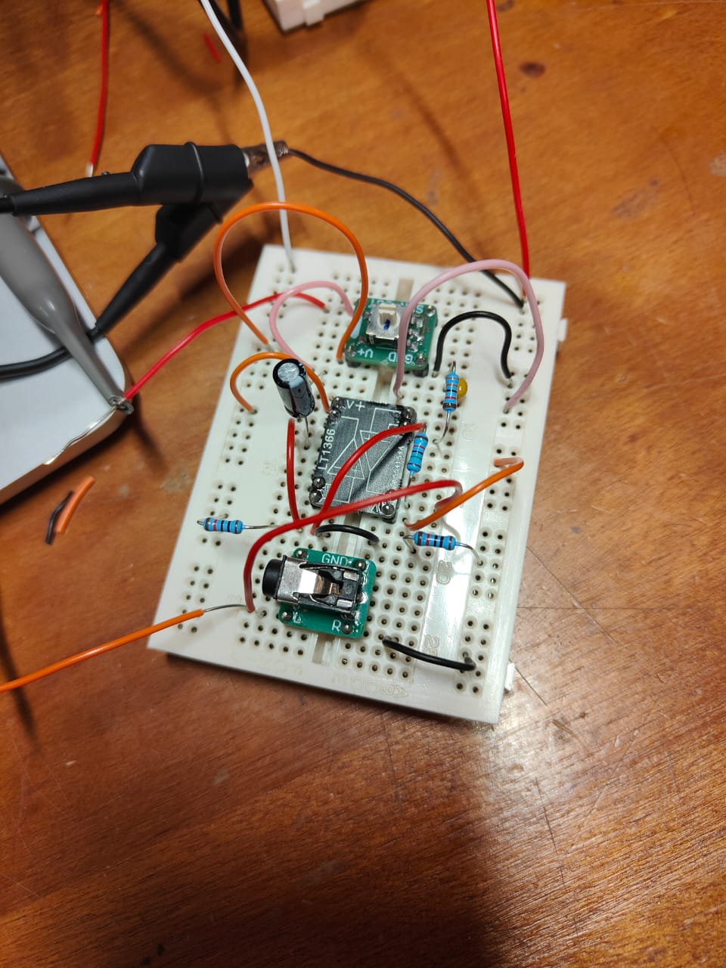In the oscilloscope above, the blue signal has amplitude of 2.35V and the input has amplitude 1.64V, the output is about 1.45 times the input. The blue signal is also in phase with the yellow so the circuit works properly.

# ADC 4: Challenge

[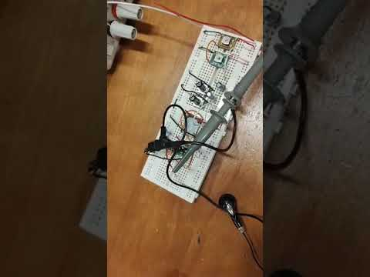](https://www.youtube.com/embed/T0BsmvJNGmw?feature=oembed)The challenge for this experiment is to make an audio mixer, by combining both signal sources where one of them plays the left hand and the other plays the right hand of a piano piece. By connecting them with the SYN pin and using a non-inverting amplifier, we can create the audio mixer.

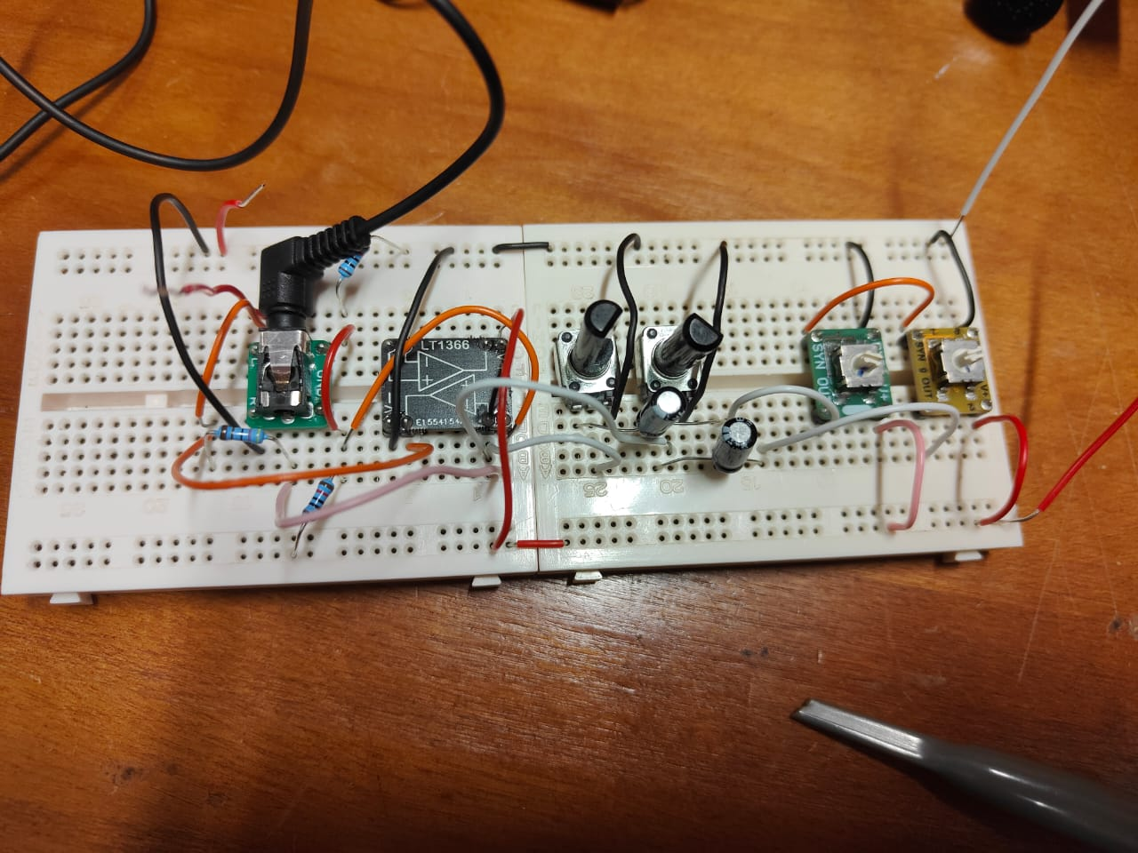

ADC 5: Bandwidth and Filtering

In this experiment we will use op-amps to create active filters and investigate the bandwidth limitations of the LT1366 op-amp.

# Gain-bandwidth product

Gain-bandwidth product is the frequency where the open-loop gain of the op-amp decreases to 0. In the LT1366, the gain-bandwidth product is 400kHz. Additionally, the gain versus frequency graph shows that the op-amp is a low pass filter to ensure that the circuit remains stable without high frequency oscillation.

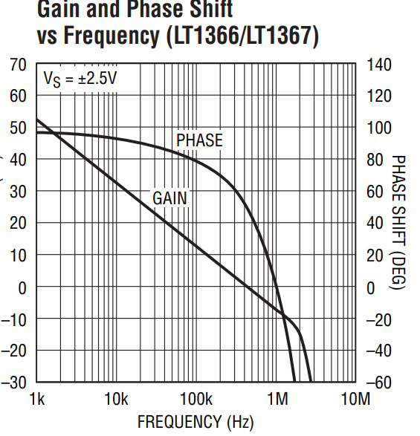

# Active filters

Active filters are filters that uses op-amps in the circuits to achieve gain higher than 1. We can use a non-inverting amplifier as an active filter, with a 1uF capacitor connected in series with the input(similar to the non-inverting amplifier in the previous circuit), and we can measure the voltage of the output. This allows us to plot the magnitude and phase with respect to frequency.

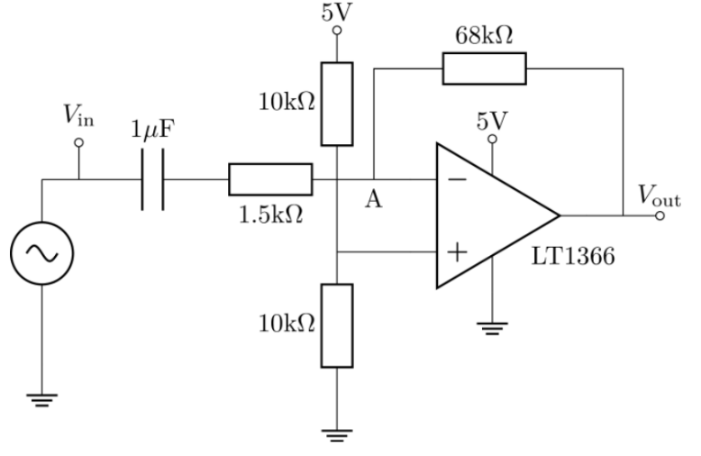

|  |  |  |  |  |
| --- | --- | --- | --- | --- |
| f | Vin | Vout | phase | gain |
| 100 | 0.54 | 4.94 | 0 | 9.148148148 |
| 500 | 0.54 | 4.94 | 1.5 | 9.148148148 |
| 1000 | 0.54 | 4.94 | 3 | 9.148148148 |
| 5000 | 0.54 | 4.6 | 16 | 8.518518519 |
| 10000 | 0.54 | 4.18 | 32 | 7.740740741 |
| 50000 | 0.54 | 1.61 | 72 | 2.981481481 |
| 100000 | 0.54 | 0.92 | 82 | 1.703703704 |

# ADC 5: Challenge

The challenge for this experiment is to make an active filter to block out the whine from mode 8 of the signal source. Using the Analog Devices Filter Wizard tool, we can create a 4th order filter where:

* The frequencies 200Hz-2kHz lie within the passband
* The unwanted signal at 8kHz lies within the -40dB stopband

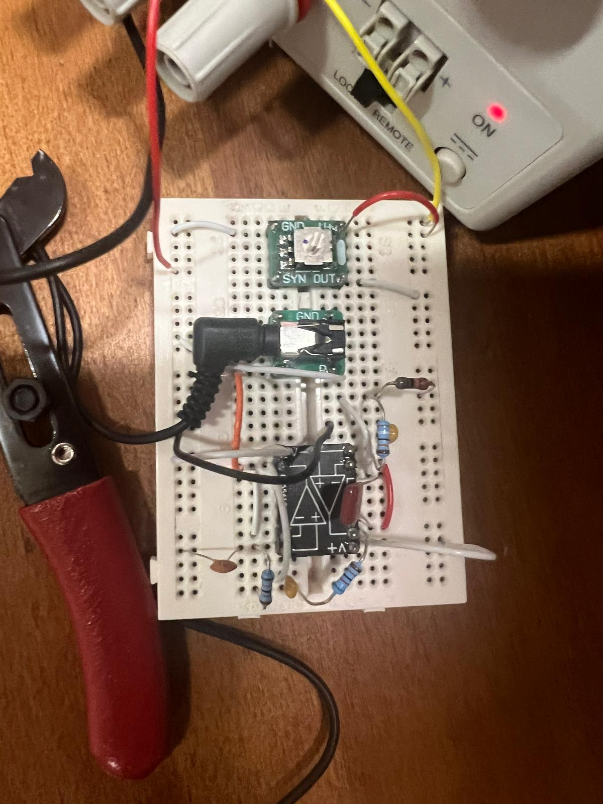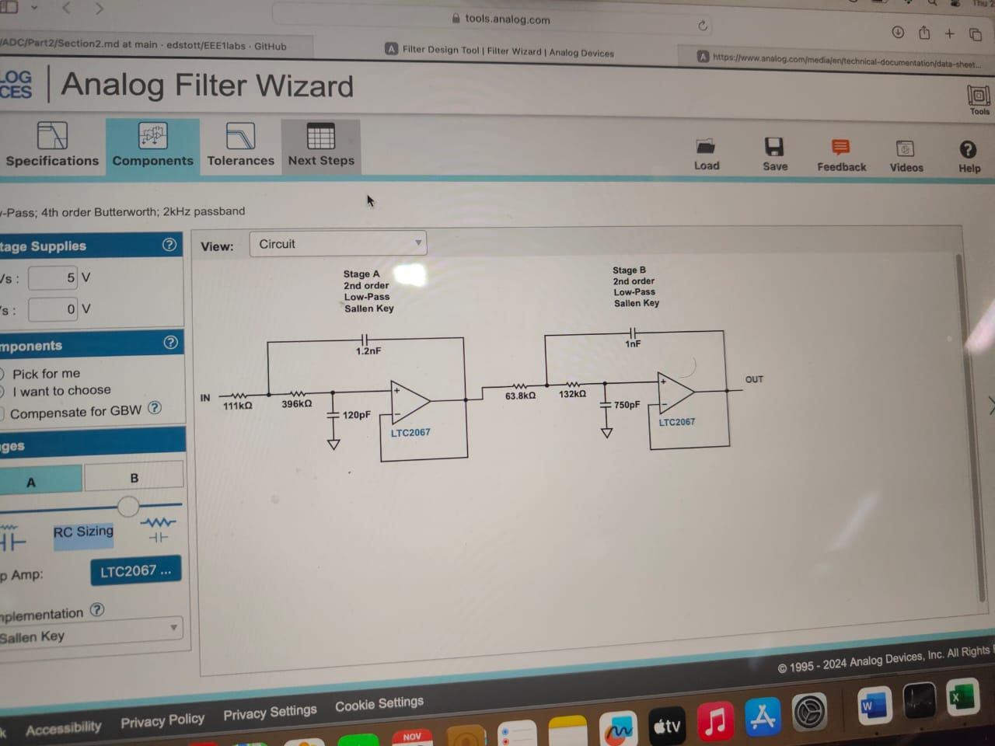For this circuit, we can use the second op-amp integrated into the LT1366. With the resistance and capacitance values displayed in the circuit, we can choose values that are close enough to the values in the diagram. This allows us to remove the whine noise at 8kHz frequency and we get to hear the proper music.

[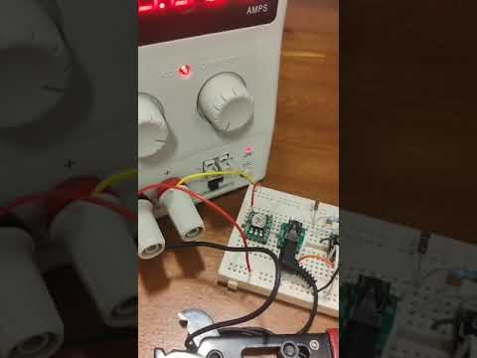](https://www.youtube.com/embed/4AtrCRc9new?feature=oembed)

ADC 6: Characterising a BJT

# BJT intro

In this experiment, we will investigate the characteristics of a BJT. Before the experiment, we can look up online key characteristics of the BJT: VA and beta(collector base current gain).

For the BC547B: hFE(beta)=200. VA can be found by extrapolating the active region of the curve in the collector current vs collector-emitter voltage graph.

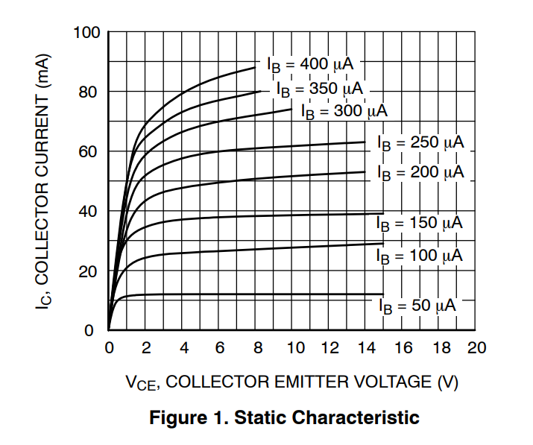Using IB=300u, 250u and 200u, we can deduce their approximate straight line equations and calculate their x intercepts. We get -50, -90 and -77 respectively, which is an average of VA=72.3

# Circuit for BJT characterisationA white circuit board with wires and wires AI-generated content may be incorrect.Characterising

We build the circuit according to the diagram as shown. The maximum collector current the transistor can take is 100mA. If we use VIN as 5V, and approximate VBE=0.7, then the collector current is about 200(4.3/33)=26mA, which does not exceeds the maximum.

Now we need to determine the value of Vin required to get a base current of 20uA. Because (Vin-0.7)/33k = IB, we just need Vin=20x10^-6(33x10^3)+0.7=1.36. Now we can start to vary the value of VCC, and measure the IC(from VC/RC) and VCE.

|  |  |  |  |
| --- | --- | --- | --- |
| VCC | VCE | V across RC(RC=100) | IC |
| 0 | 0 | 0 | 0 |
| 1 | 0.412 | 0.588 | 0.00588 |
| 2.5 | 1.93 | 0.596 | 0.00596 |
| 5 | 4.78 | 0.607 | 0.00607 |
| 7.5 | 6.86 | 0.632 | 0.00632 |
| 10 | 9.33 | 0.655 | 0.00655 |

Repeating the process, we change VIN to get IB=50uA and 100uA. According to the graphs, we can extrapolate them to get the experimental value of VA. We get x-intercepts of 55, 65 and 70 respectively, which gives us an average of VA=63.3, which is quite close to the extrapolated value of 72.3.

ADC 7: Common Emitter Amplifiers

The CE amplifier uses a BJT to amplify small signal inputs.

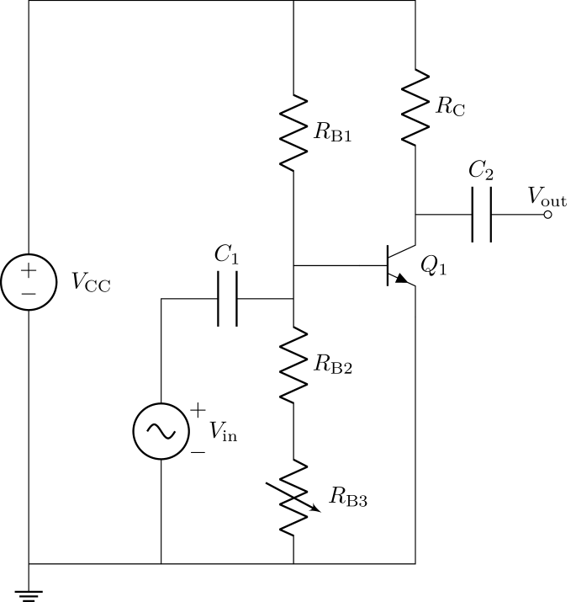

# biasing

Before adding the small signal Vin, we need to add a DC offset to the circuit to operate the BJT at the steepest gradient of the Vout vs Vin graph (quiescent operating point). Generally the quiescent operating point is at Vout=VCC/2, which is 2.5. Now we need to find the value of RB3(potentiometer) to obtain Vout=2.5.

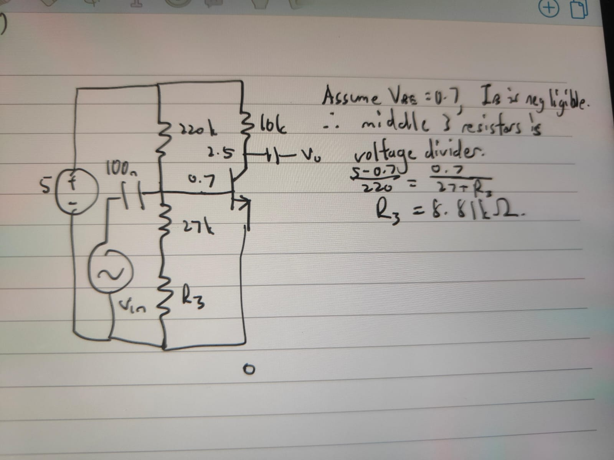

When I hold the transistor, the Vout decreases to a minimum of 2.09V. This is because the BJT is largely temperature dependent, where Is, beta and VT all depend on temperature. When I hold it, the temperature increases and IC increases, so Vout=VCC-ICRC decreases.

# Amplifier Performance

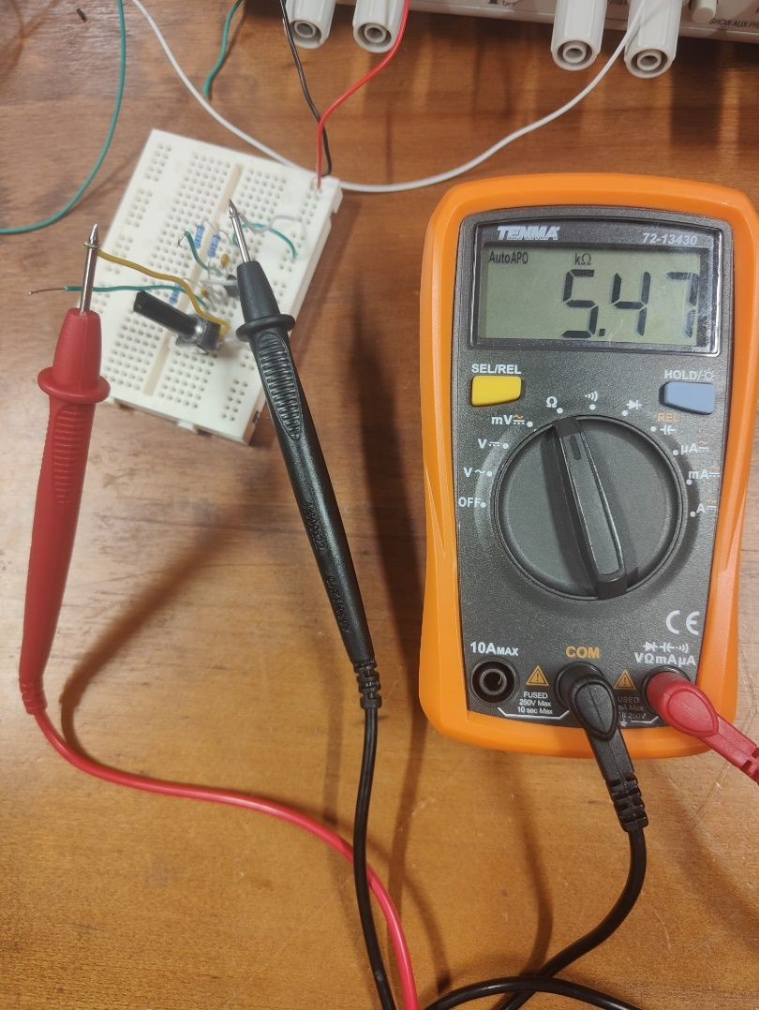Now we build the circuit. Before measuring the output voltage, we measure the dc bias point of the output voltage and change the resistance of the potentiometer RB3 to get the desired 2.5V. The actual resistance of RB3 is not the same as the estimated one.

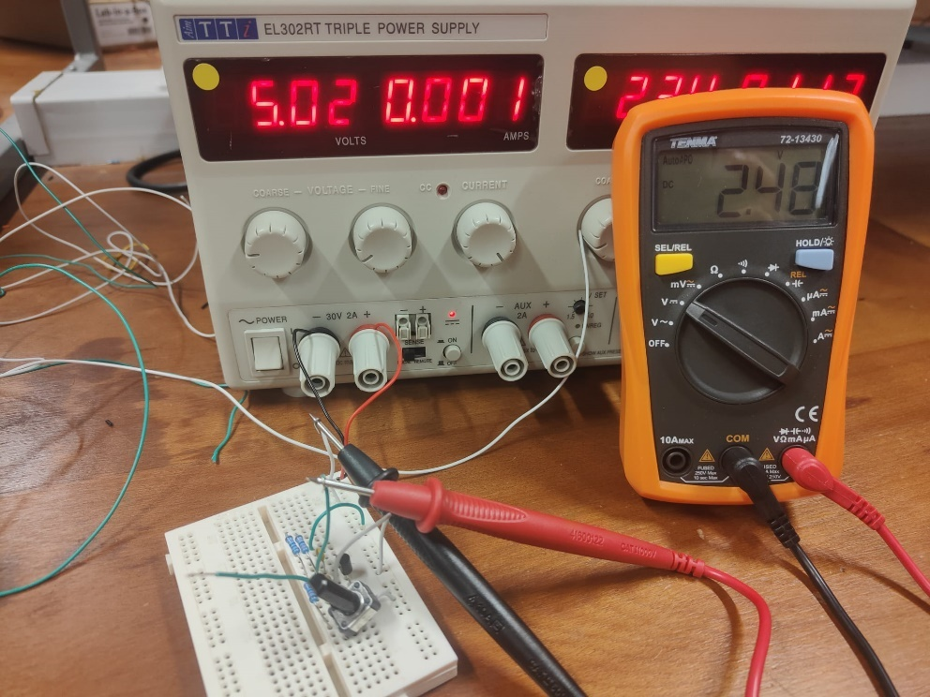The resistance that we need for the potentiometer is 5.47k.

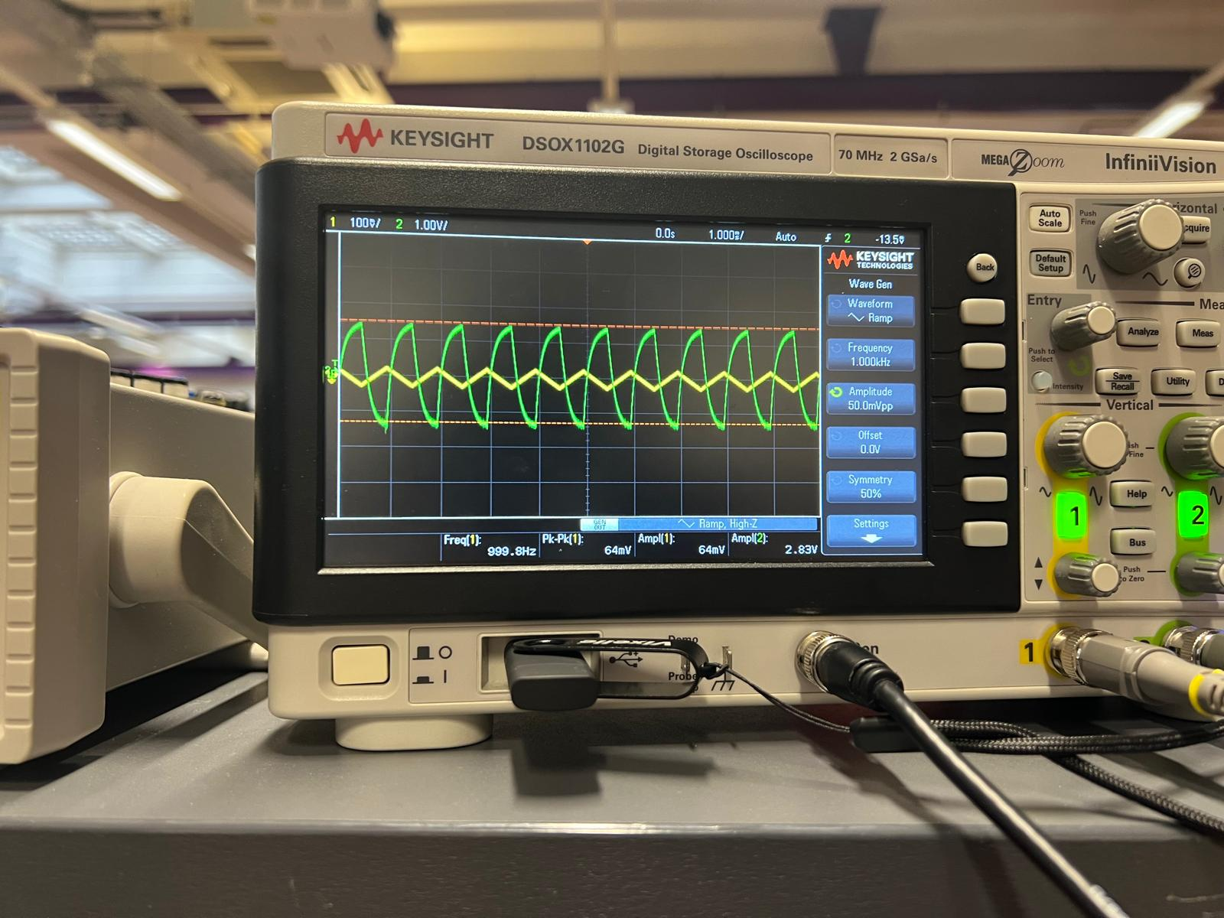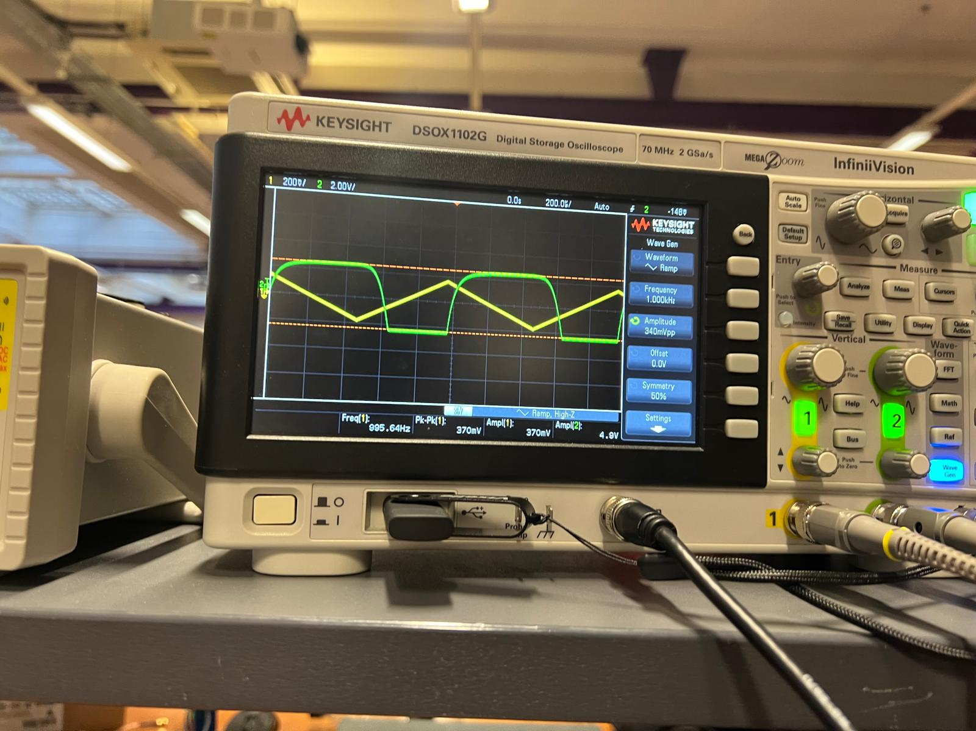Now we put in a triangle wave with 5mV amplitude and 1kHz frequency, then measure the output voltage from C2. At small amplitudes, the output signal will look like a triangle wave, as the input voltage is swinging in a small range inside the active region. At larger amplitudes, the output signal will swing out of range into the saturation or cut off region which distorts the output signal.

We switch the input signal to a sine wave with same amplitude, then find the output voltage amplitude, which we can use to find the small signal voltage gain, which was found to be 50. We can also introduce a 10k resistor in series with the signal generator input, then by using the equation VOUT1=VOUT2(1+10k/Rin) and measuring the output voltages before and after adding the resistor, we can get the input impedance of the amplifier.

# Emitter Degeneration

Emitter degeneration involves adding a resistor at the emitter end of the transistor. This reduces the dependence of the amplifier on temperature(using load line method). 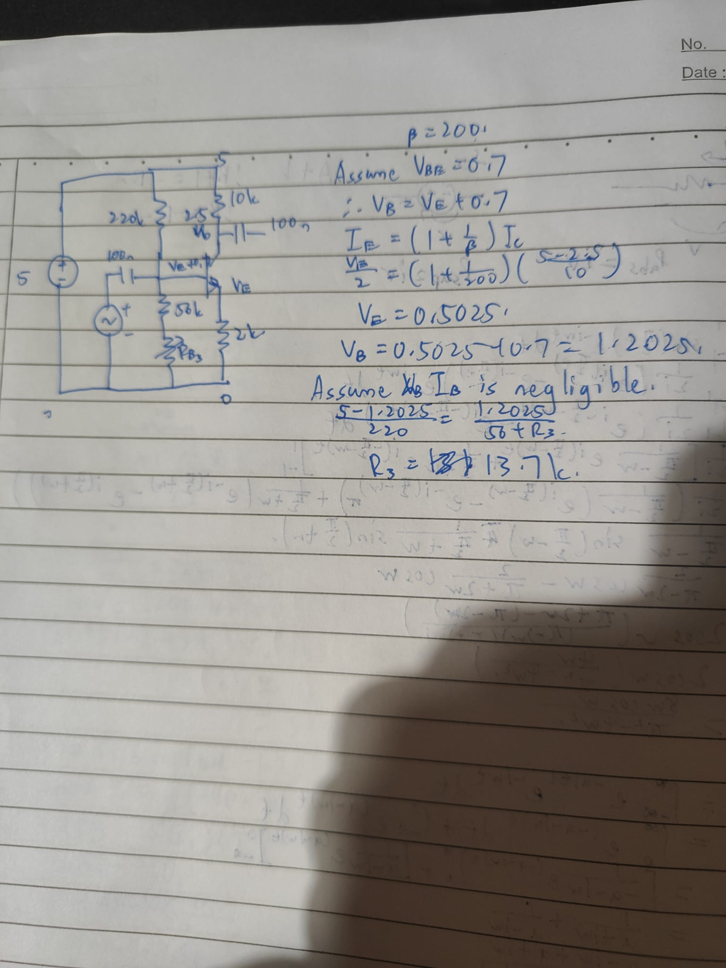

We calculated that RB3 needed is 13.7k, but the potentiometer can only go up to 10k. So we use the maximum value of 10k and we obtain an output dc bias voltage of 2.45, which is close enough for our experiment.

In this case, the gain that we get is 4, which is lesser than without emitter degeneration. This is because the emitter resistor causes negative feedback which decreases the output voltage, making the gain only about alphaRC/RB.(alpha: collector emitter current gain).

When we add a capacitor in parallel with the emitter resistor, we find that the gain is about 51, which is about the original value of the gain without emitter degeneration. This is because the capacitor acts as a short circuit at high frequencies, making the degenerated circuit like the original circuit, which gives us the original gain. The emitter resistance is only there to decrease the dependence of the dc bias on temperature.